Section 1- The Fundamentals

**Security**

**Authentication:-**

It is the process of letting an application know who we are whether we have access or not

**Authorization**

It is the process of application determining how much access we have depending on the role that is assigned to the user

Ex:- when we login in banking application , we need to give user id and pw and banking application will validate user id and pw. This process is called authentication

Once we login in application , it uses role to do authorization.

Each role is mapped to certain urls or method in the application and user with certain role have access to certain functionality within the application and certain user will not have access to certain functionality in the application.

**There are different way of authentication**

**Http :-**

Basic

Form based

**Restful**

Oauth single sign on

Note : we can create our own authentication and authorization process as well

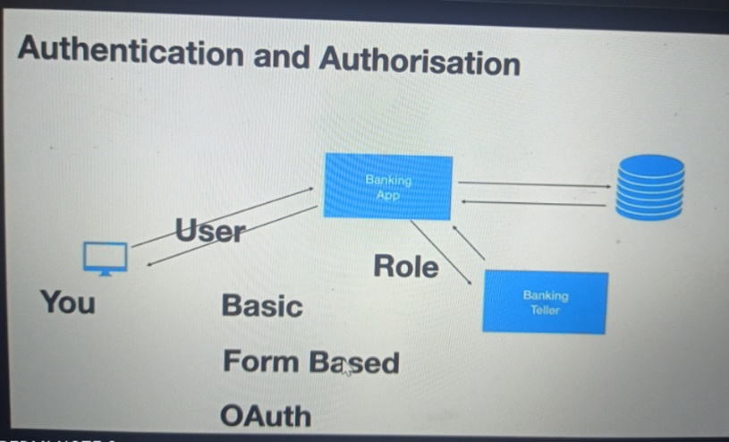

**Confidentiality**

Application ensure that the data they are sharing is not vulnerable to hackers

**Example :--**

if our neighborhood hack the credential over the n/w then what will happen that is where encryption and decryption come in . The simplest way of doing encrypting and decrypting is by using https

Hackers not able to do anything even they got credential until they got private key which will use by application to decrypt data

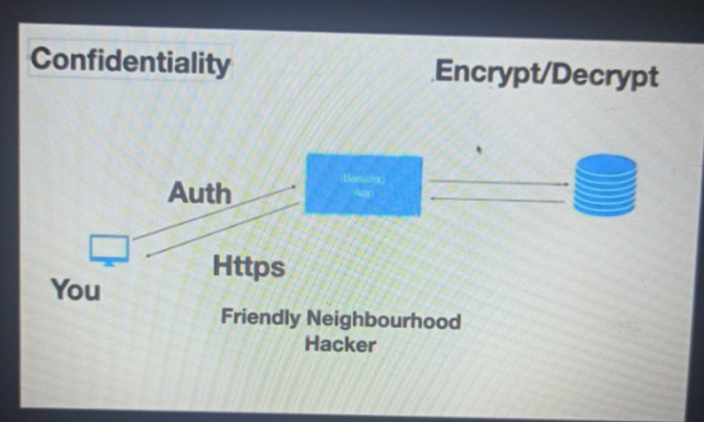

**Integrity**

Integrity is check using signature , when token send it will be signature

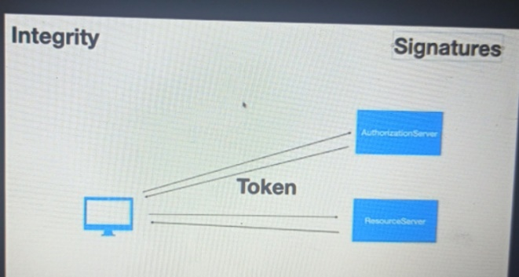

**CSRF:-**

**Cross site request forgery (prevent)**

Will prevent another website to submit data on your behalf

**CORS**

**CROSS origin resource sharing (allow)**

Browser donts allow cors we should enable cors in server side application , frontend and backend running on different domain

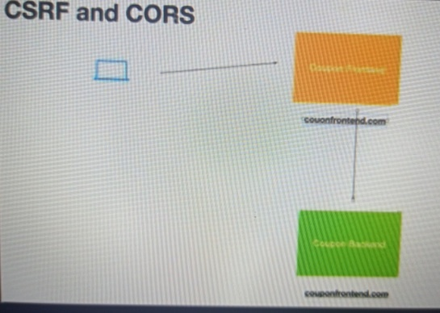

**The key security components**

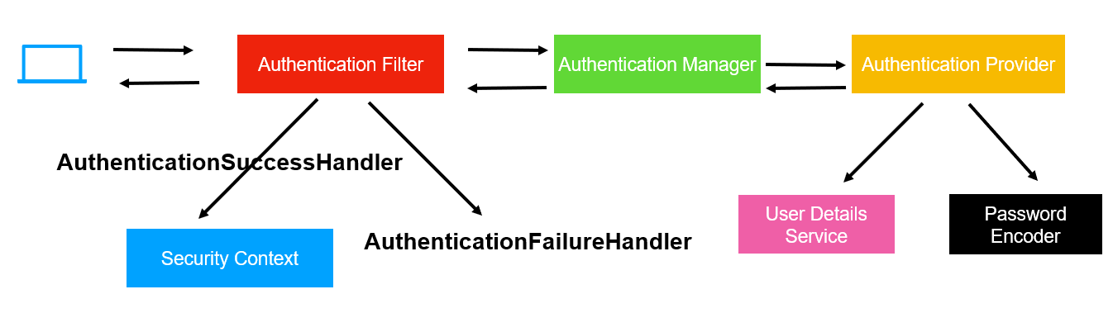

When end user or restful client send a request to restful application the very first component in spring security

Intercept the request is the **authenticationFilter** . AuthenticationFilter is servlet filter class that will see

If user has been authenticated if not it will send back that request to **Authentication Manager** to check that the details sends by the user is correct( user name and password are valid). Authentication Manager intern uses

**Authentication Provider** this is where login logic or authentication logic is defined. Authentication Provider will

Not fetch user details from ldap, d/b or in memory, it will use User Details Service for that purpose.

It also uses **Password Encode**r because we don’t want save p/w in plain text. Once the authentication provider

Check the user detail and password is correct it will send the appropriate response back to the

Authentication Manager. The Authentication Manager hand back to Authentication Filter. If the authentication

Or user details is ok means authentication success then Authentication Filter use **AuthenticationSuccessHandler**

And store the user information , the user entity itself in instance of **SecurityContext**. If the Authentication failed it will use **AuthenticationFailureHandler** to send appropriate response back to the client.

**UserDetailsService** is responsible for fetching the information , it could be ldap, authorization server of oauth,

It could be d/b or in memory etc

**PasswordEncoder :** is responsible for encoding the pw

**SecurityContext :** is where user information is stored for future

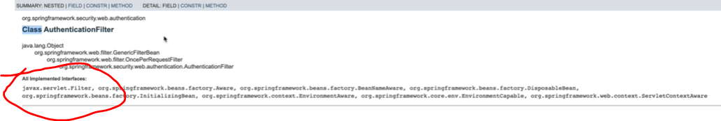

**AuthenticationProvider ---- interface ------**

having method authenticate while will take Authentication as object

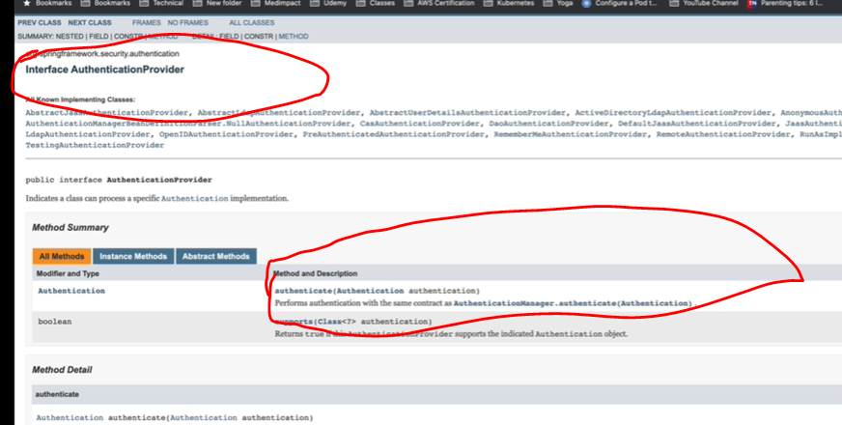

Except AuthenticationFilter all are interface

**Note**

**Spring provides default implementation that will be enabled when we use spring security**

PasswordEncoder

AuthenticationManager

AuthenticationProvider

UserDetailsService

We can customize when we want to use our own security we will override UserDetailsService,AuthenticationManager

**Note:** if we don’t want default we can configure this

**Spring security**

**Note :**

By default it uses basic authentication

**Spring Security in action**

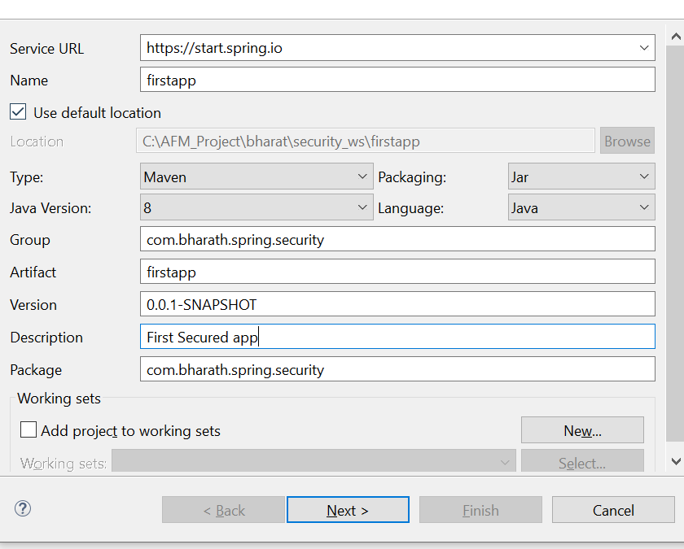

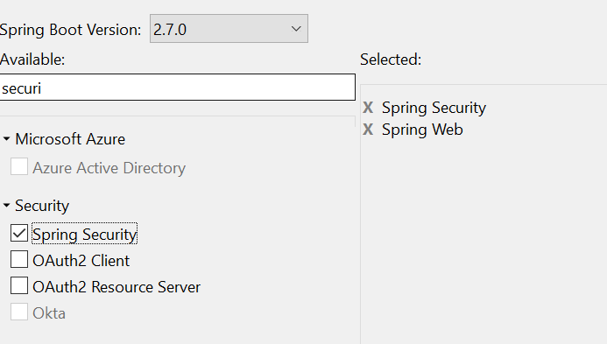

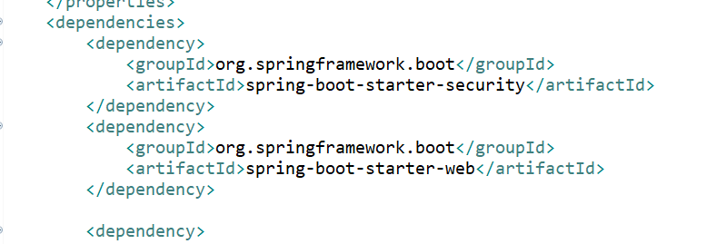

Note:--

As soon as will add spring-boot-starter-security, security is enabled for authentication

UserDetailsService job (default):---- it will create pw in console and create user by name user

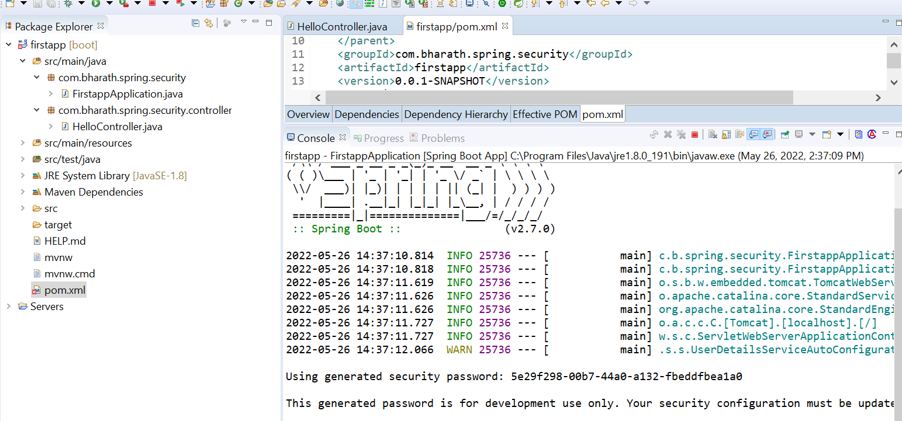

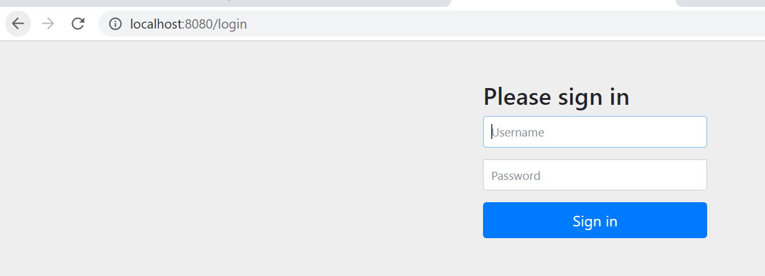

**Note:-**

And it stores username and pw in memory. If we restart application both are gone

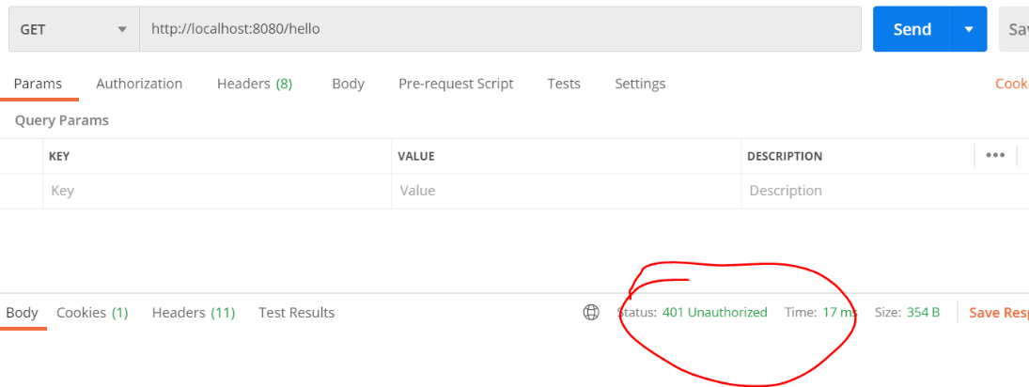

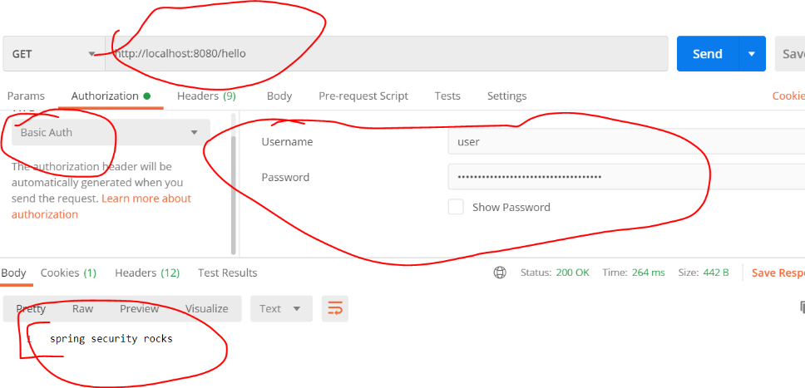

**Note :--**

the default passwordencoder does not encode pw. It uses the plain text

**Resending Basic Auth details**

How basic authentication flow work behind the scene

**It will generate a cookie**

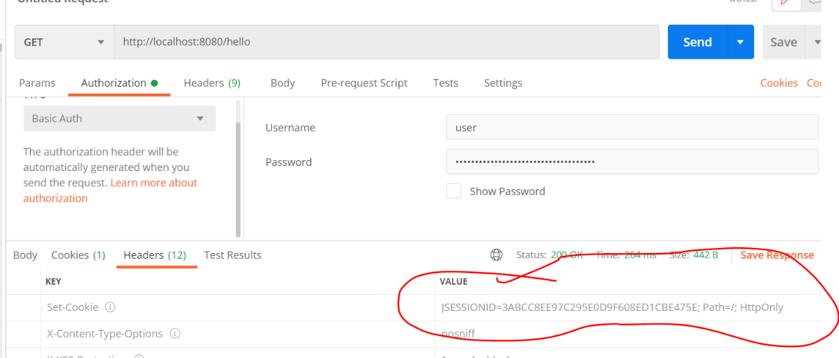

In web application it will generate a cookie , jsessionid and it stores it inside security context.

They will send cookie back along with the request everytime we are hitting it . The next time filter will see the cookie and check if there is corresponding response is there. That is the reason from second time onwards it doesn't asked basic authentication

First time request :-- jsessionid will create

Second time request :-- jsessionid will use as key and it will check by AuthenticationFilter

**Create Custom Security Configuration**

**Requirement :-** will create our own user and p/w

**httpSecurity** :---

how the url within the application should be accessed

**AuthenticationManager :**

Will configure user name and pw

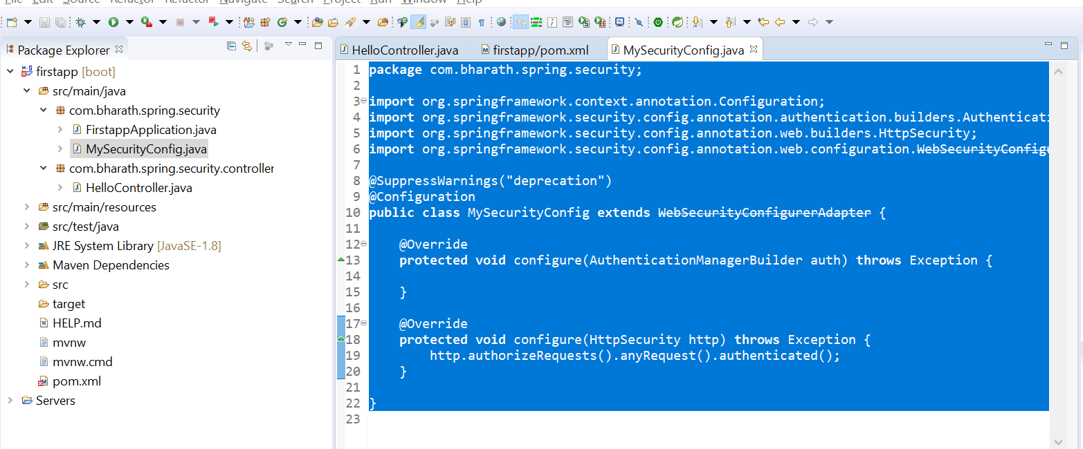

**Use Custom UserDetailsService**

How to Use UserDetailsService and password encoder

**Imp**

1-AuthenticationManagerBuilder auth have method UserDetailsService

**2-AuthenticationManager** which internally uses **AuthenticationBuilder** knows how to use **UserDetailsService**

**3-But UserDetailsService doesn’t know which user need to use while using below line**

4-InMemoryUserDetailsManager userDetailsService = new InMemoryUserDetailsManager();

Note:

When we run our application internally authenticationprovider use passwordencoder automtically

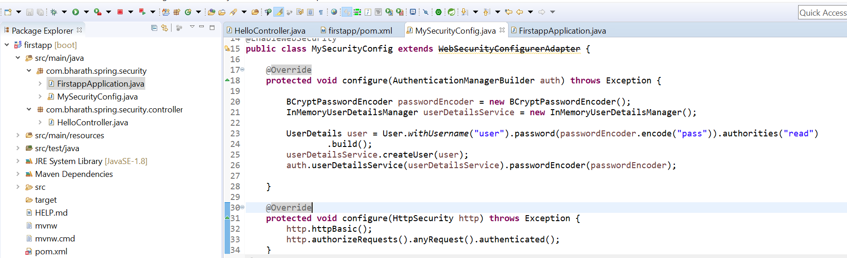

Whatever we are storing in memory like pw that also should be encoded

**Test**

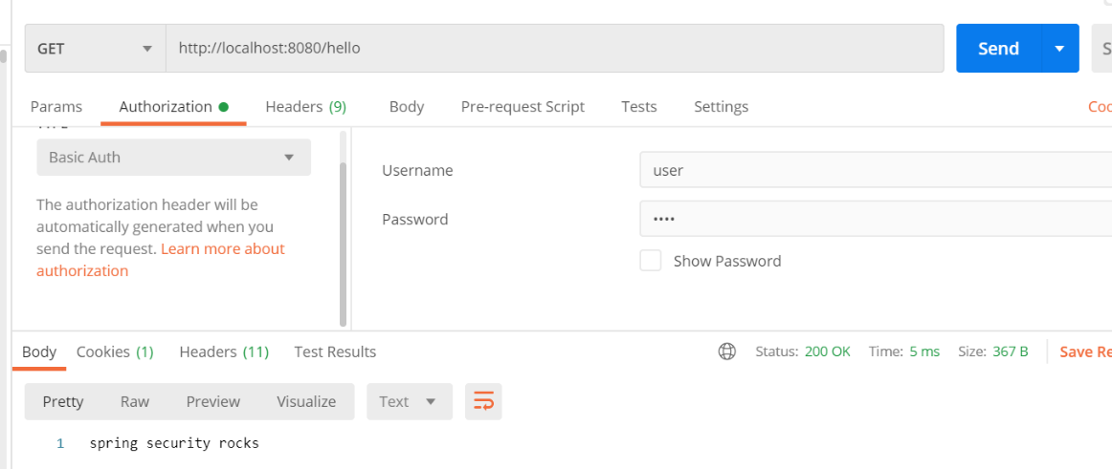

**Tweak the password encoder**

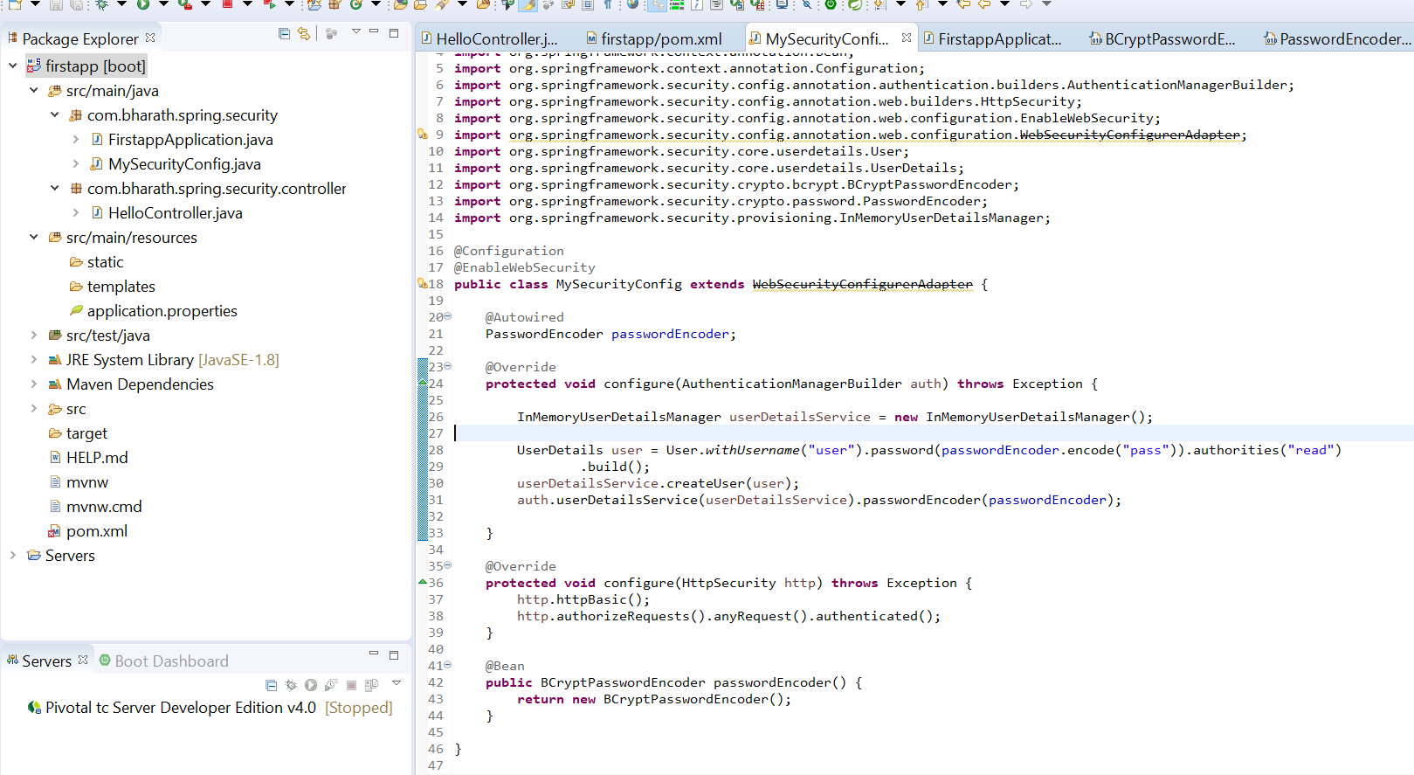

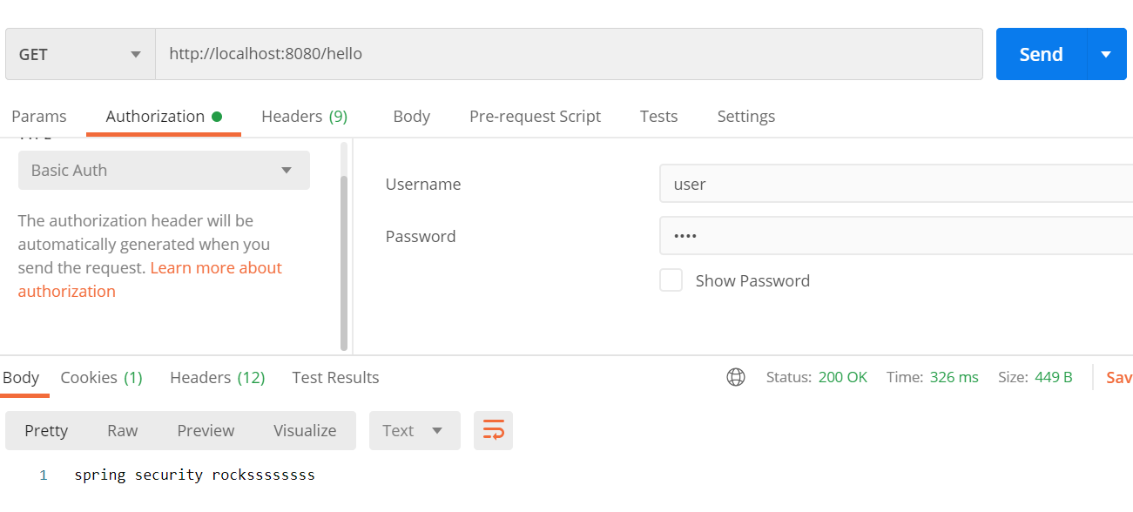

**AuthenticationManager will find passwordEncoder automatically**

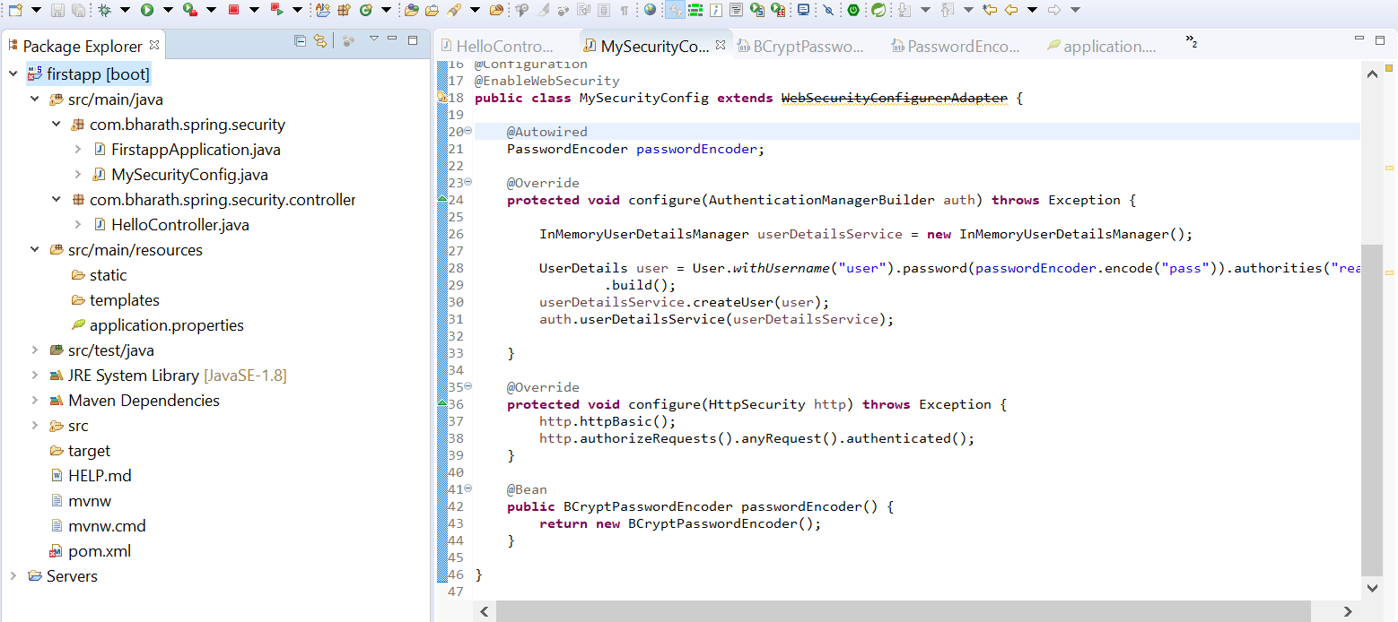

**Create Custom AuthenticationProvider**

UsernamePasswordAuthenticationToken will go back to AuthenticatoinManager

AuthenticatoinManager passes authentication object in support method and it check whether this type of authentication is supported or not

The job of AuthenticationManager to to see all AuthenticationProvider and see it is supported or not

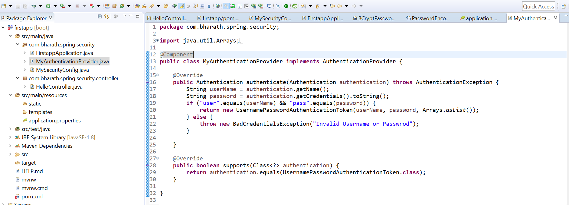

**Note :**

The first method write the authentication logic and second method tell the authenticationmanager this guys support UsernamePasswordAuthenticationToken

**Test**

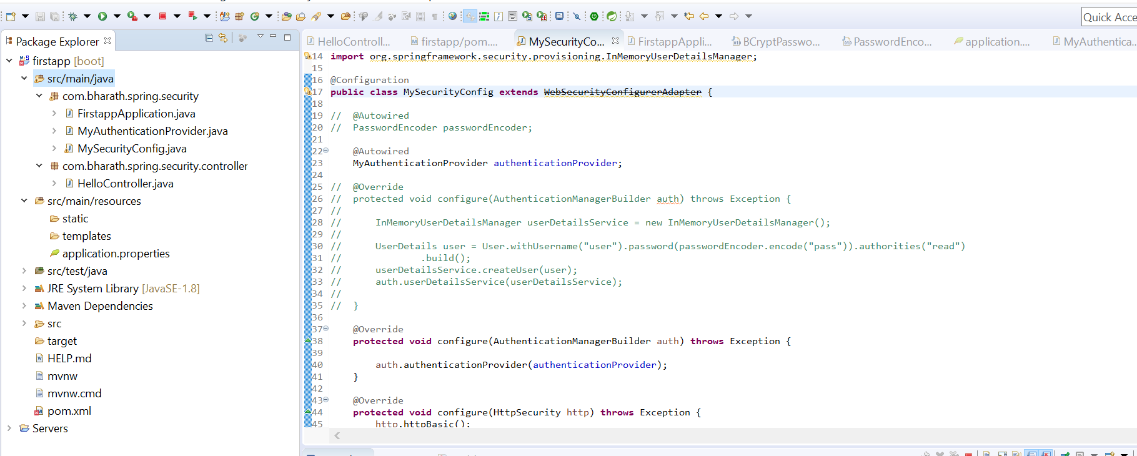

**Use form based login**

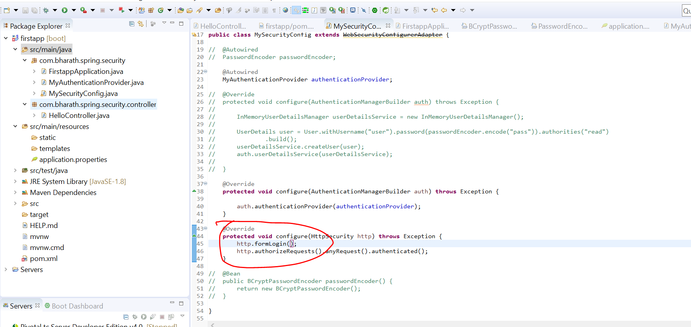

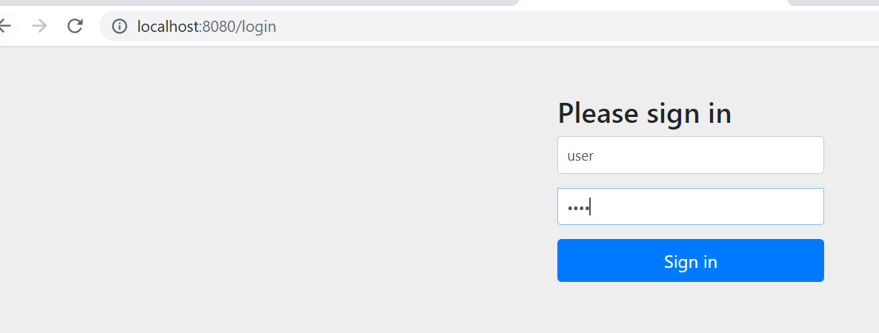

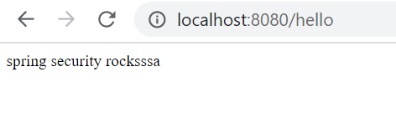

Note : spring security have different filter for various authentication

**Few More Methods**

**So far we test for all url**

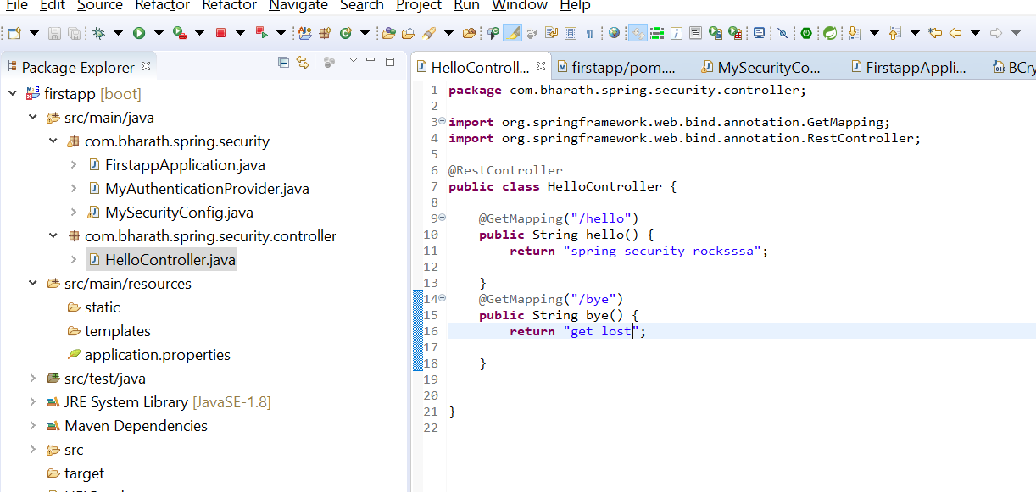

**Note :--**

**Only authenticated user will able to access hello endpoint**

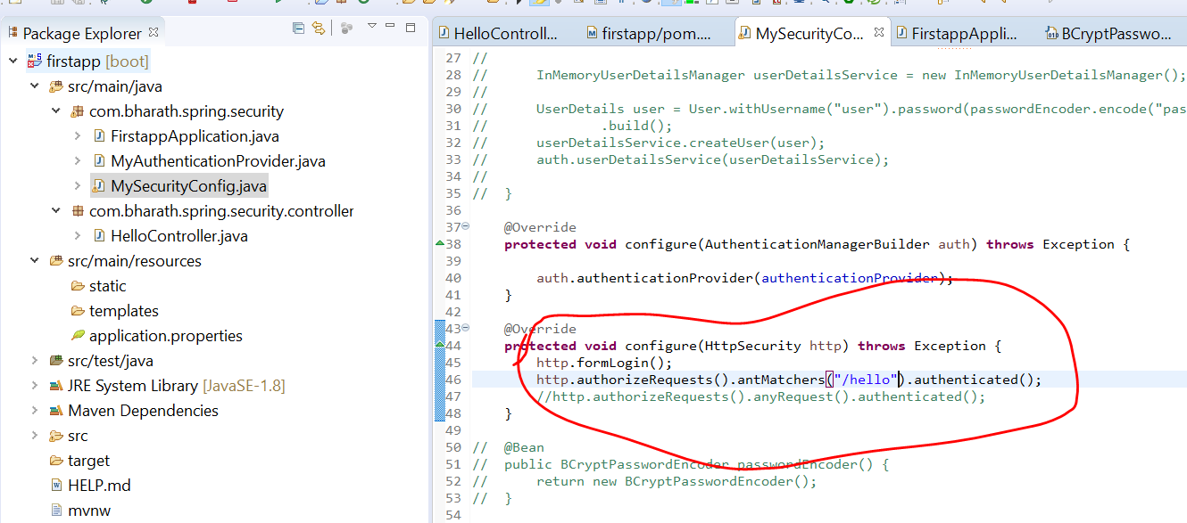

**In this case we are able to access bye endpoint without security**

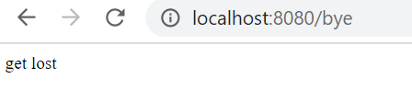

**But in case of hello end point will get security page**

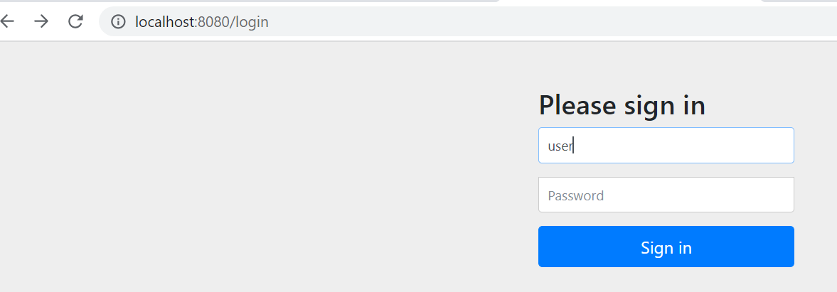

**In this case only hello endpoint will be access and any other endpoint will not access**

DenyAll is rarely used



**Create Custom filter**

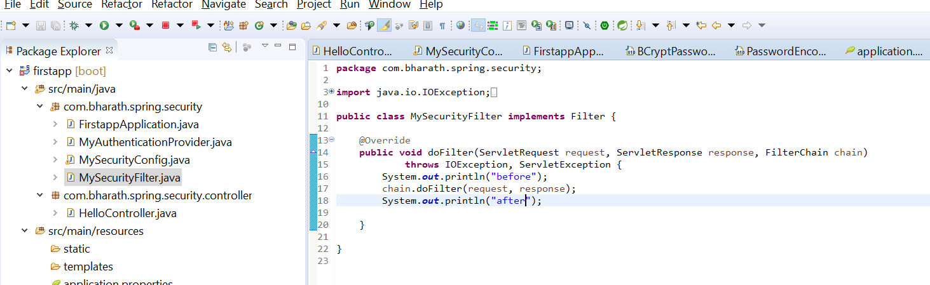

**We need to add this filter**

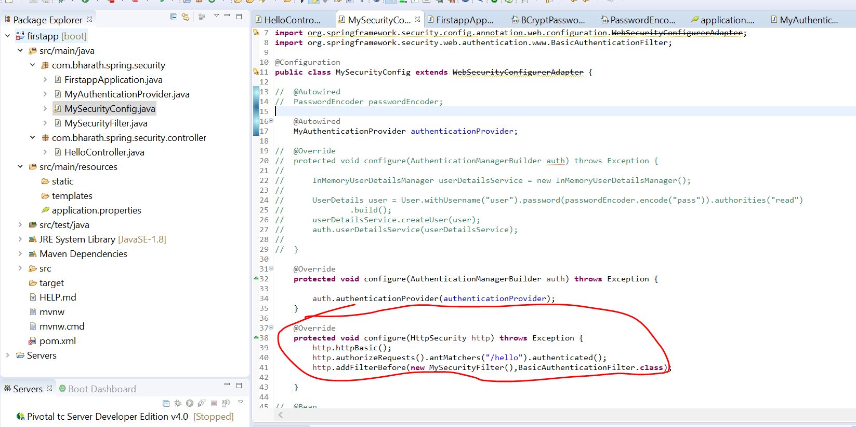

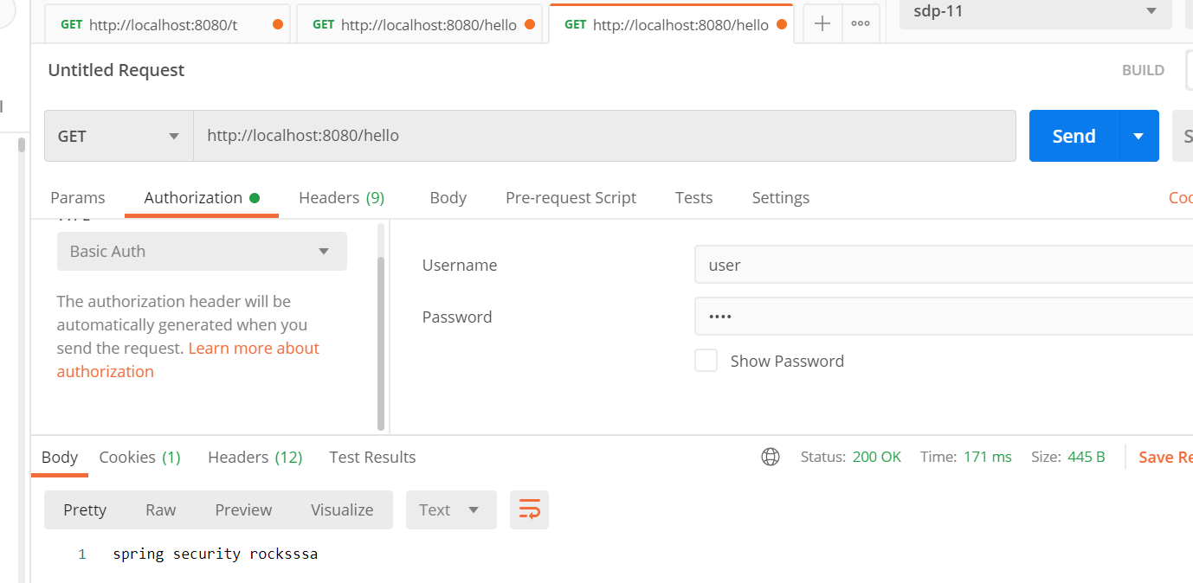

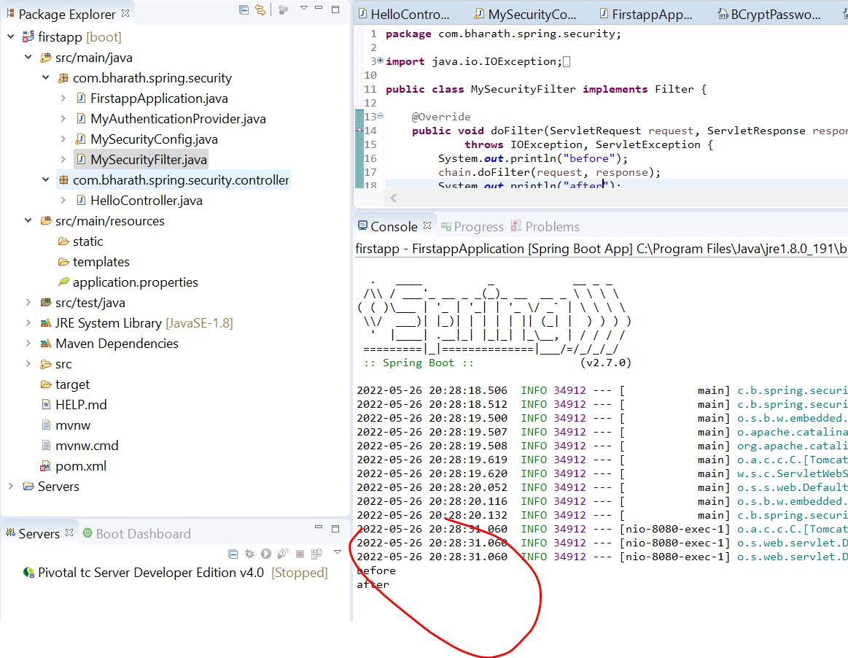

**Other PasswordEncoder**

BCryptPasswordEncoder is an implementation of PasswordEncoder interface in spring security. Spring security provide various implementation of encoders not only BCryptPasswordEncoder .

It is reponsibility of PasswordEncoder encode that pw that is coming from client and matches with pw that is already encoded and save

In d/b and return a boolean value.

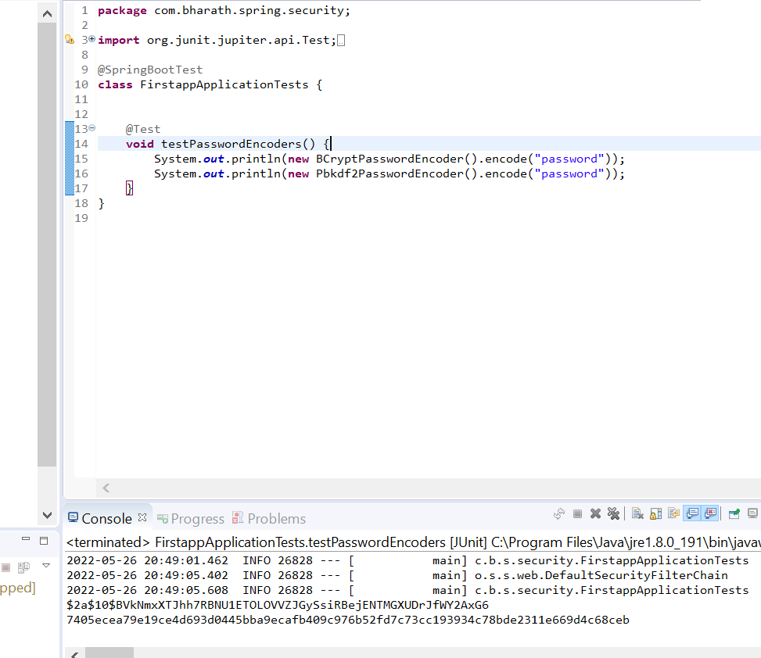

**DelegatingPasswordEncoder :-**

can be used to support multiple encoders

It works list of encoder we need to give then at runtime we need to pass key

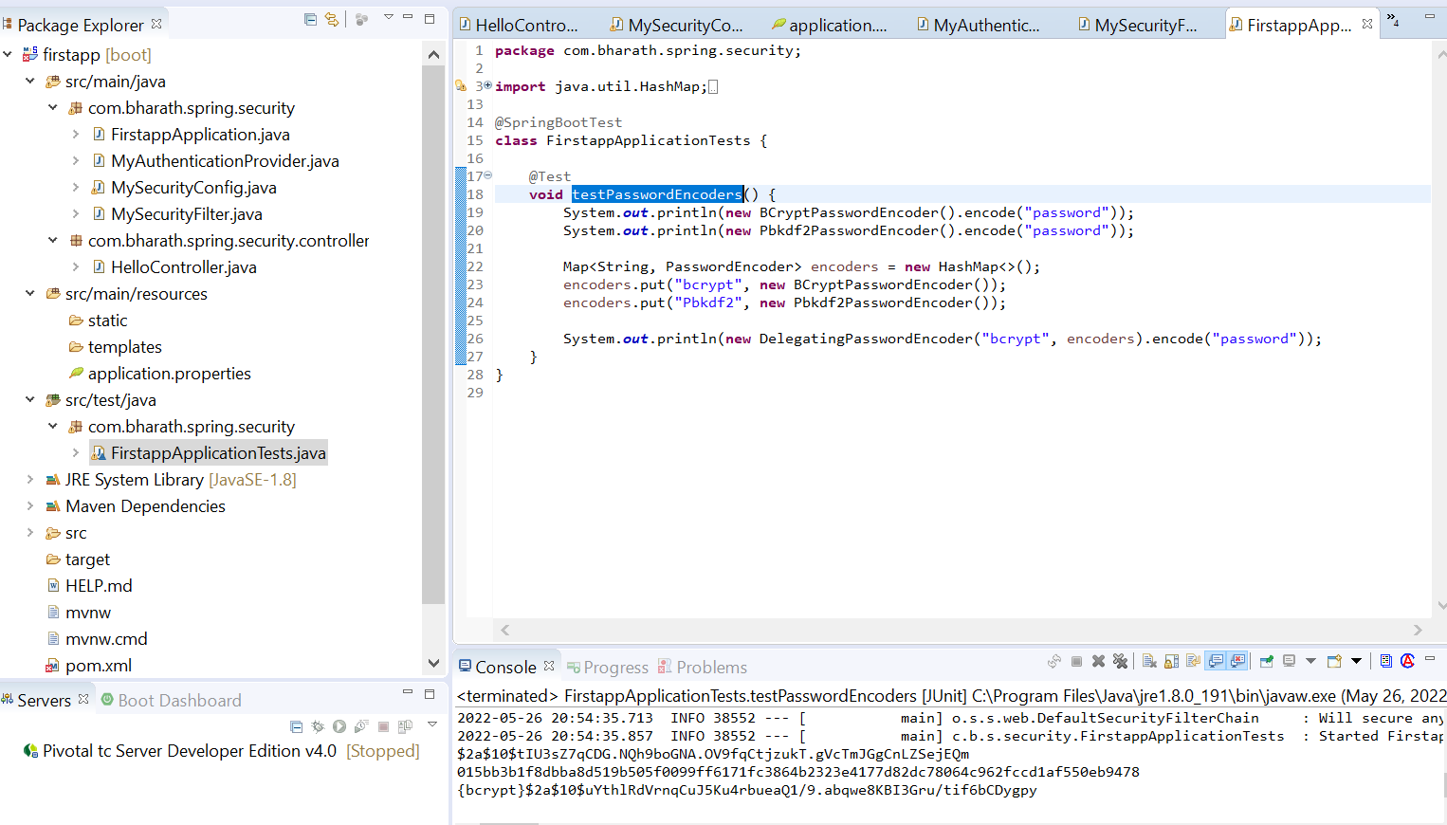

**Section 2 :-Create Microservices**

**Usecase**

Product m/s

Coupon m/s

These two m/s will expose restful api which will allow client to create a product and in the process

Product service will use a coupon service to apply a coupon code that client passes in and

Get the discount so all the coupon information is maintained by coupon service and product service is only responsible for creating the product in the d/b along with price and description details which the client passes.

**The process here ;-**

is take client request , the product service will call the coupon service get the discount for coupon code which the client would have passed apply the discount on the price which the client passes

And then save the product to the d/b. all the coupon info will save in coupon service d/b

**Client ------------product service (ms1)------------couponcode -------------coupon service (ms 2)**

**Table info**

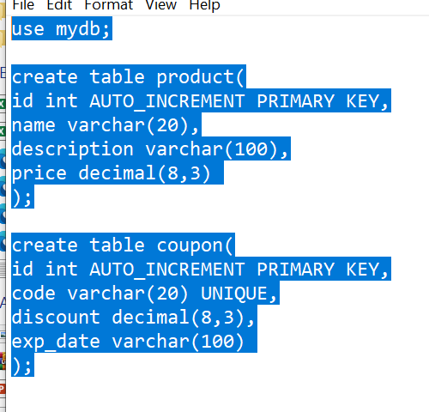

**Steps**

Create the project

Create model and repository

Create the rest controller

Configure the data source

Test

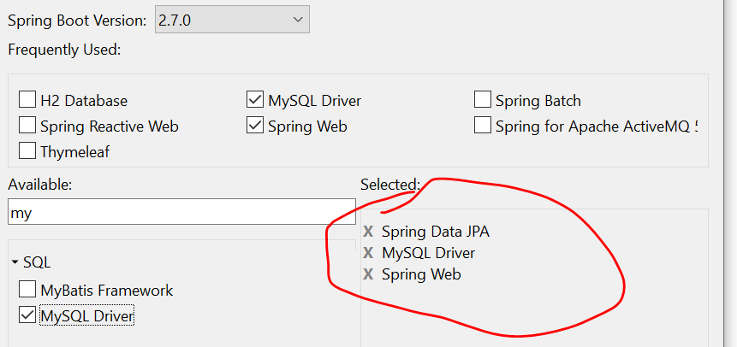

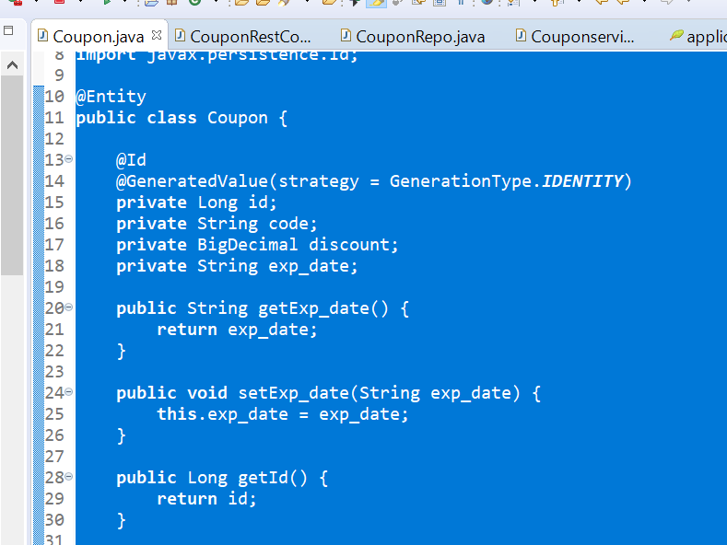

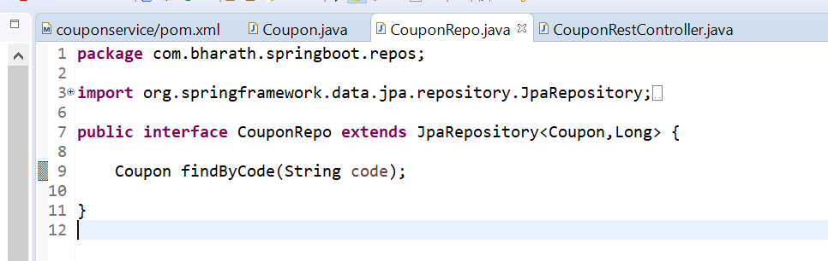

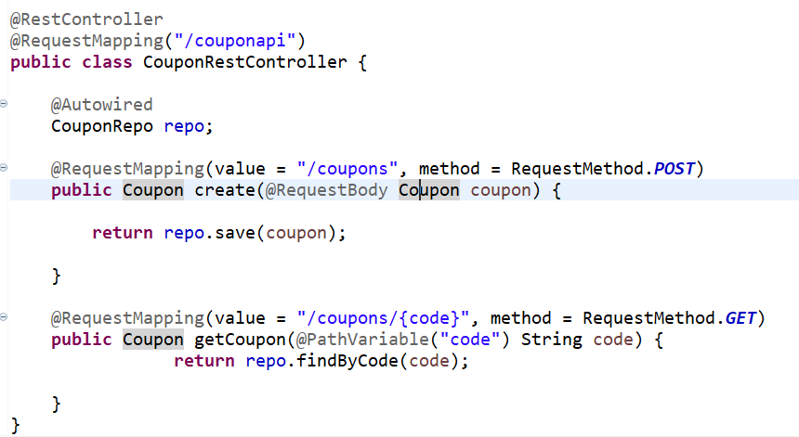

Configure the data source

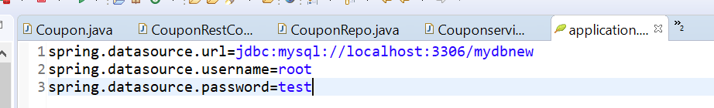

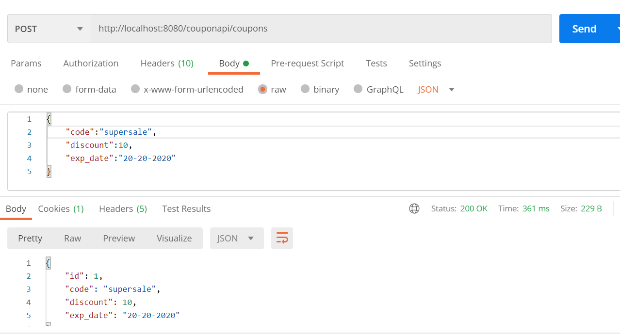

Create Product Microservice

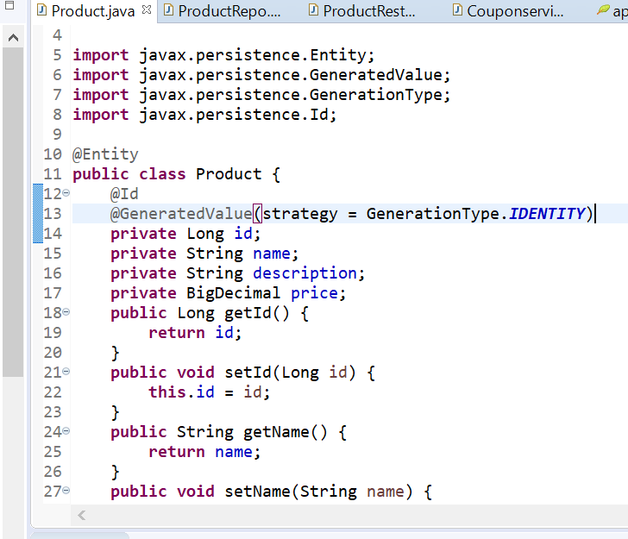

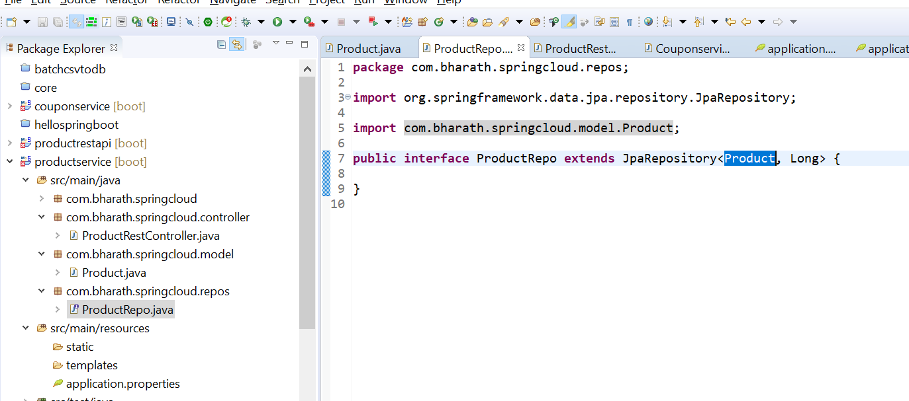

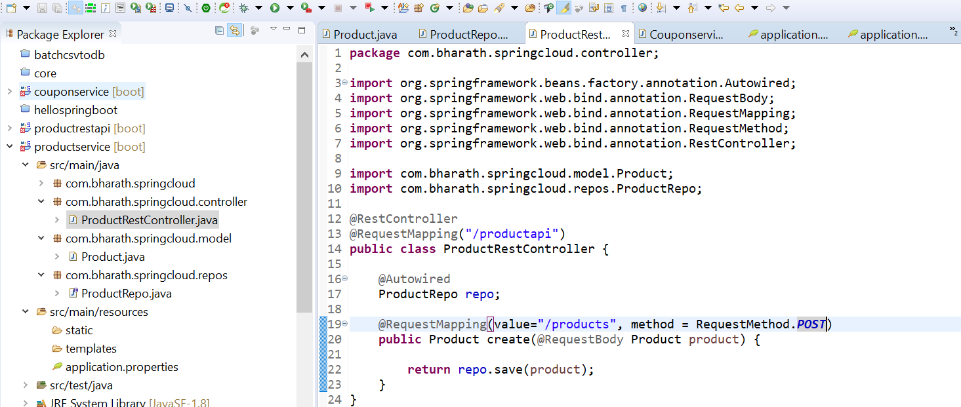

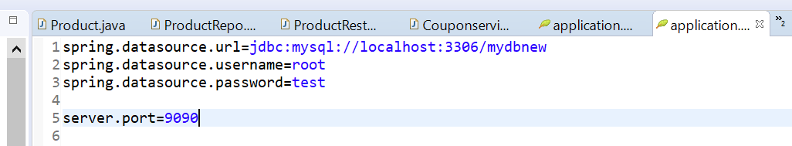

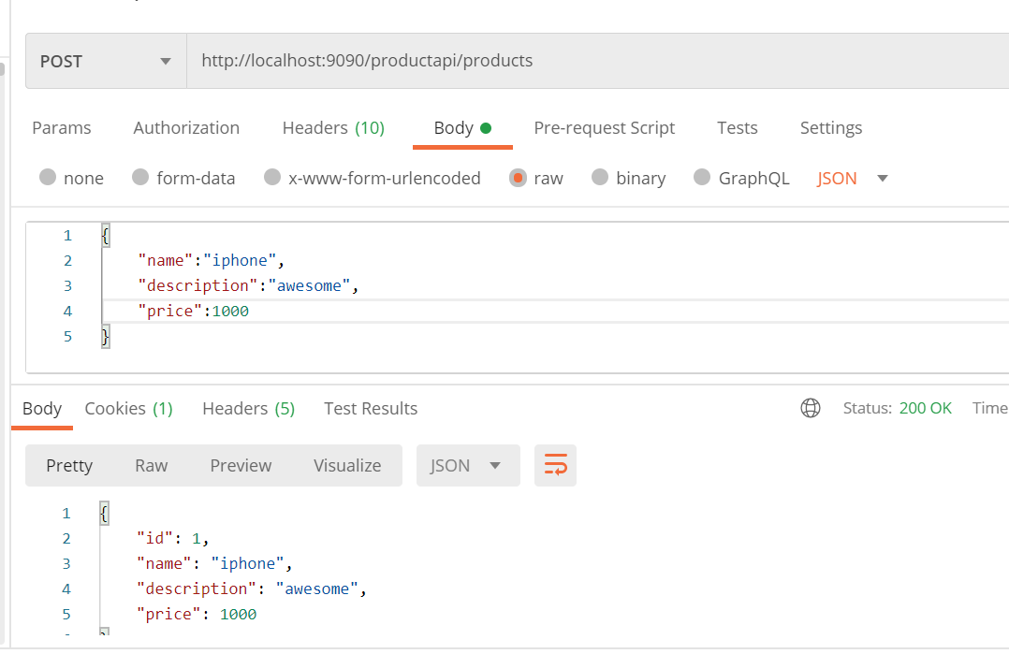

Integrating Microservice

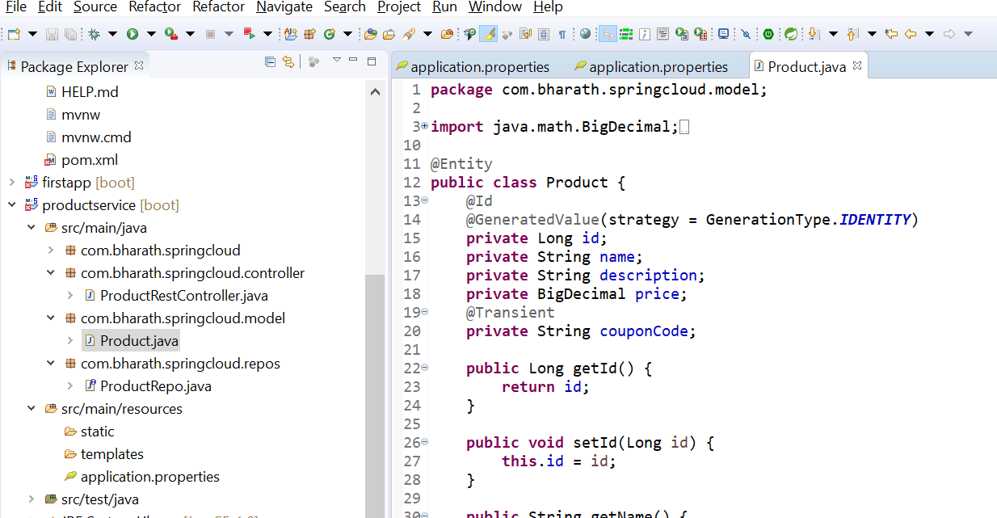

Spring offers RestTemplate to call restful client

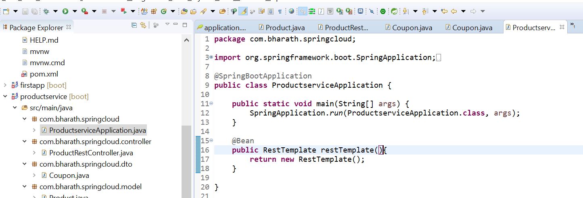

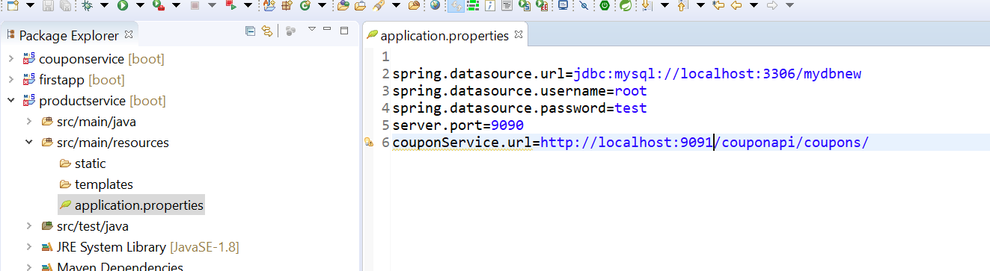

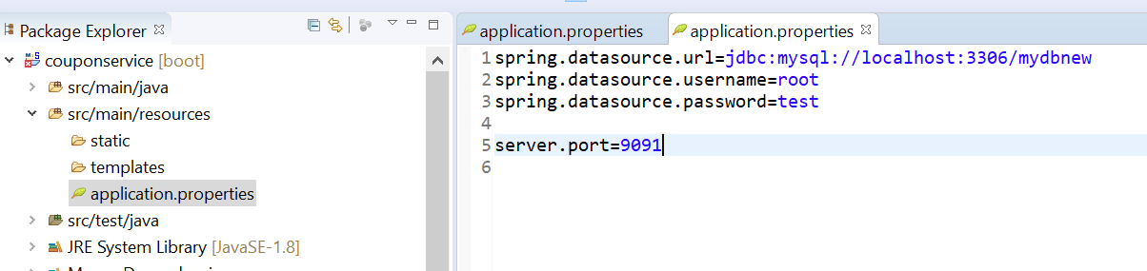

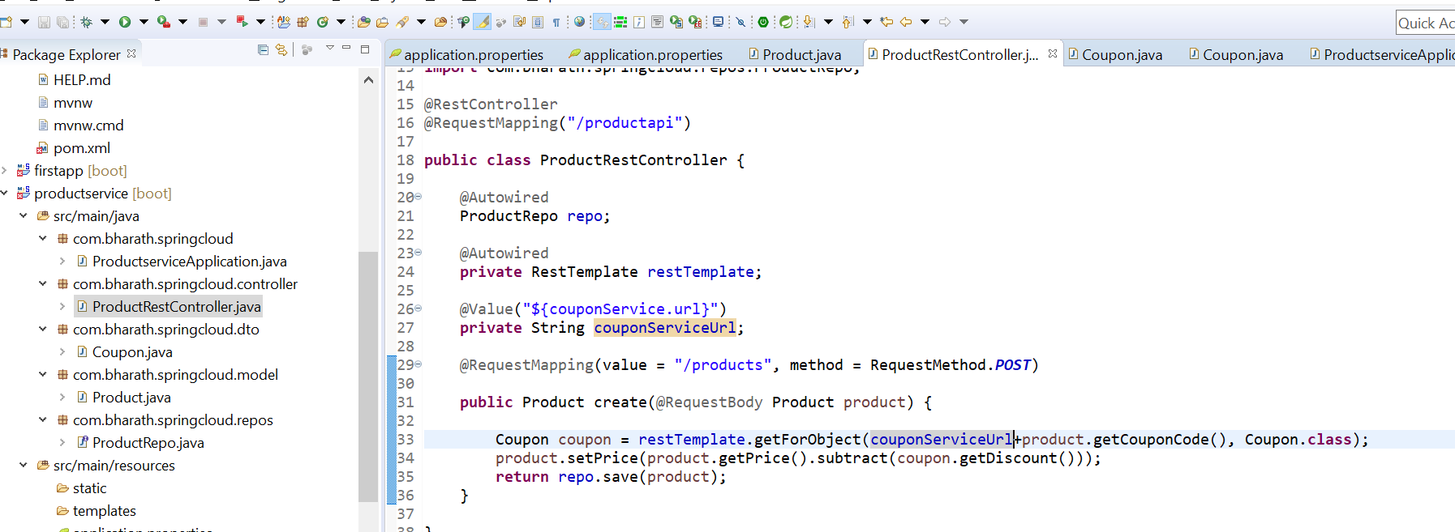

**Integration Testing**

**productService :-- 9090**

**CouponService :9091**

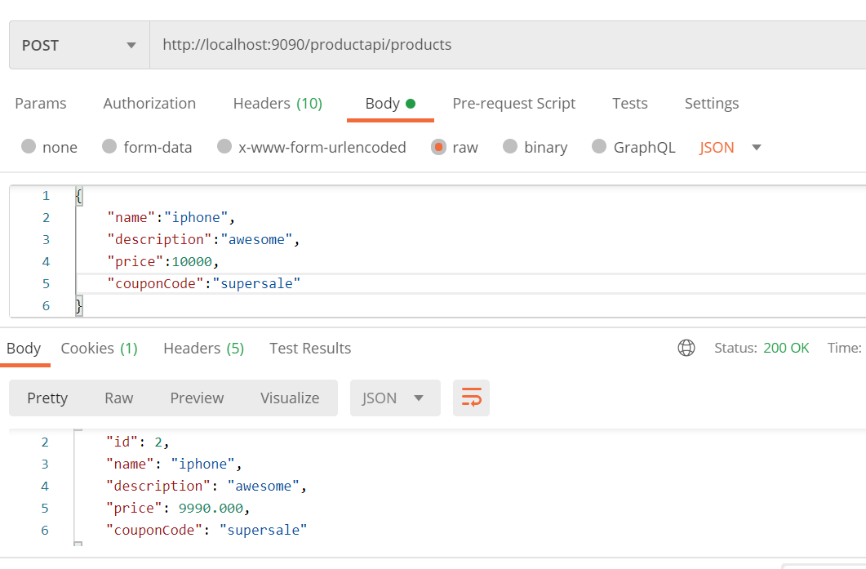

**Refactor**

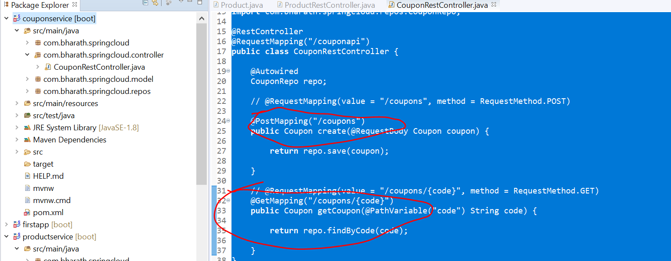

**Section 3 :- Secure Rest api**

**Requirement :---**

configuring authorization and authentication for coupon ms

Step:

Will create UserDetailsService which will fetch user and role info from d/b

Will create user table, role table and mapping table which will map user and role in d/b

Will create two user

User 1:- create coupon and retrieve coupon

User 2- retrieve coupon

Role:-- whether it is admin or regular user

User and role :- define jpa relationship many to many

**Step 1- create tables**

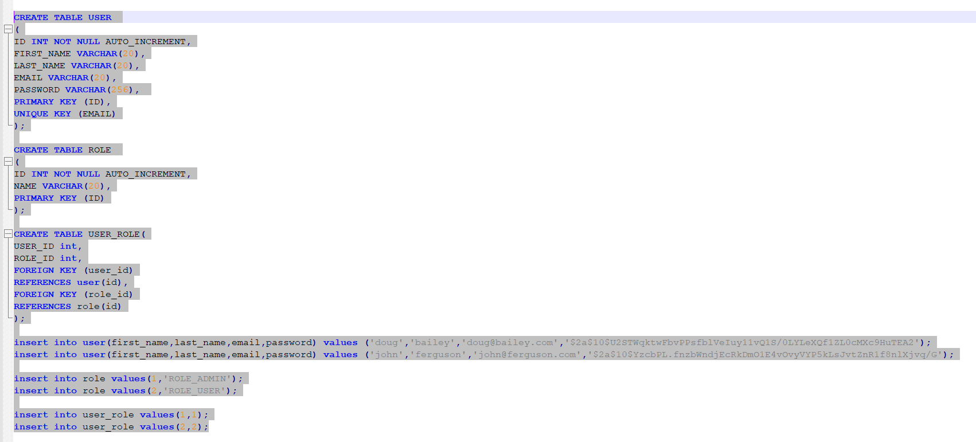

Here we are mapping using user_role table to user with rolle by id

user 1-------Role_admin

User 2 -------Role_user

**Create entities**

**Requirement :-**

Secure the coupon m/s

Step2 :----add security dependency

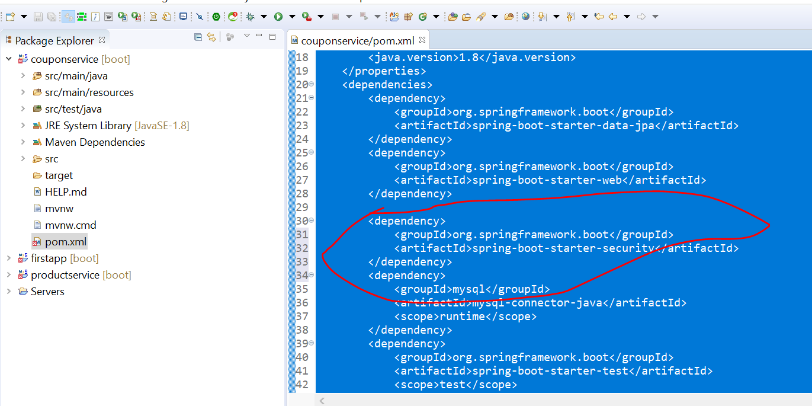

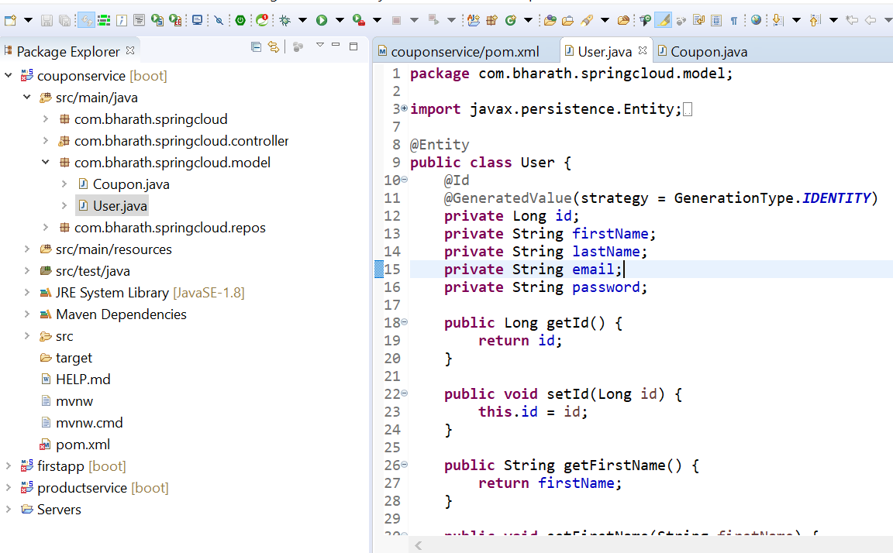

**Note :**

getAuthority will invoke internally by spring security and it should return name of the role

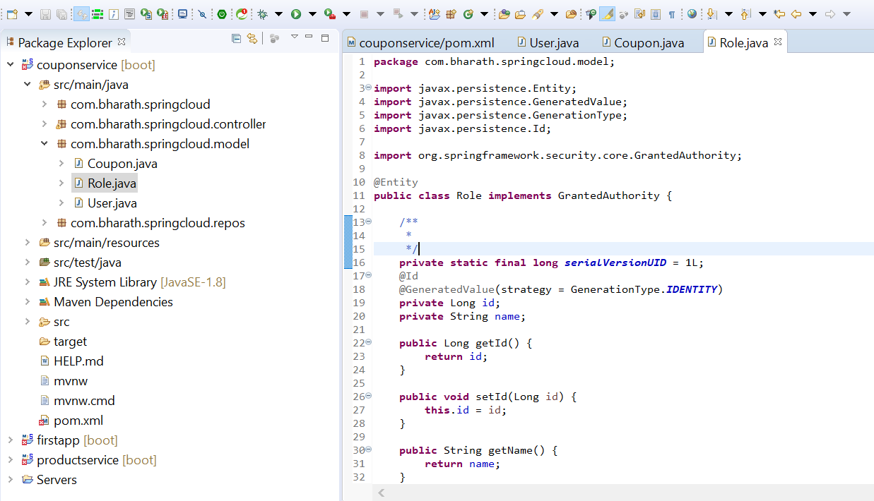

**Define Entity Relationship**

**Objective :---** define r/s between user and role entity

One user can have multiple

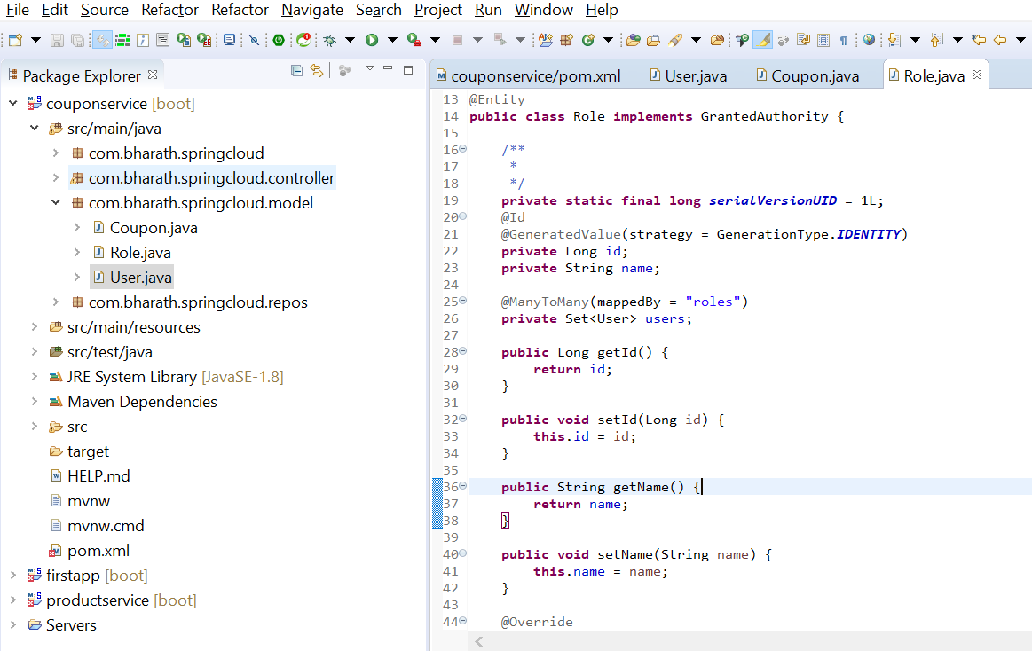

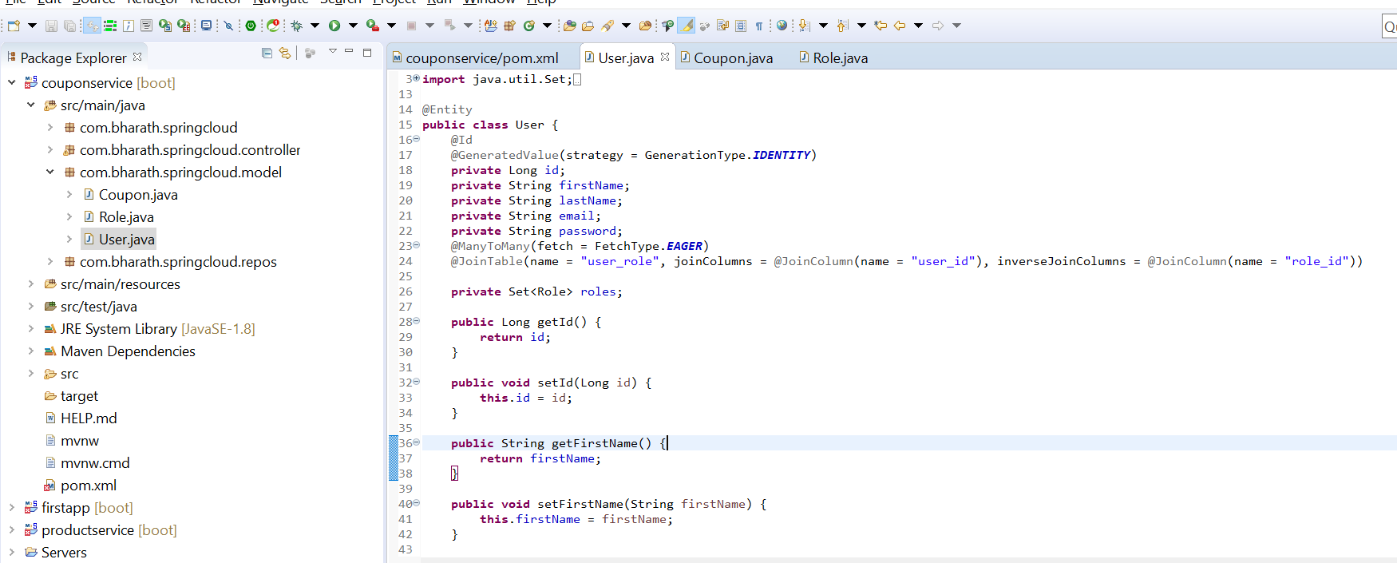

**Create Repos**

**Objective :-**

define repo for user and role

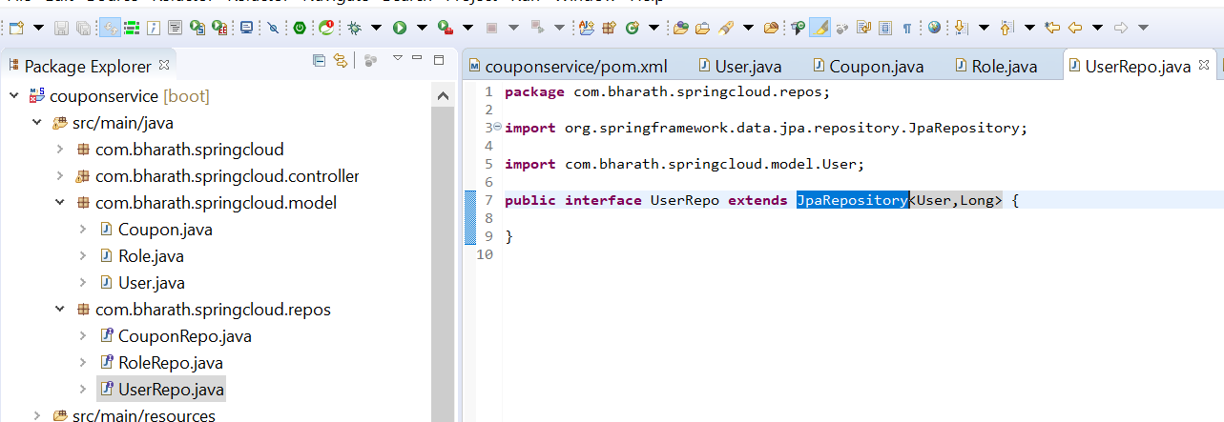

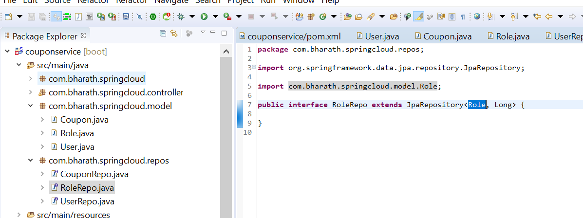

In userRepos we need to get details of user by giving his email

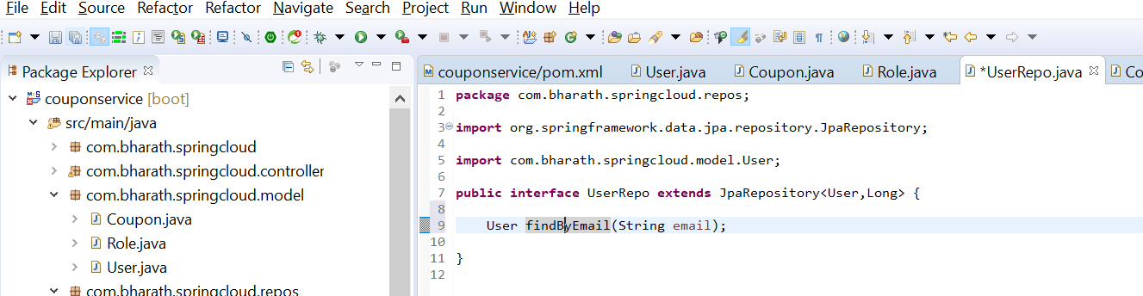

**Implement UserDetailsService**

UserDetails will be use by Authentication Provider in spring security

**Note :-**

it give user object of it own from spring security

Username will send by client in request

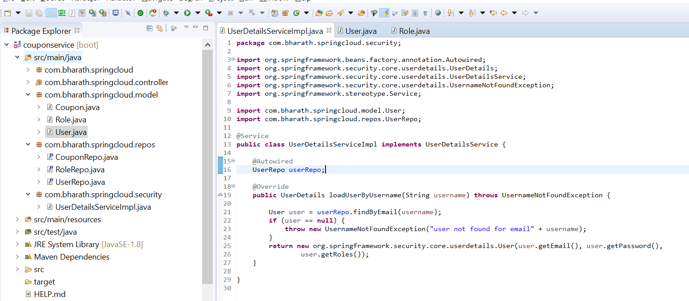

**Create WebSecurityConfig**

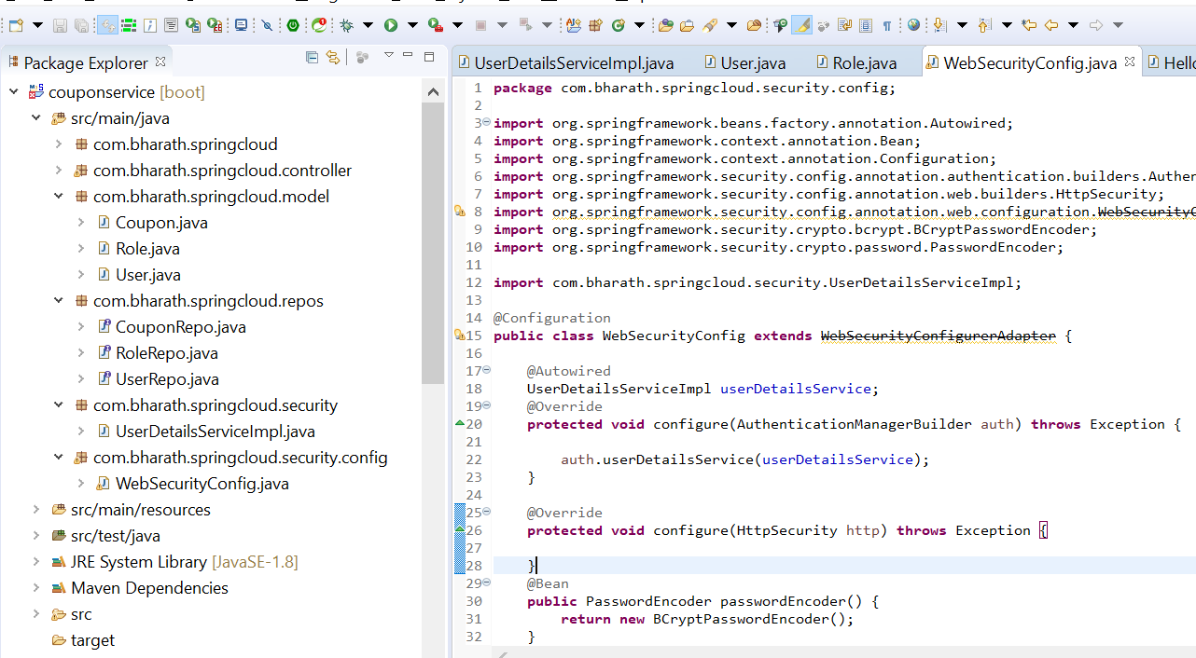

**Secure the URLs and Methods**

What type of authentication we want and how the authorization should happen

**Note :**

by default csrf is enabled in spring security and if it enabled we cant perform post operation in postman

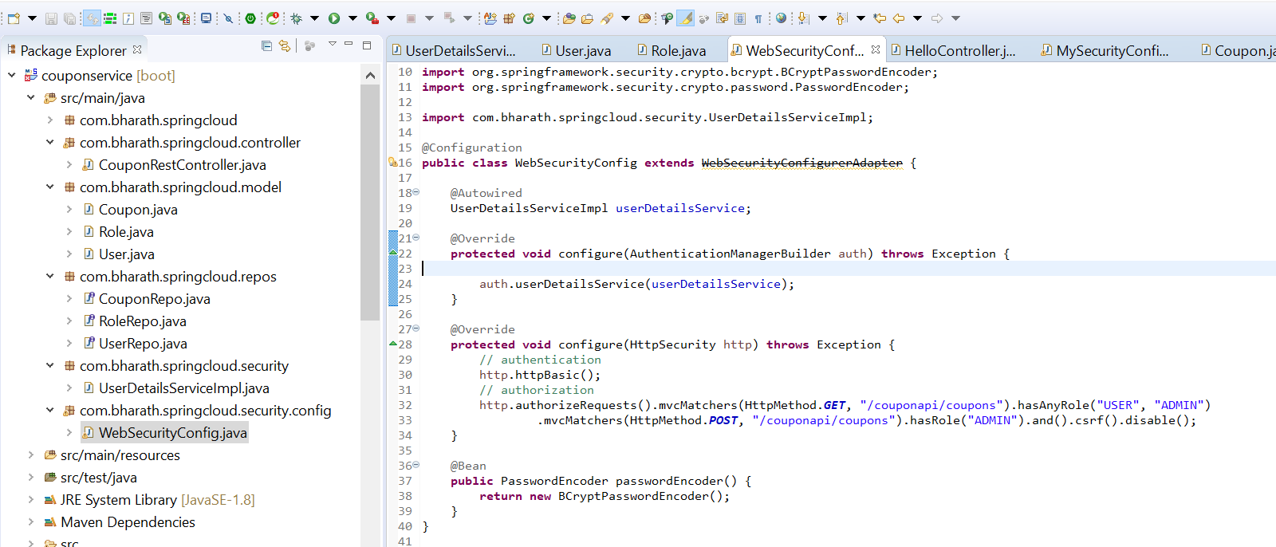

**Test Security**

**Objective :---**

Test the authorization and authentication for our application

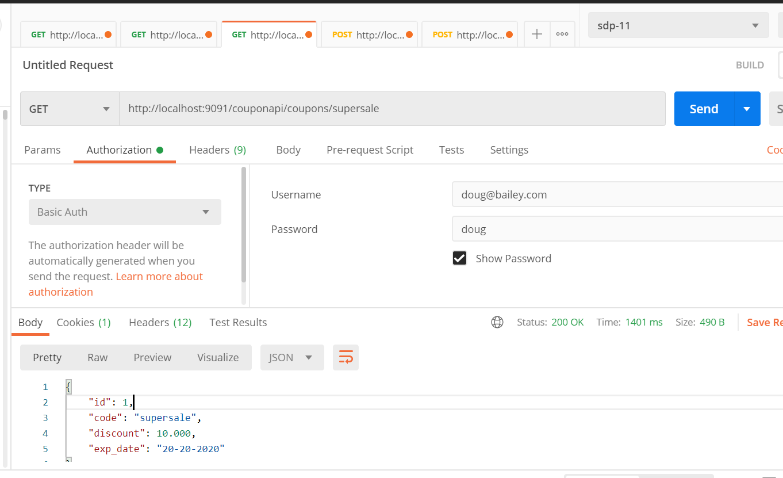

**Note :**

Authentication and authorization is working

Testing post with regular user who don’t have access of post only admin has access role of post

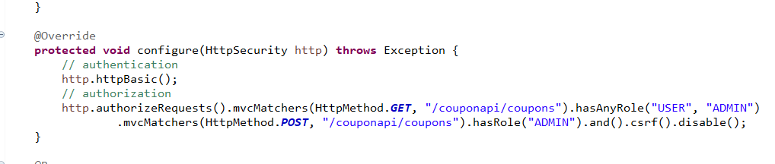

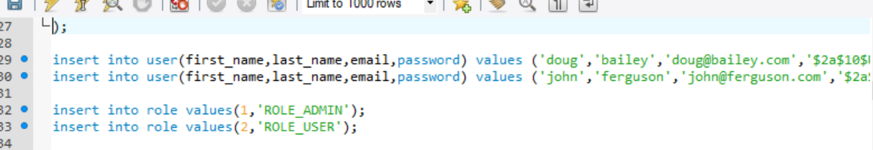

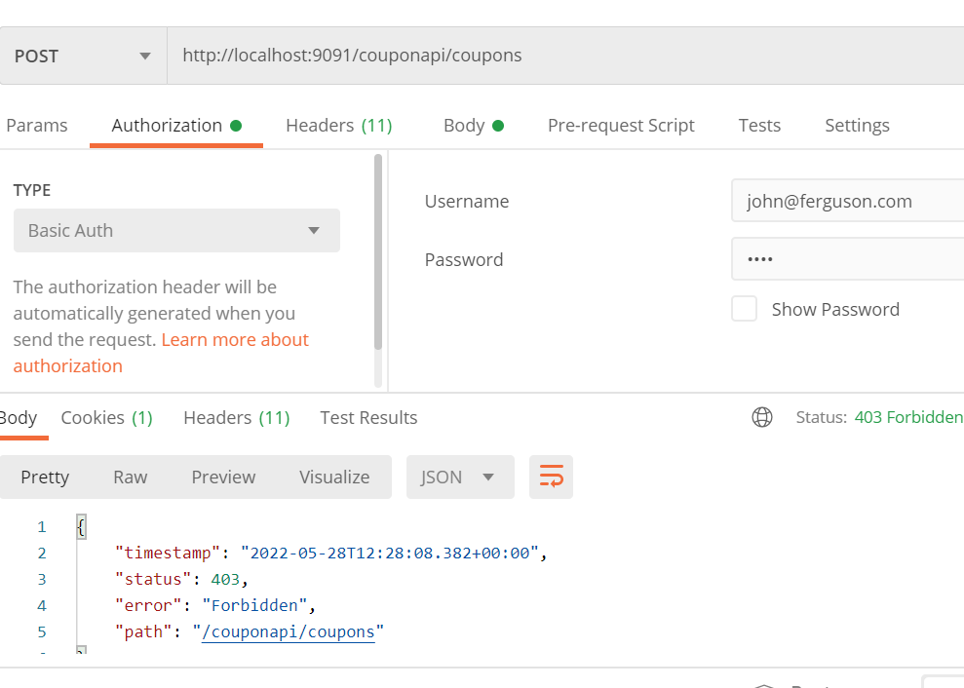

**Now test with admin user**

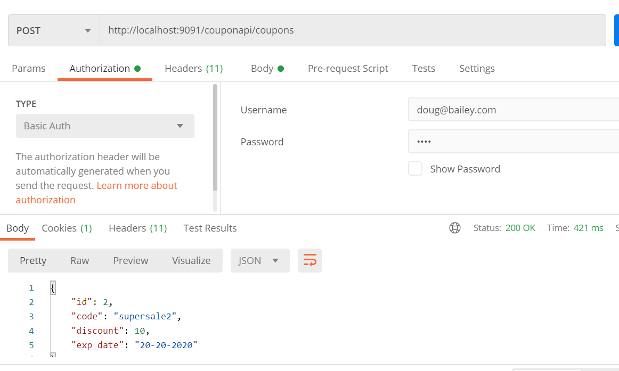

**More about mvcMatchers**

**Note :**

in url we are using supersale still it allowing

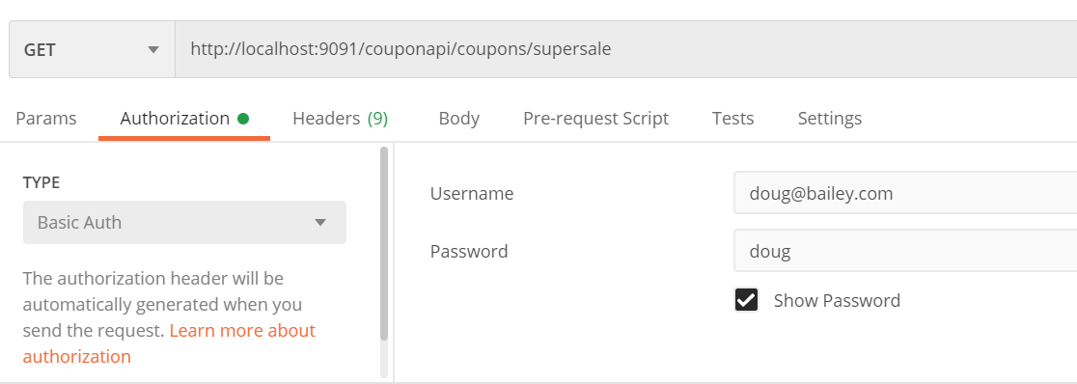

But here we are not using it

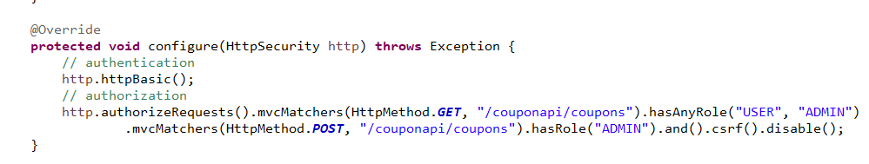

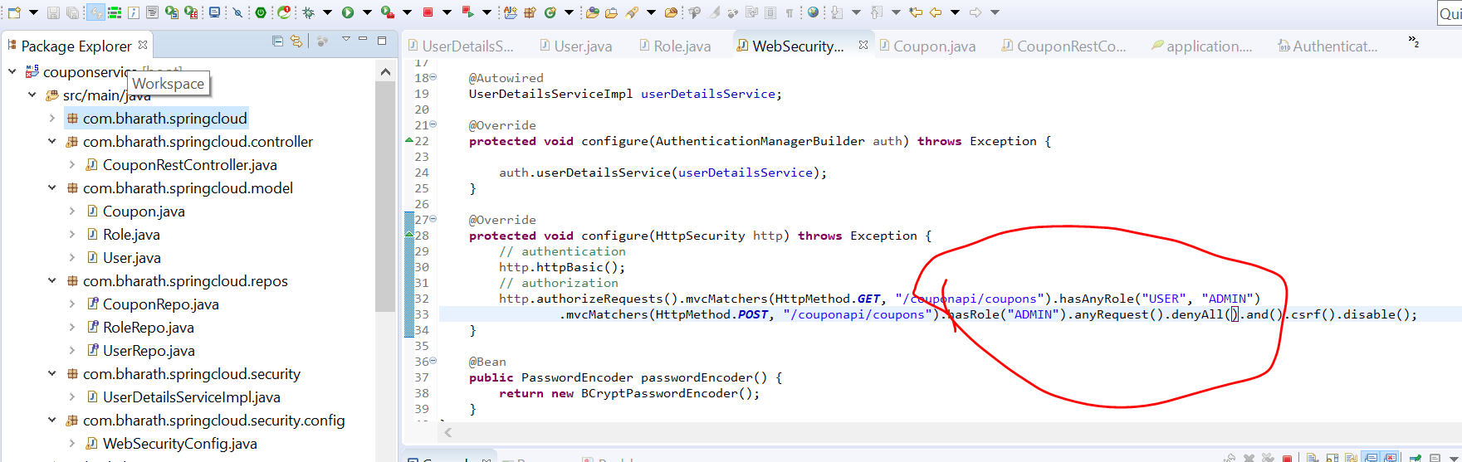

Not it will not allow , it will accept only /couponapi/coupons

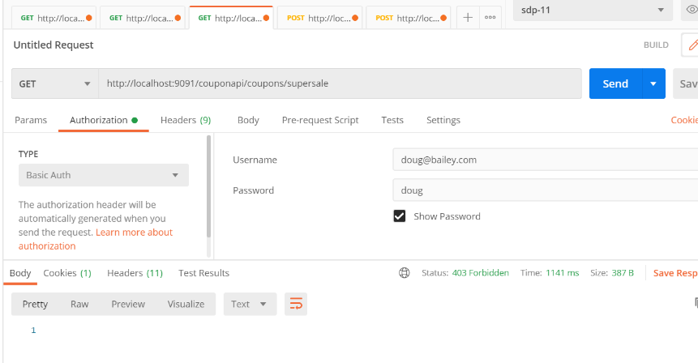

That’s why we are using **

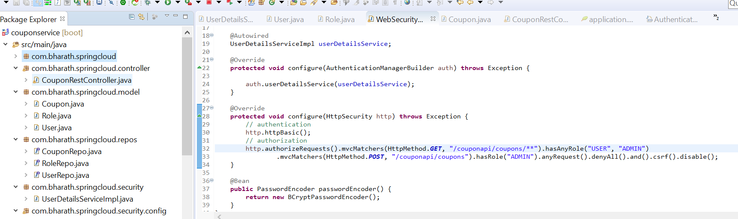

Now we are getting response

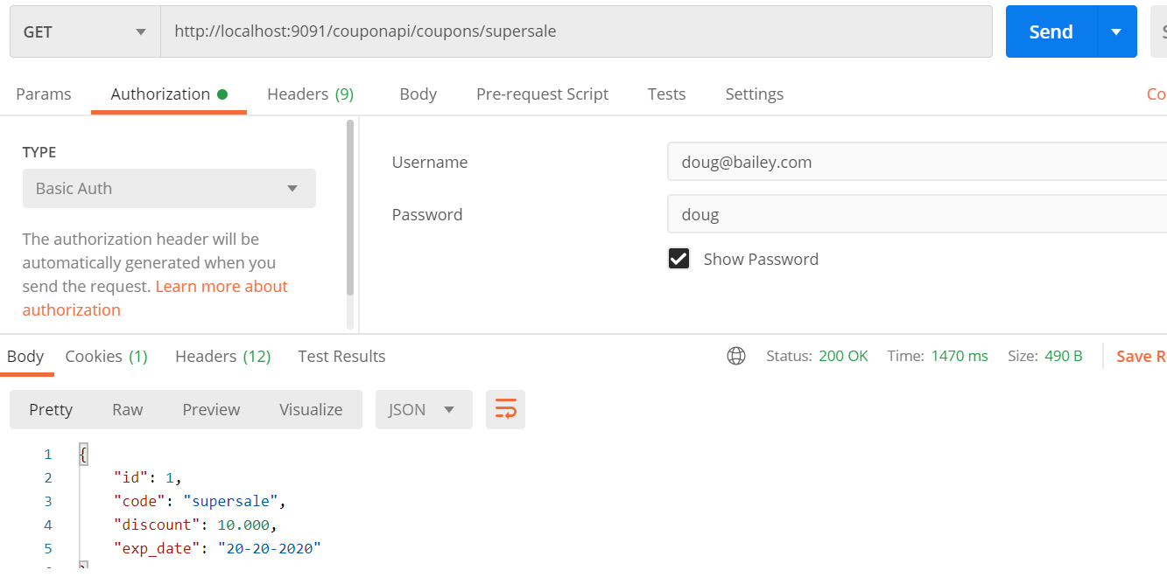

**Opp of denyAll is permitAll**

**mvcMatchers vs antMatchers**

**Note :--**

MvcMatchers intoduced in latest version they are more intelligent :-----

/couponapi/coupons.html-----------if this is url if able to identify by writing this /couponapi/coupons

**Using RegularExpressoin**

**Note :--**

Instead of ** we should use regex in our expression otherwise anything can be pass in url which will damage our system

Using this it will follow a pattern in api

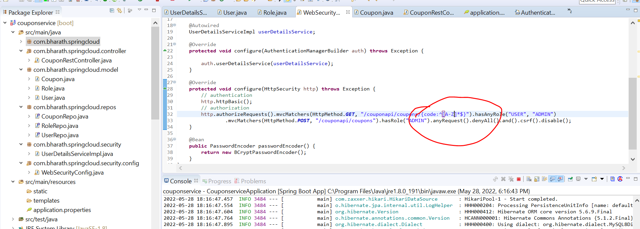

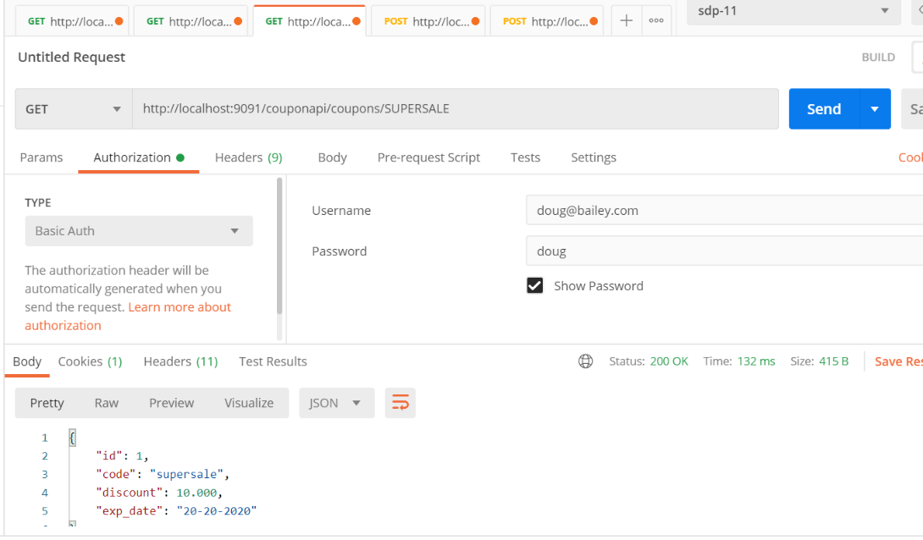

**Secure a web app**

**Steps**

**Objective:**

Create custom login page

**Create Index page**

**Objective :-**

create web layer for coupon service

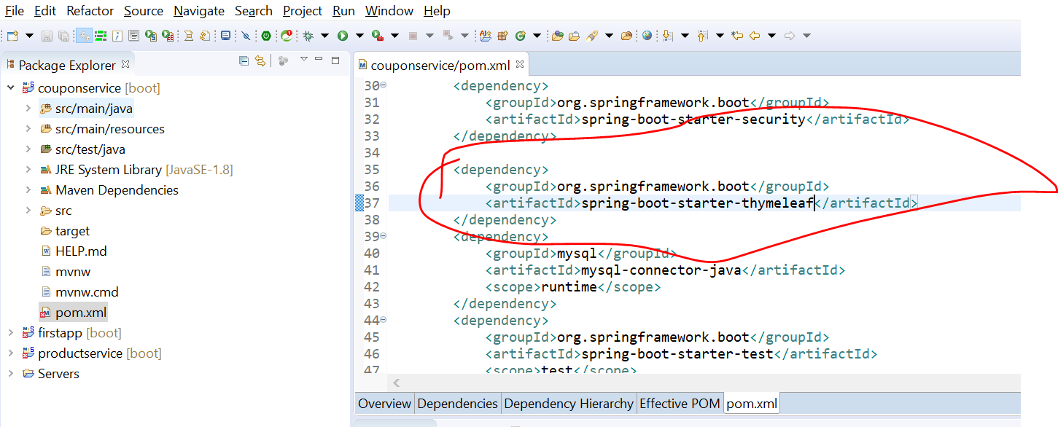

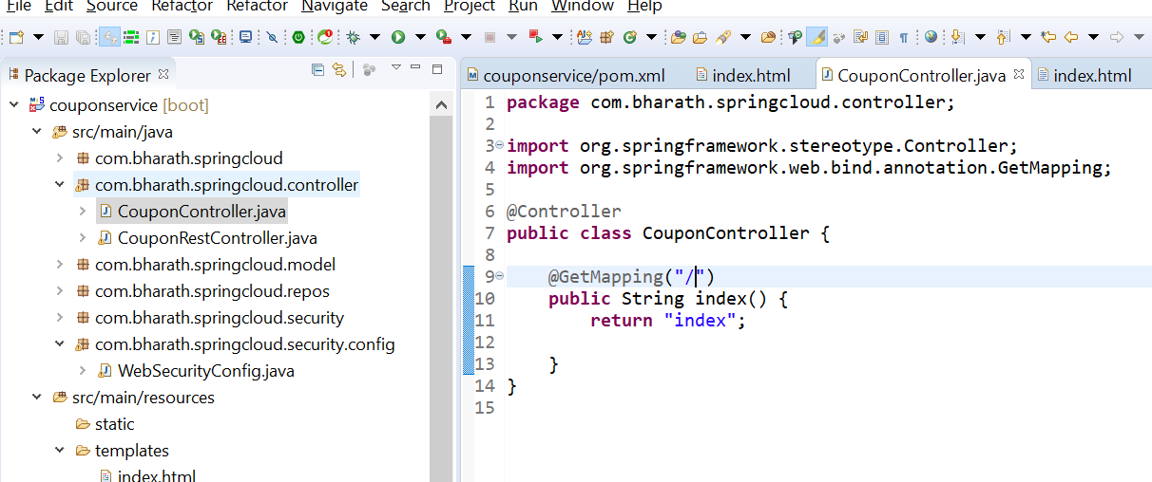

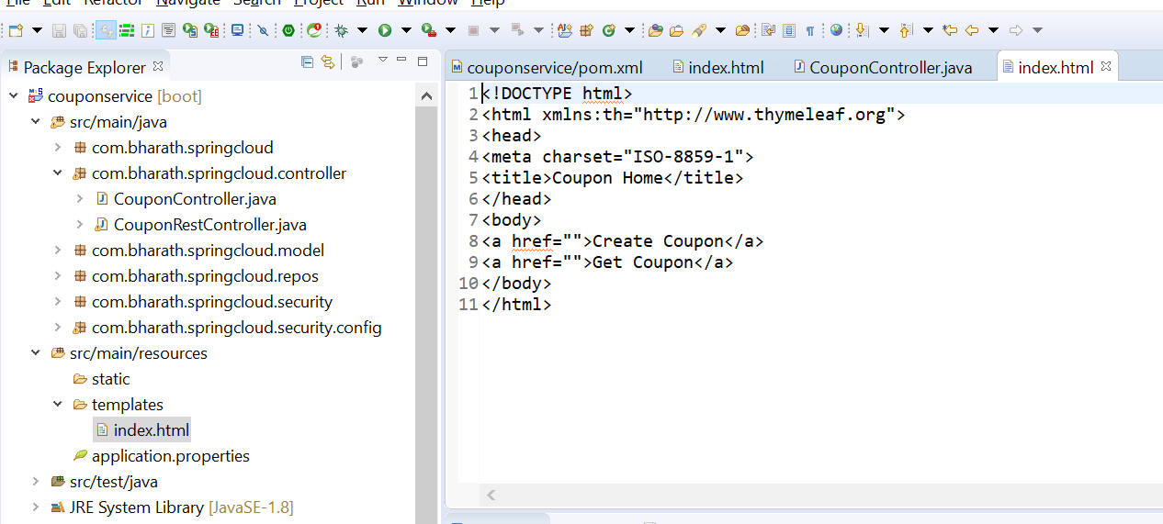

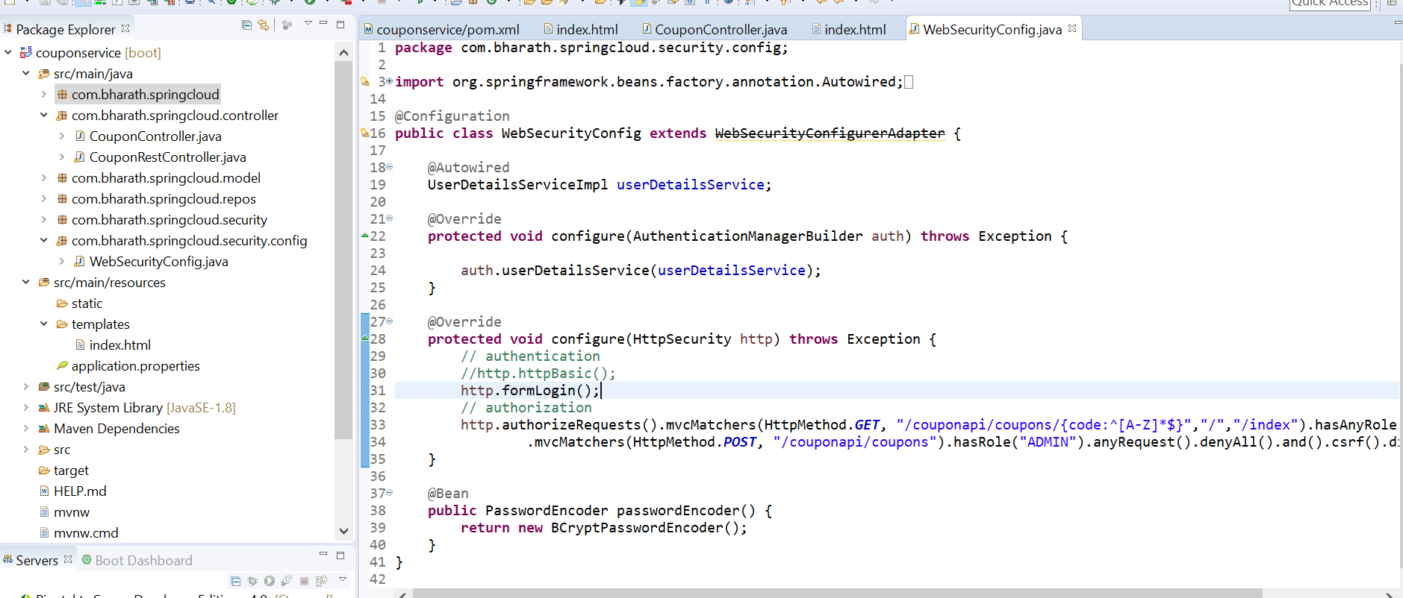

Later on will add our own login

Our security still works in thymeleaf

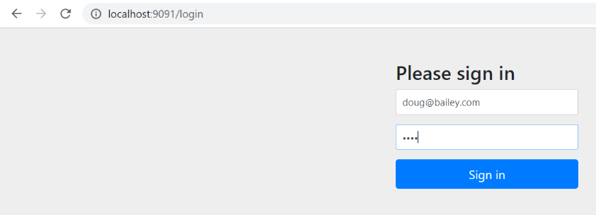

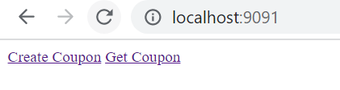

**Render Coupon Form**

**Need to map form with model object**

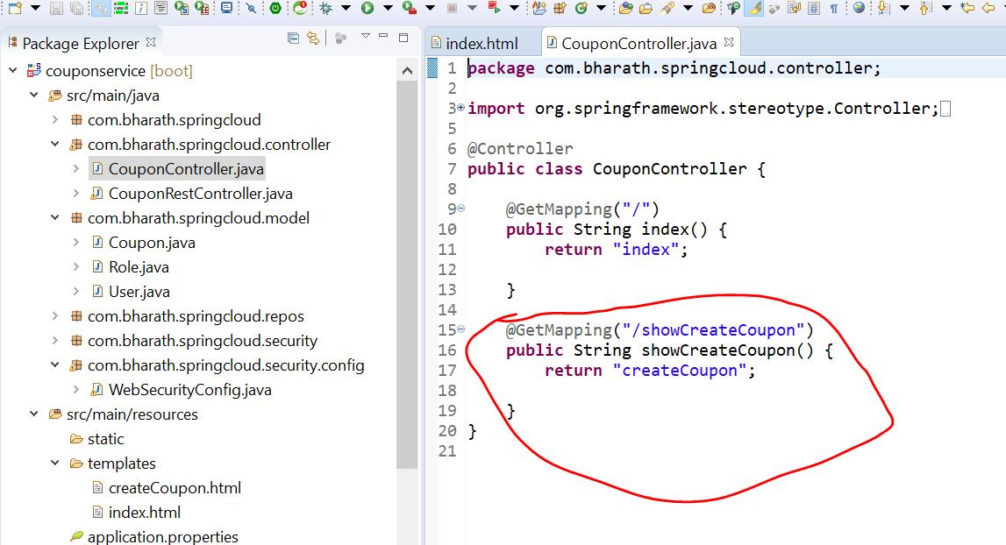

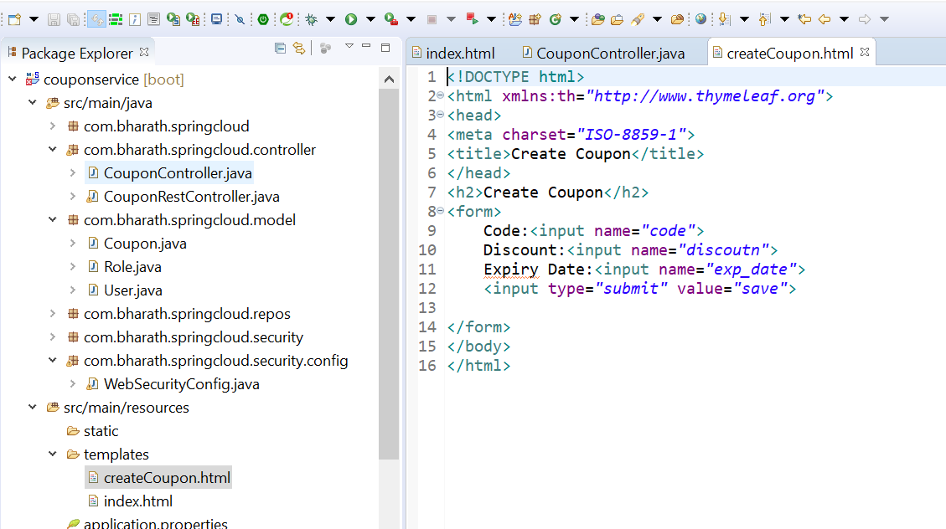

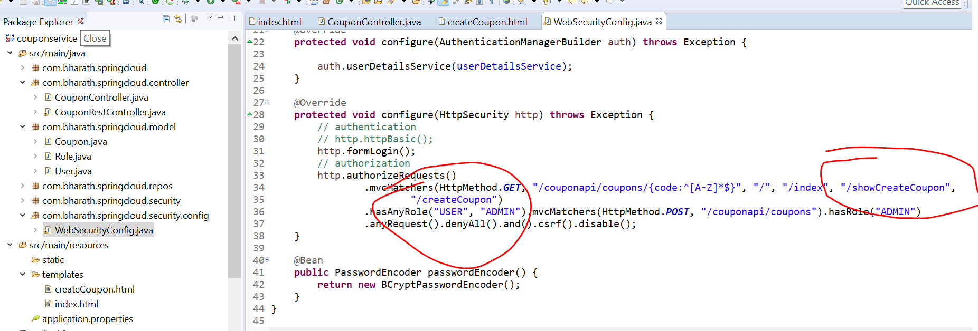

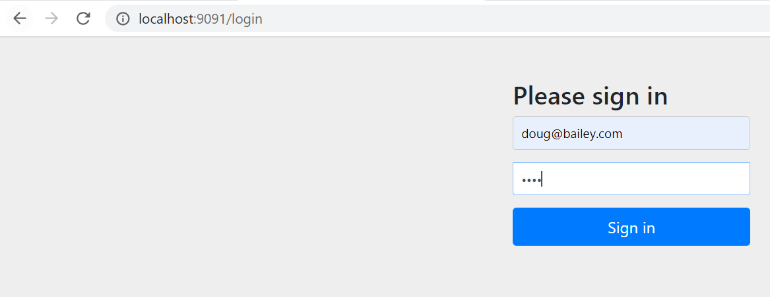

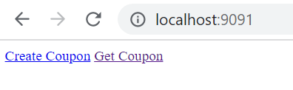

**Click on create coupon**

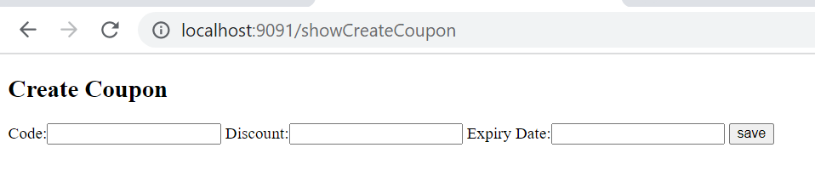

**Create coupon**

**Objective :-**

coupon creation flow

When the form is submitted coupon come in request

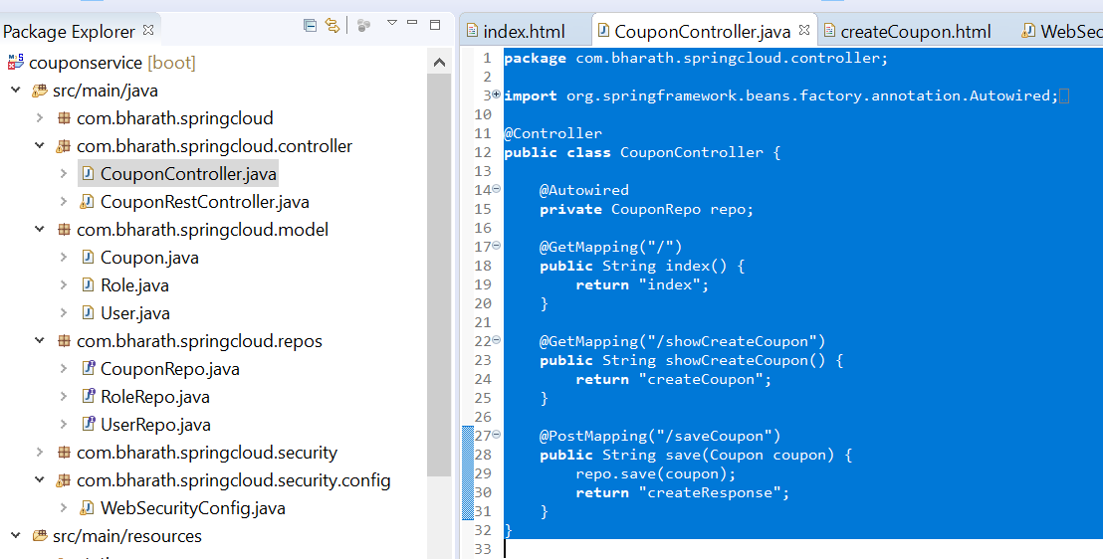

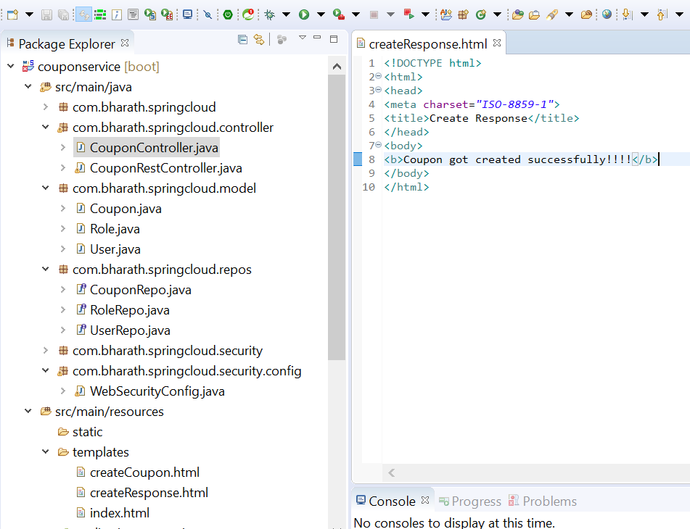

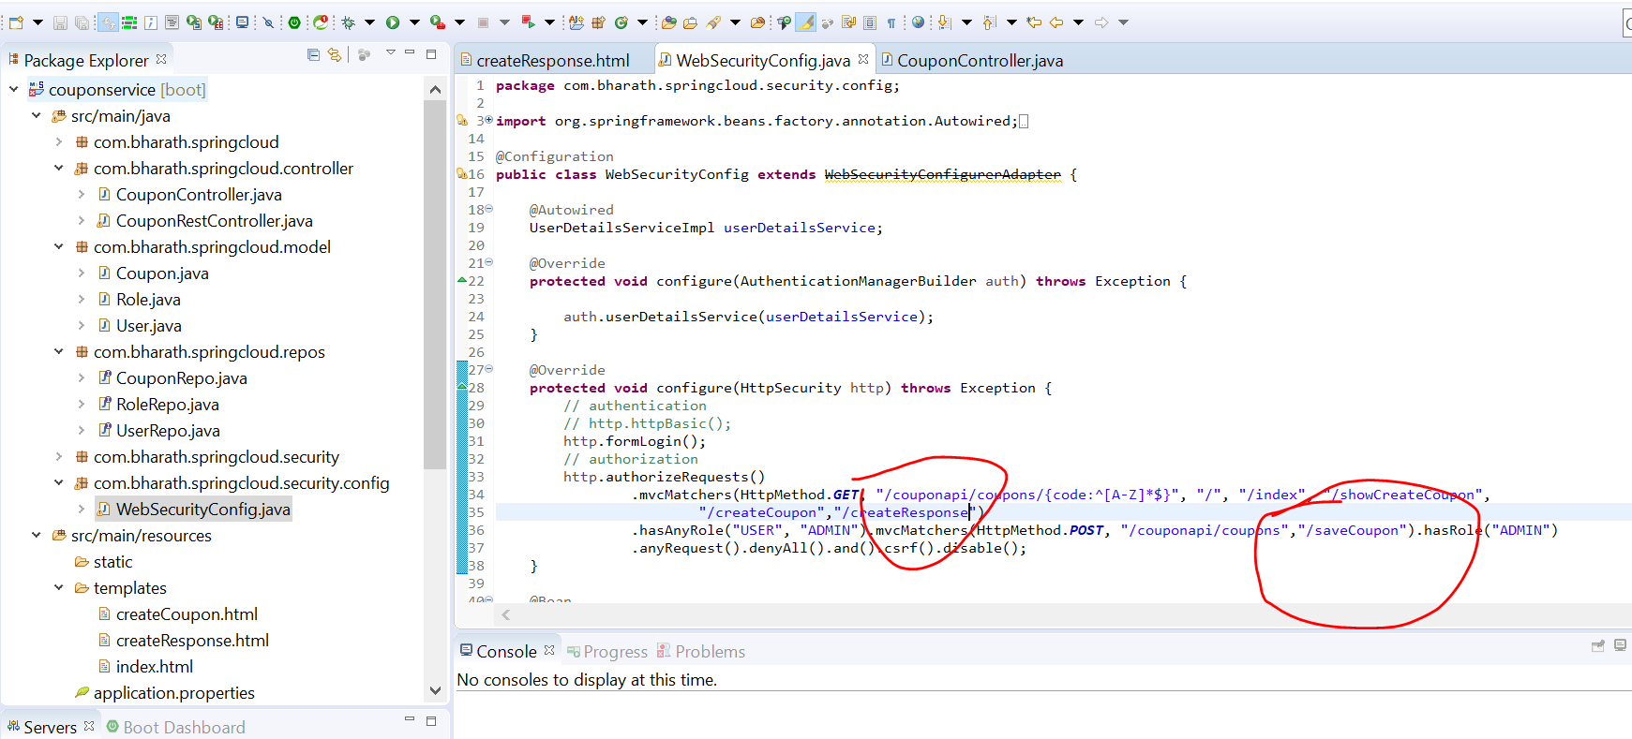

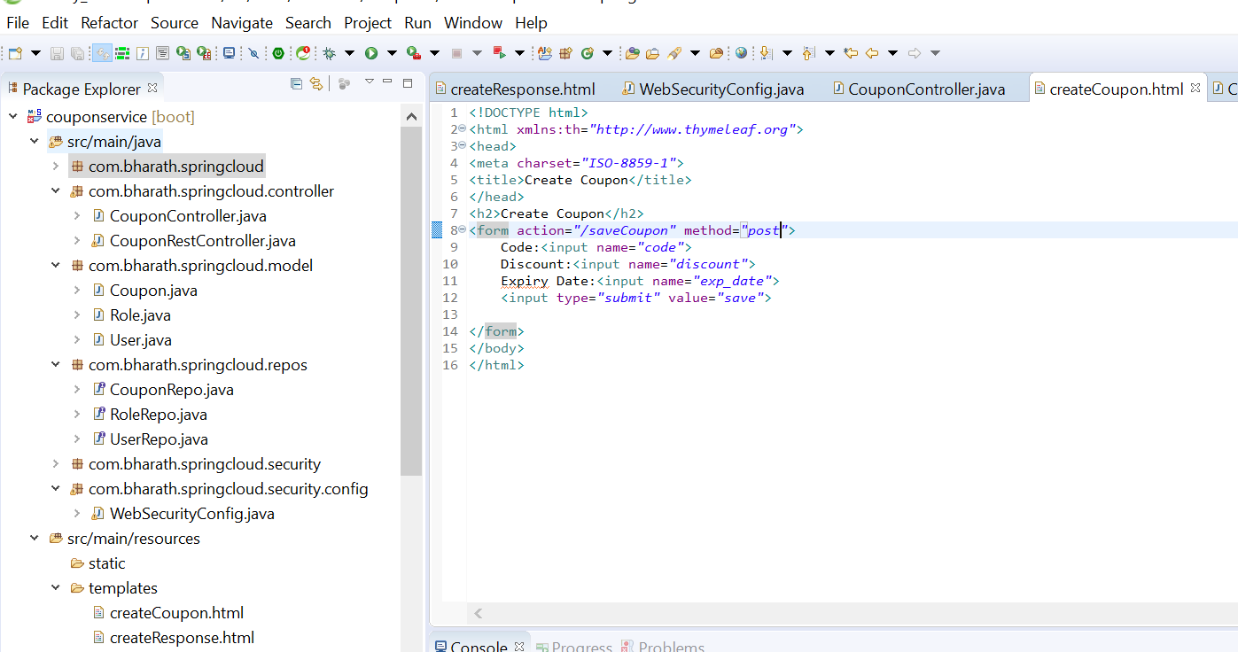

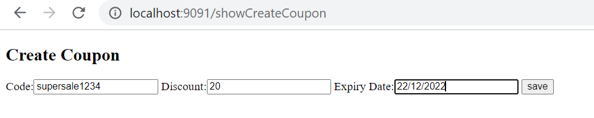

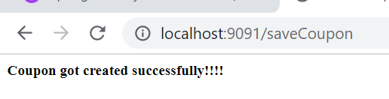

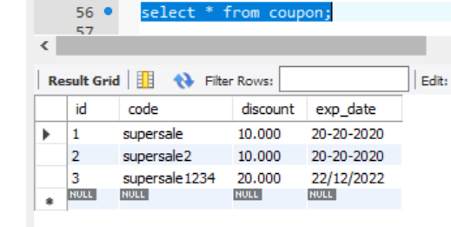

**Render Get Coupon**

**Objective :**

Implement get coupon functionality

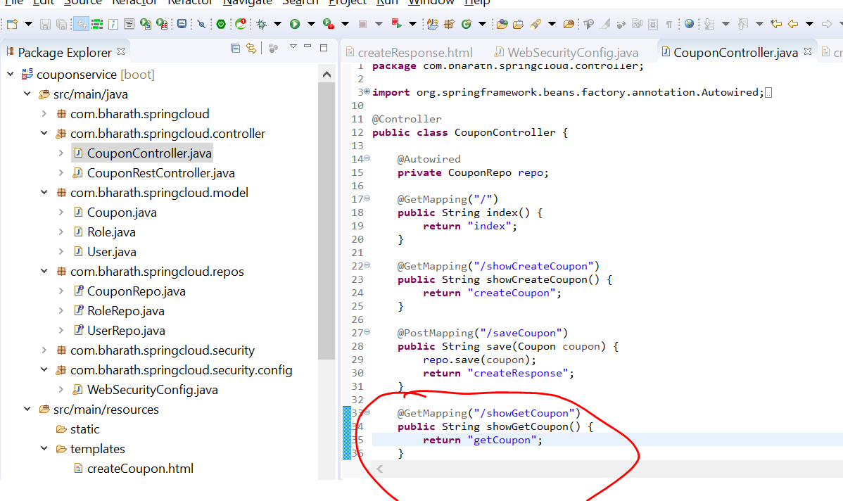

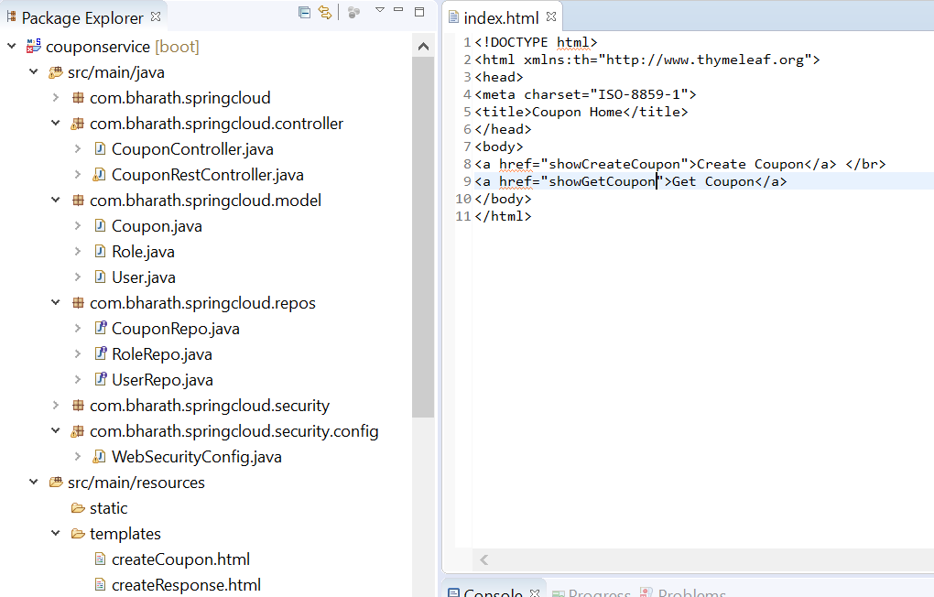

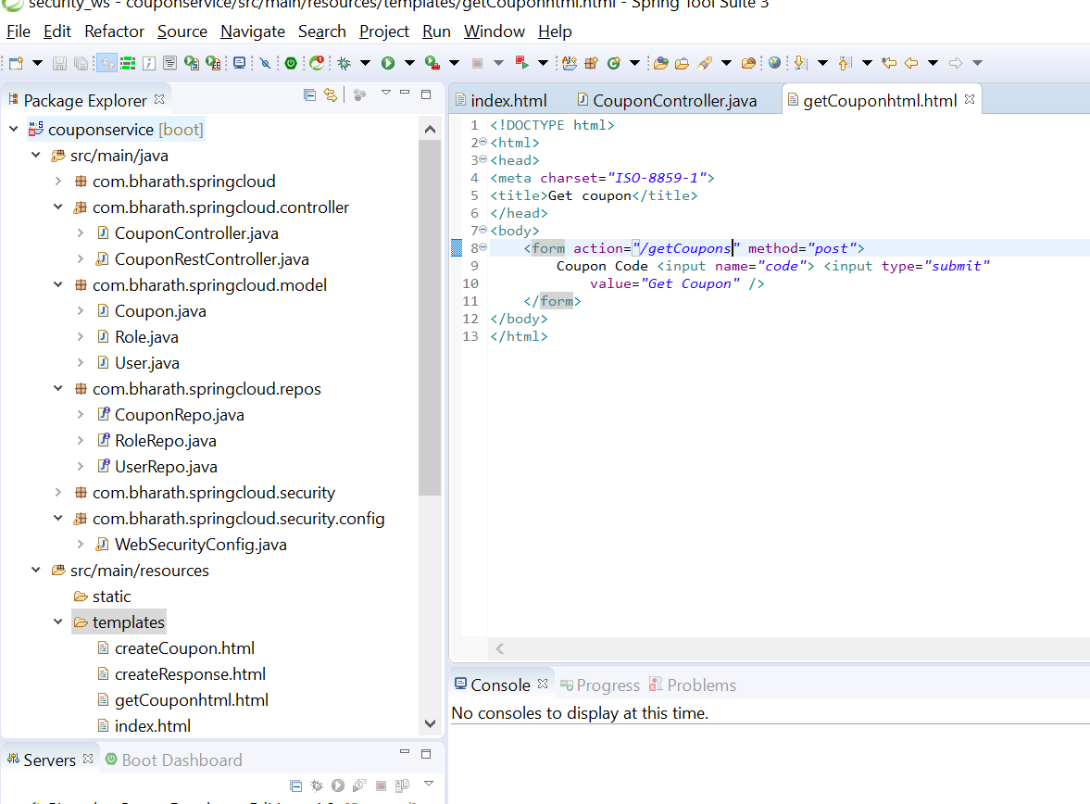

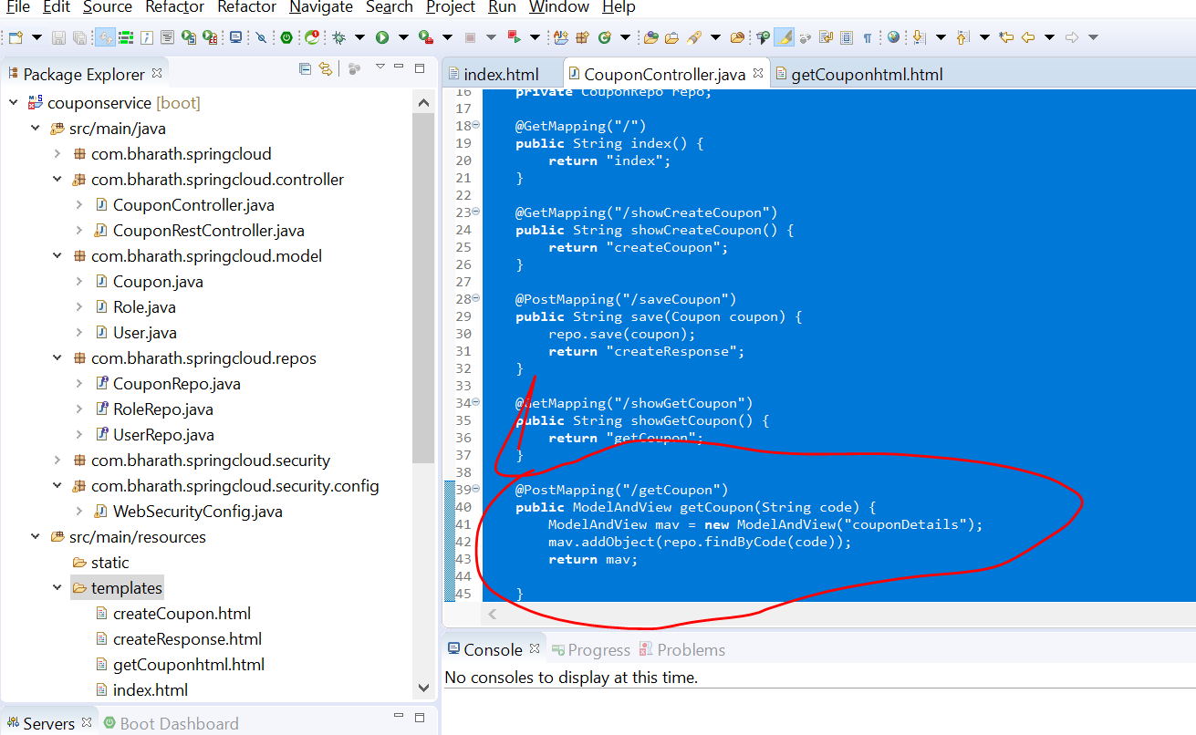

**Test Get Coupon**

**Note :**

We are looking by findByCode so it will automatically use class name in lower case in html

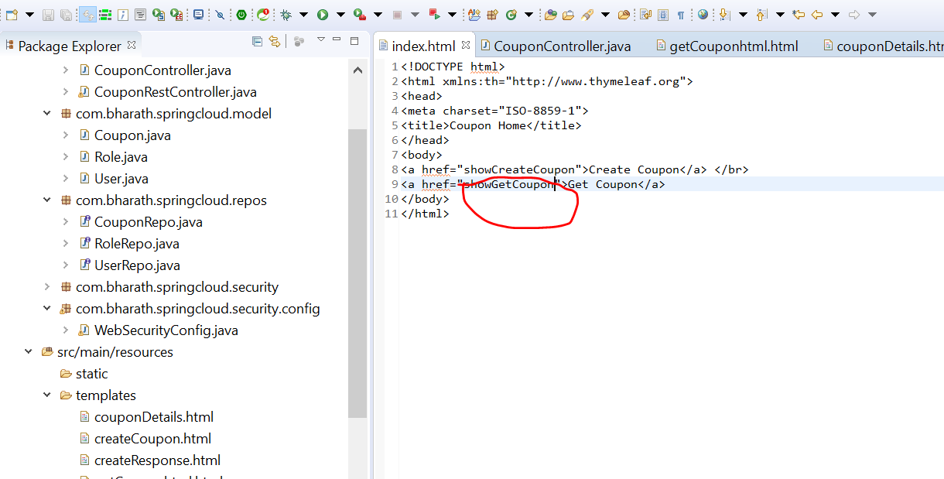

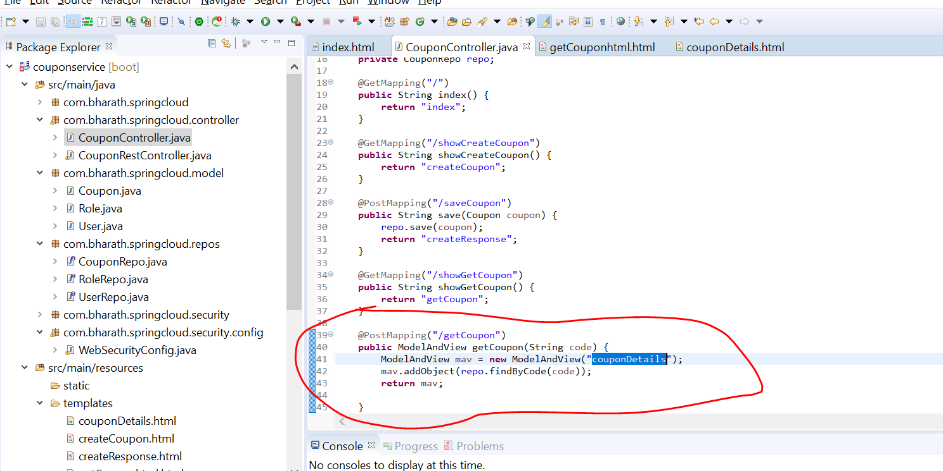

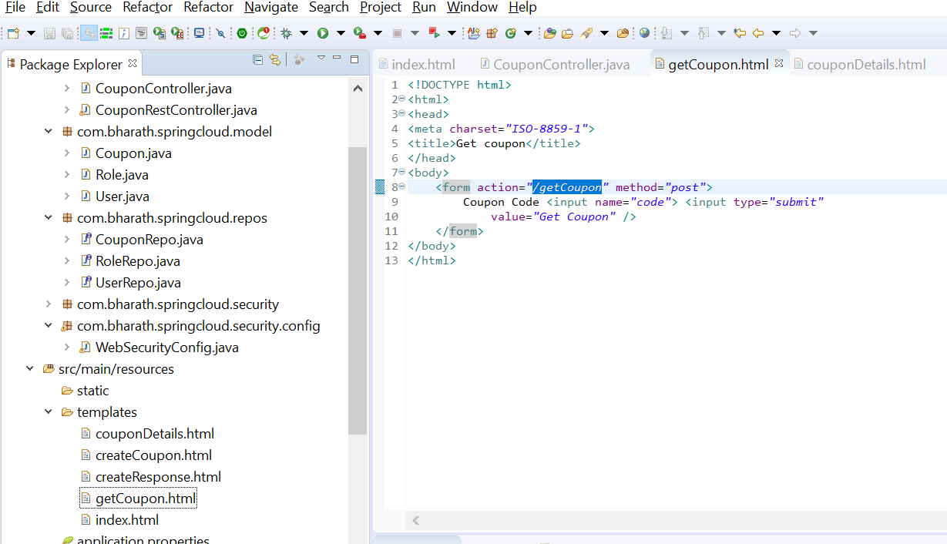

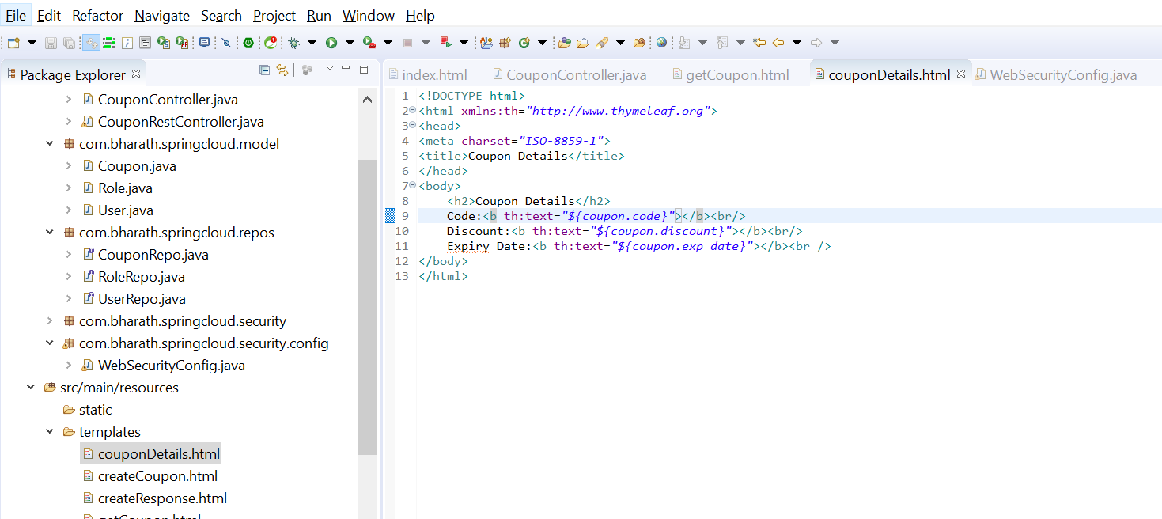

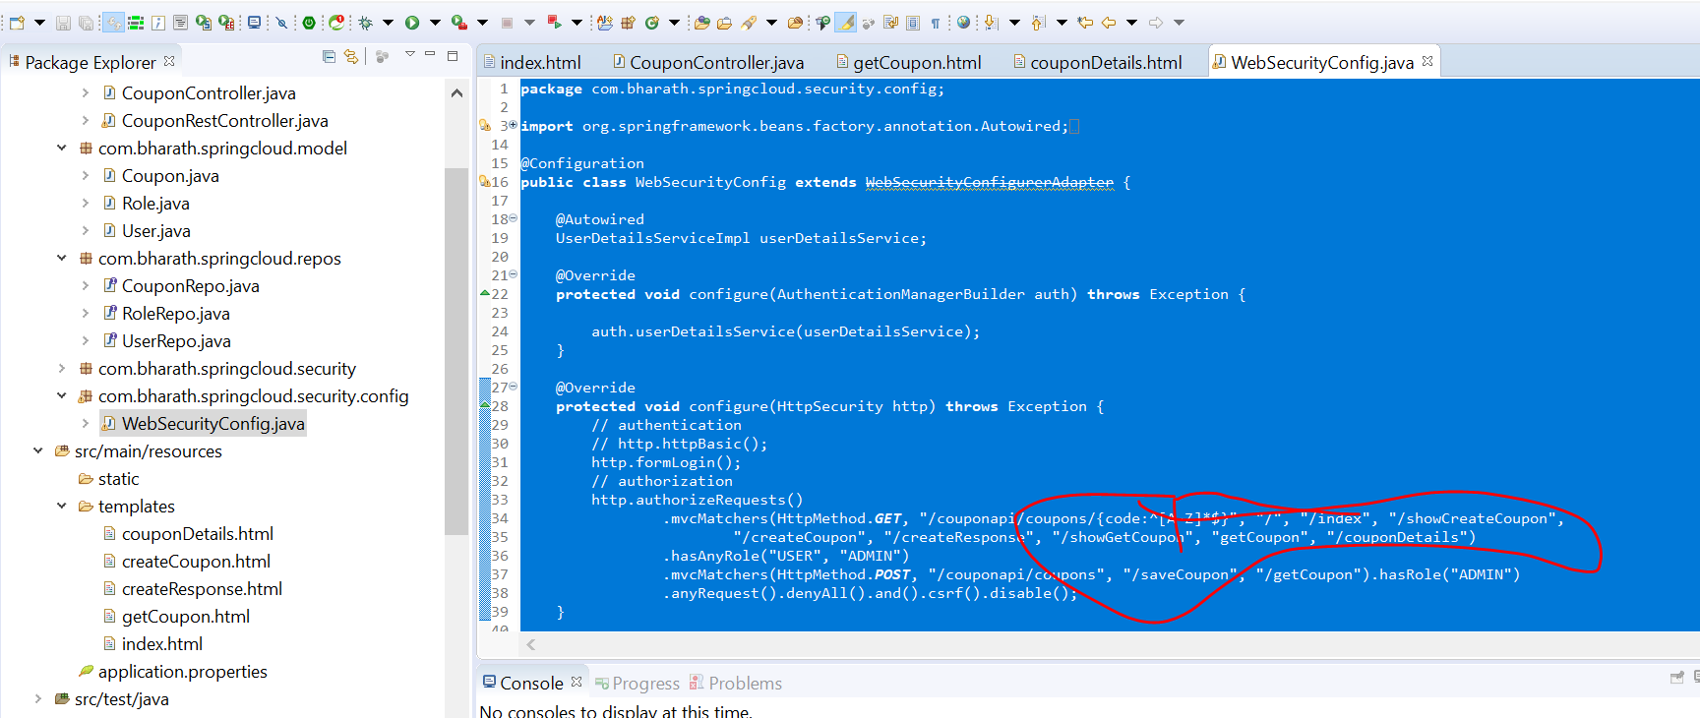

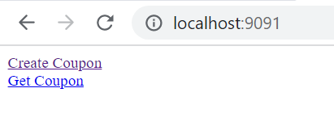

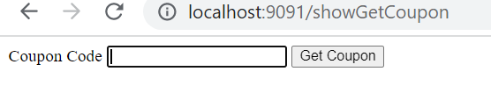

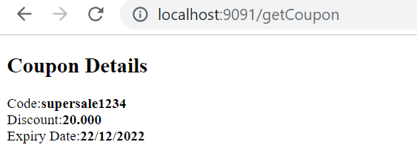

**Refactoring**

**Objective :---**

refactor webSecurityConfig

Create coupon will not be allow by user john

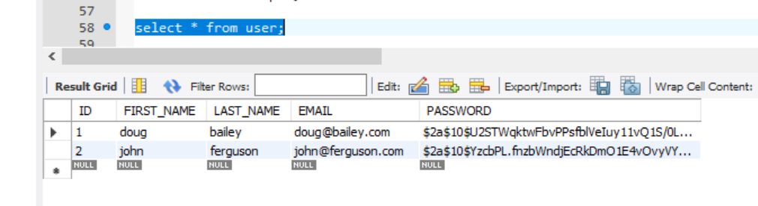

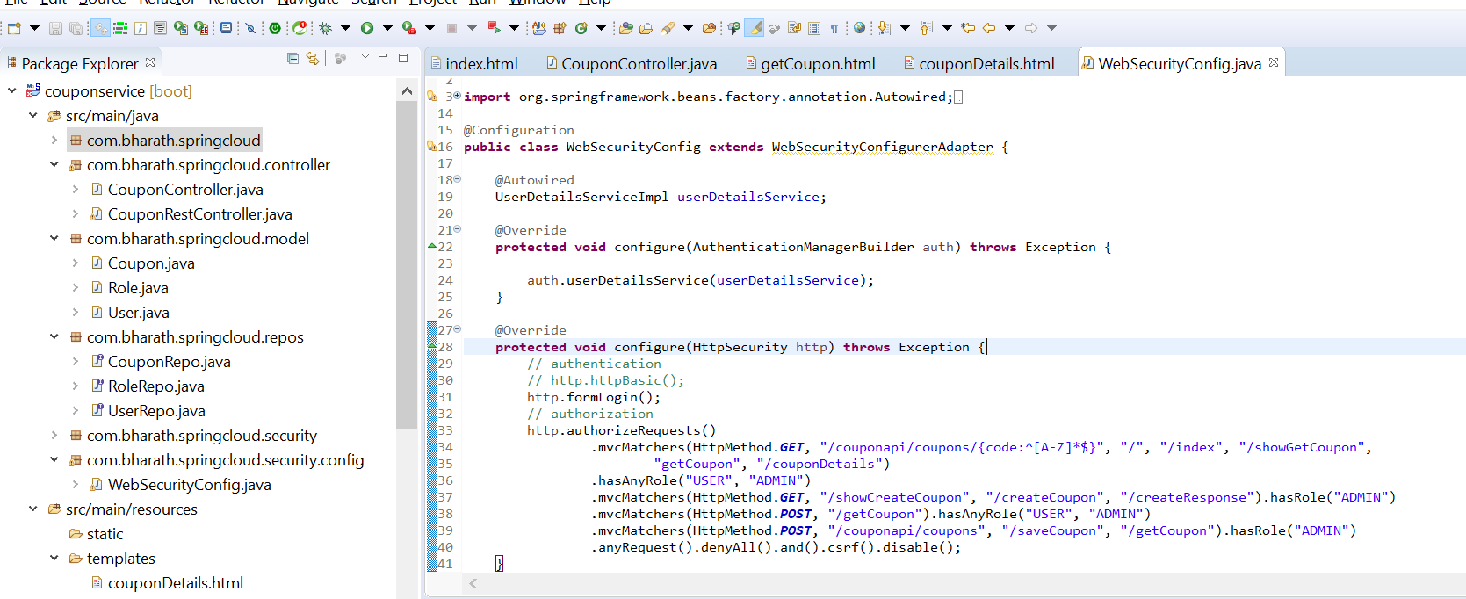

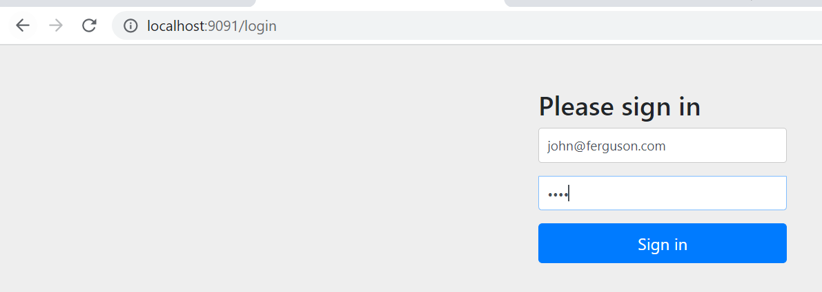

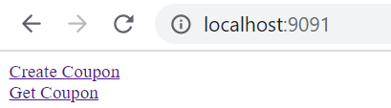

Click create coupon

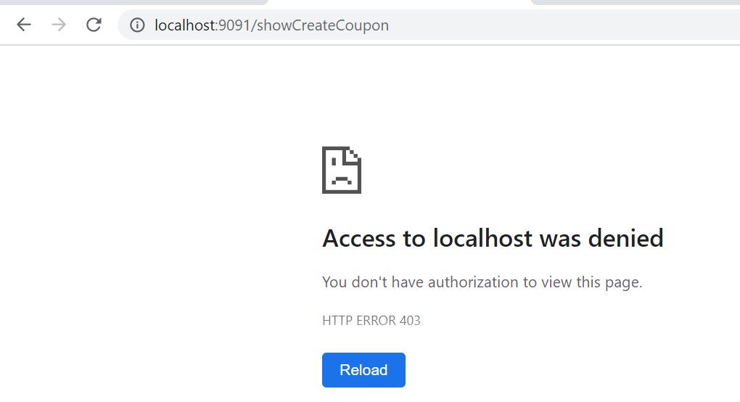

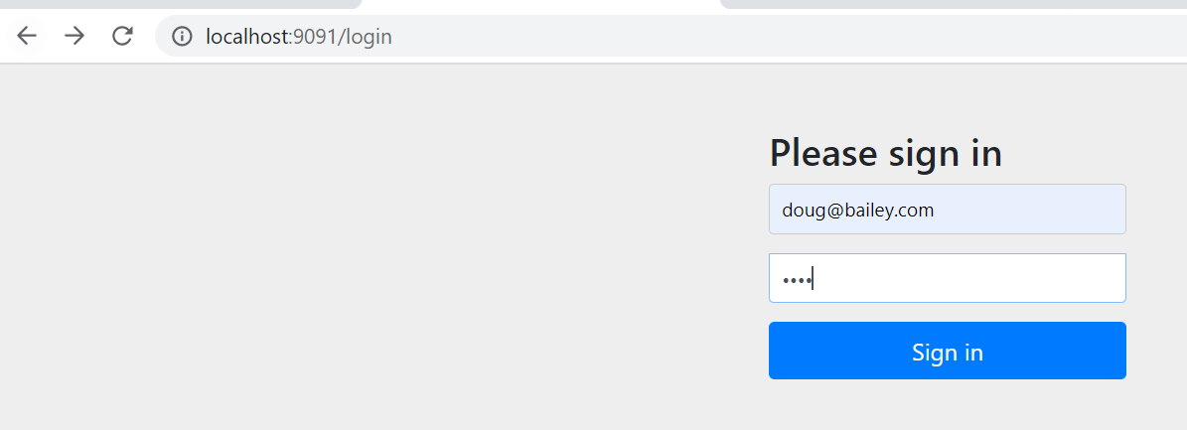

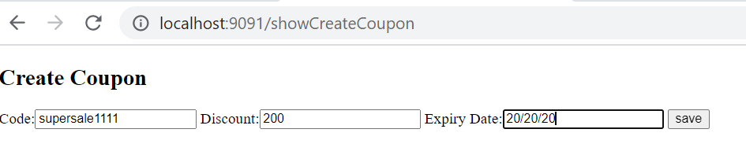

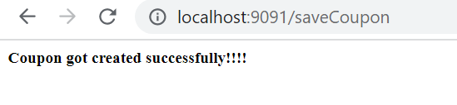

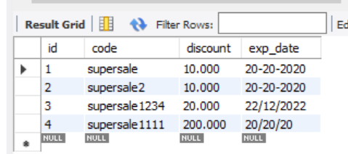

**Implement Custom Login**

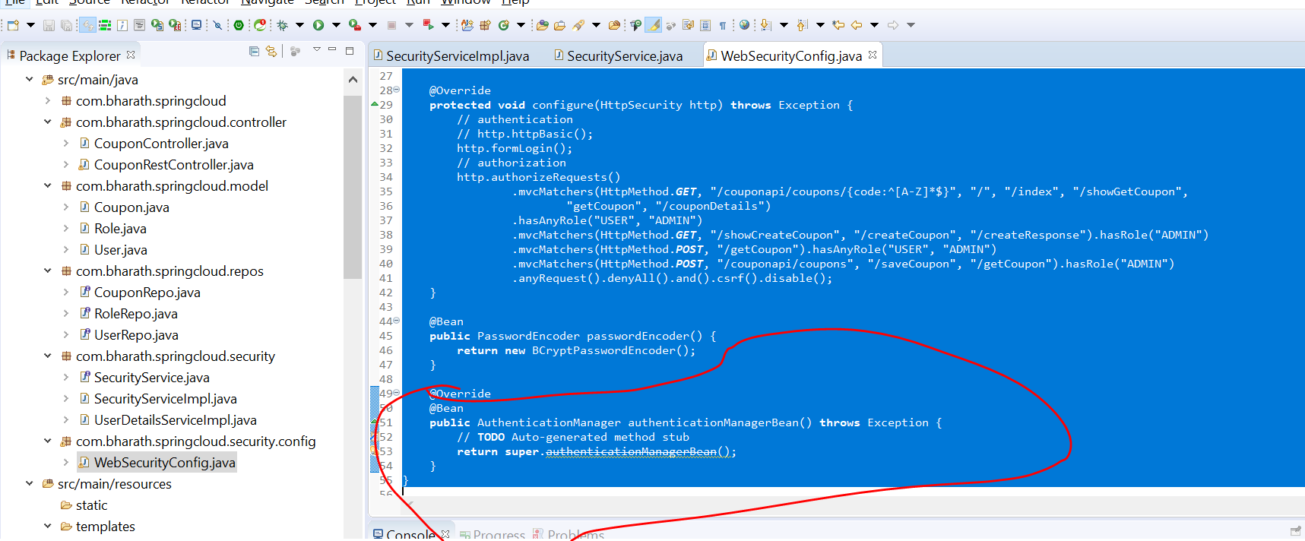

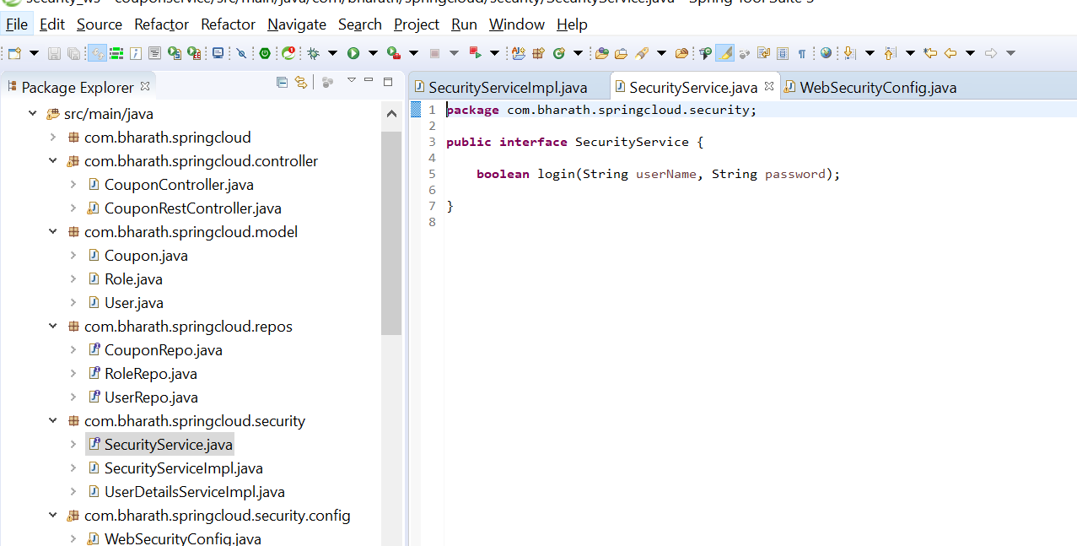

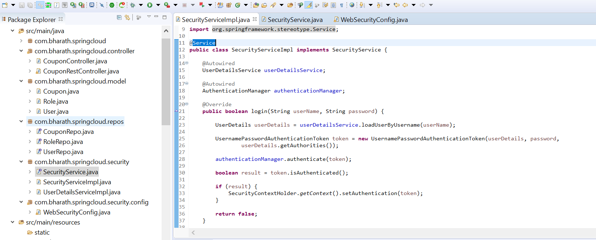

**Create the view and controller**

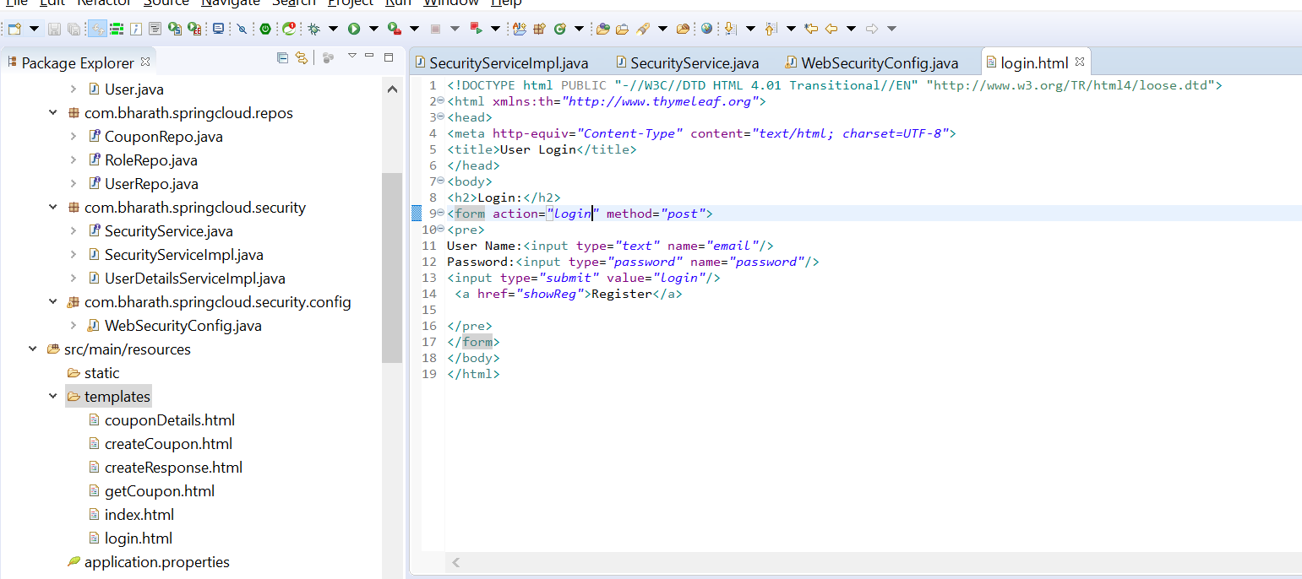

Note :

@RequestParam is spring web annotation

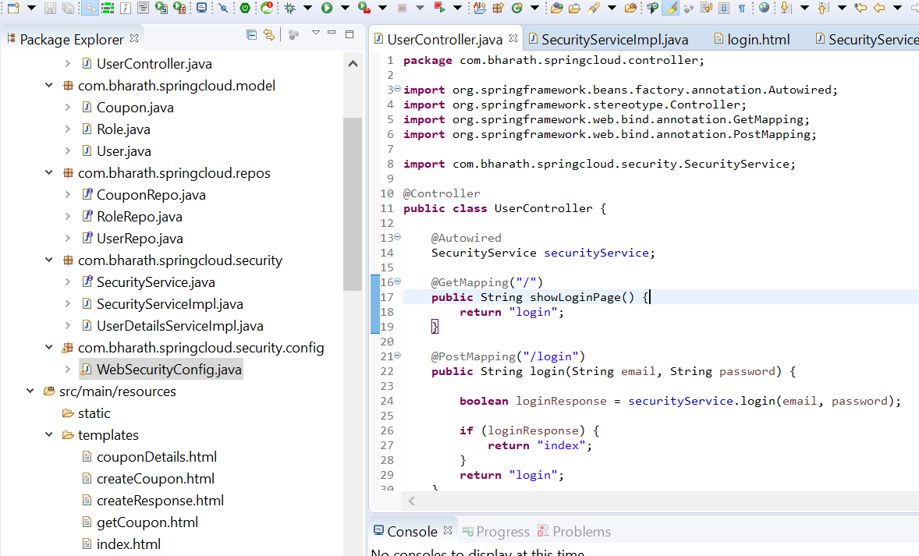

**Configure and test**

We have created our own login page so comment this http.formLogin

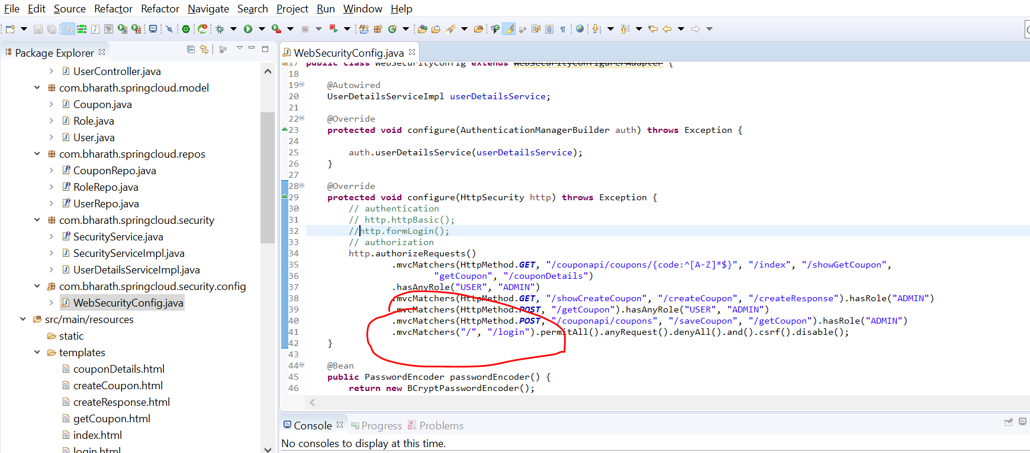

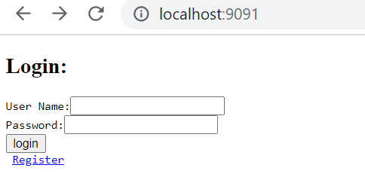

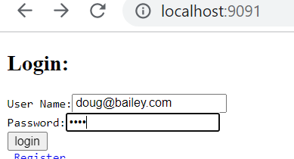

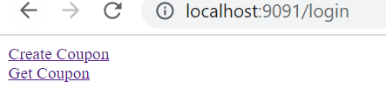

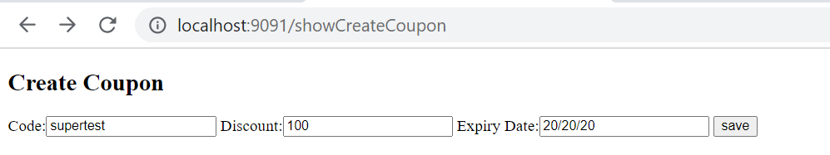

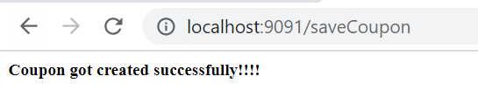

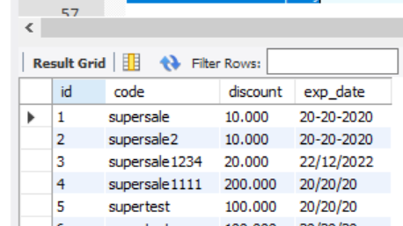

**Logout**

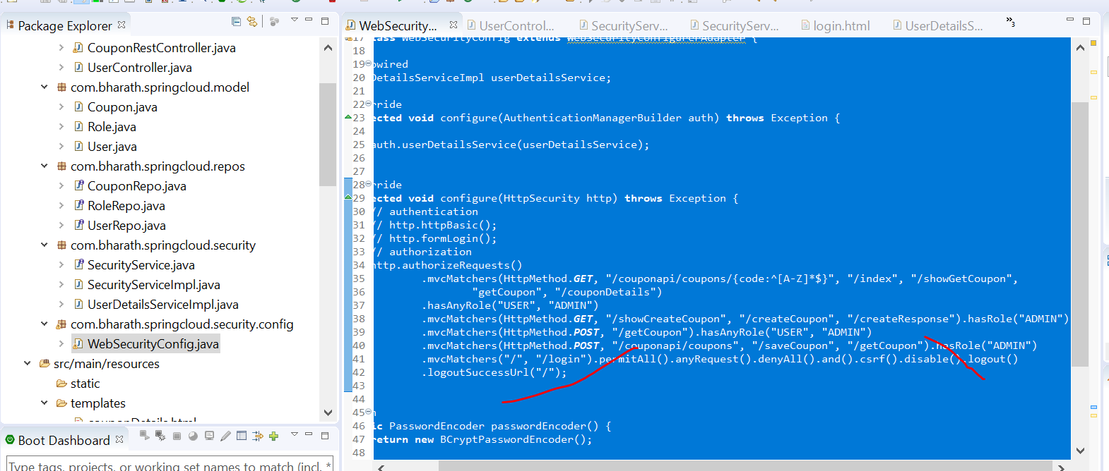

**Note :**

We don’t need to write any mapping for logout in spring

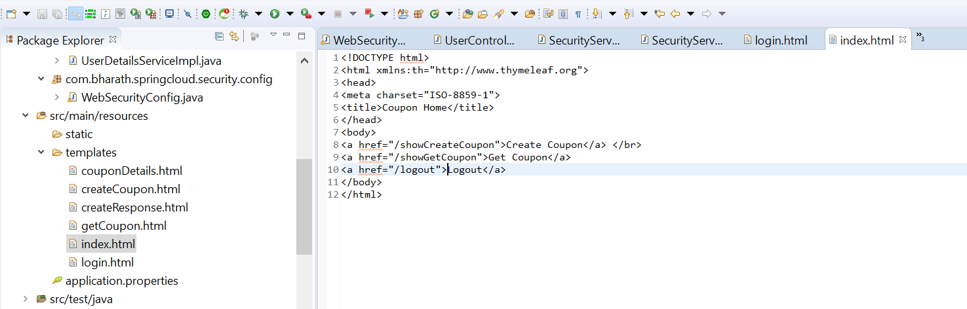

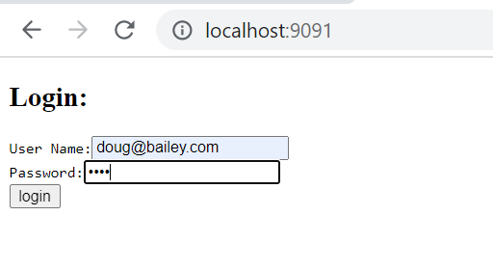

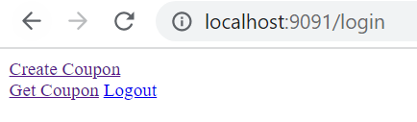

Click on logout , it will come to login page again. At this point session is invalid

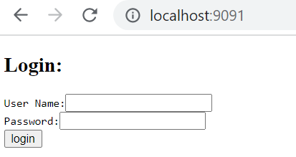

**Implement User Registration**

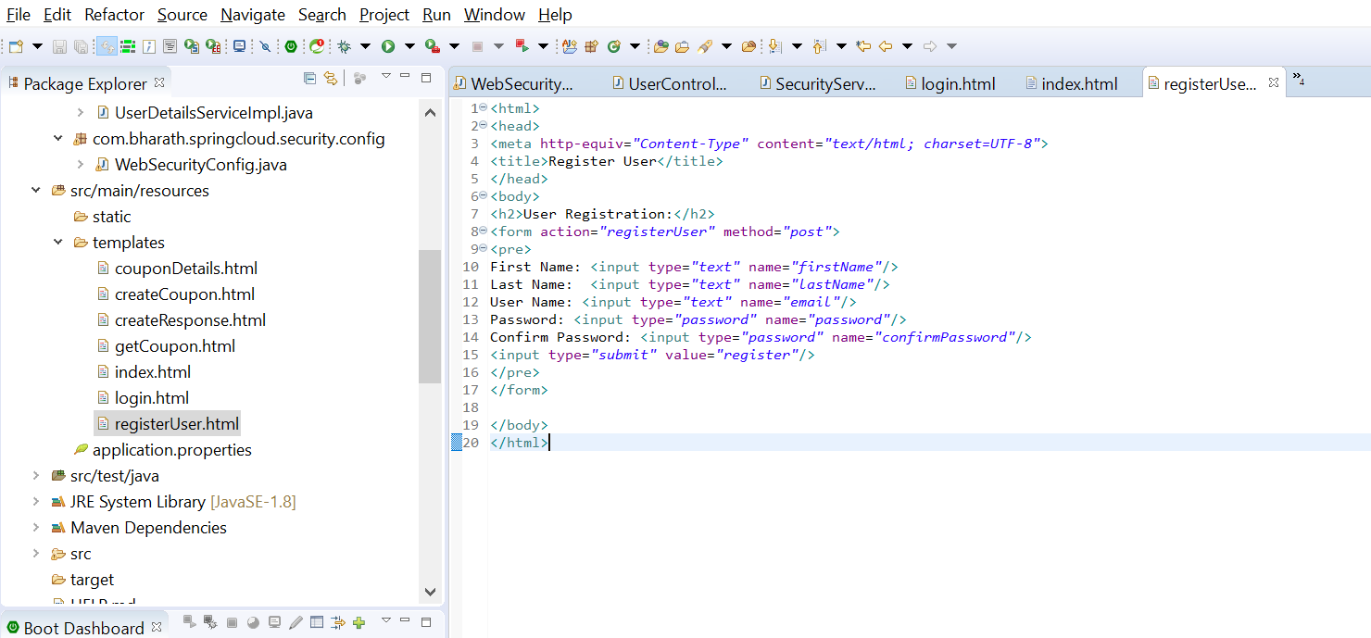

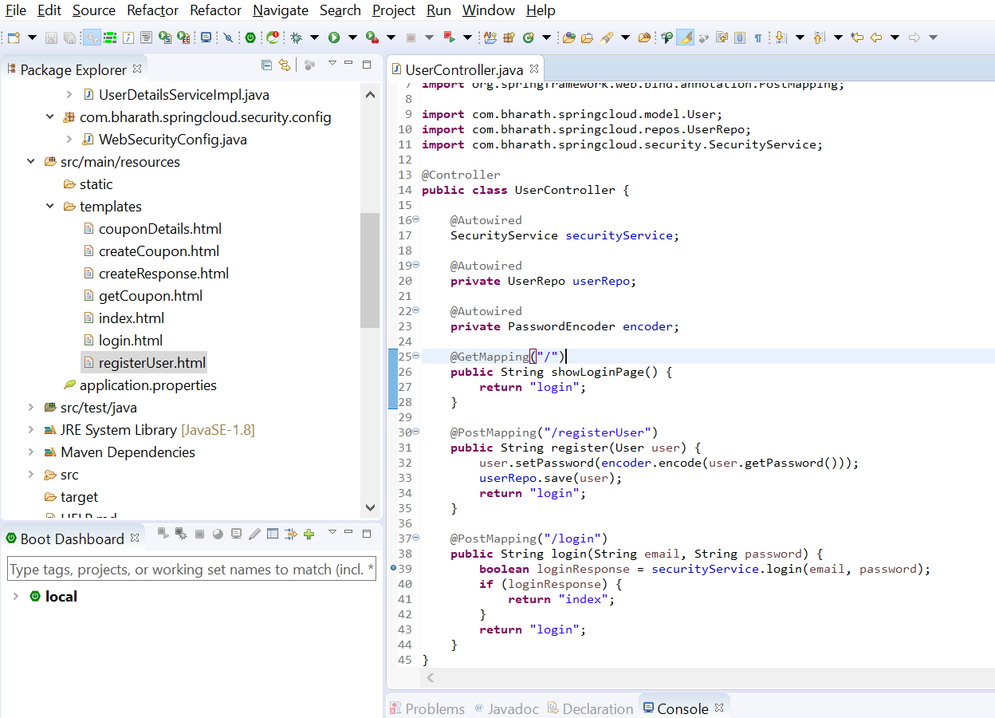

**Test User Registration**

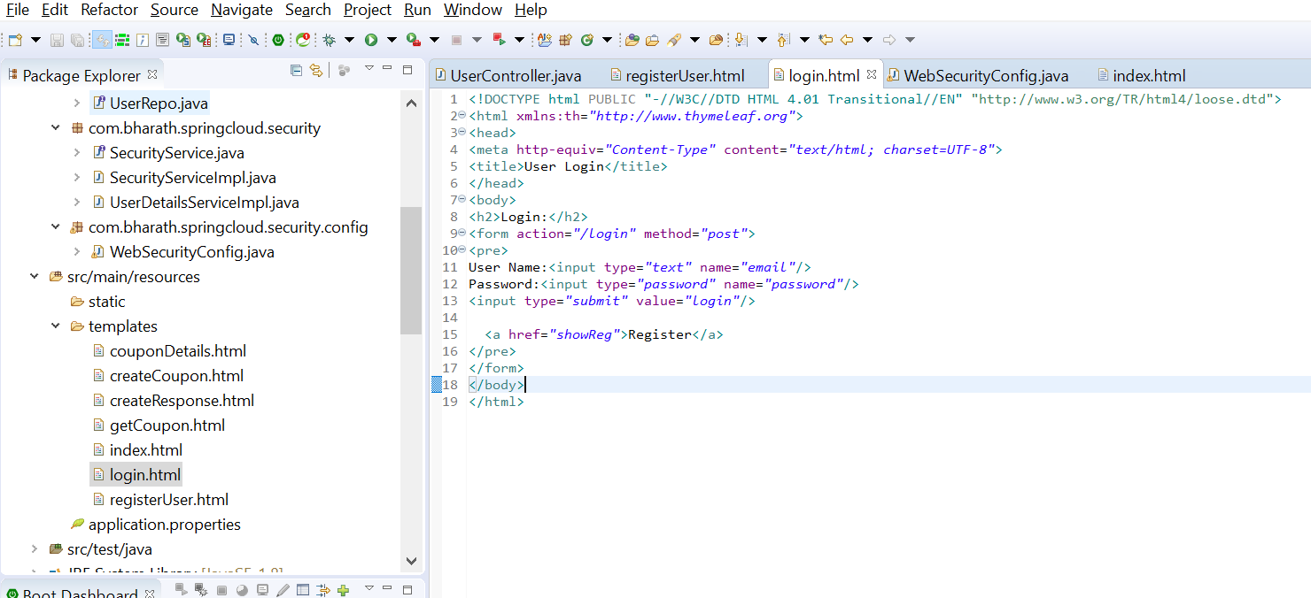

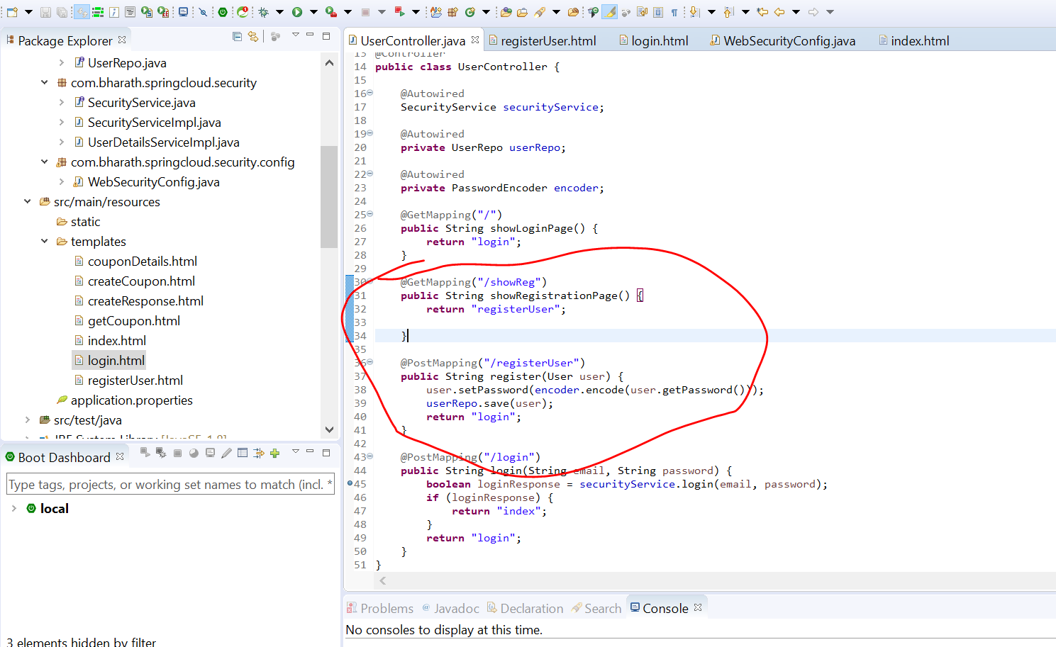

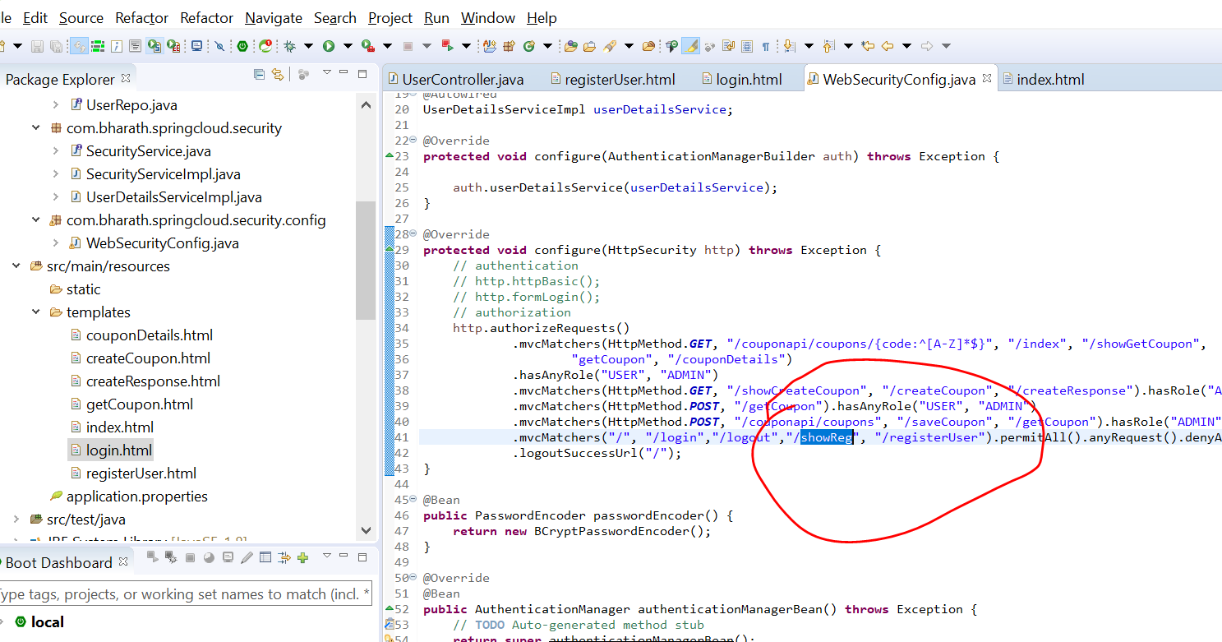

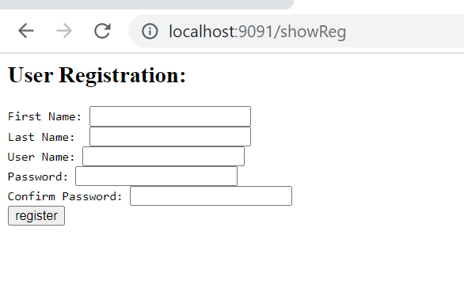

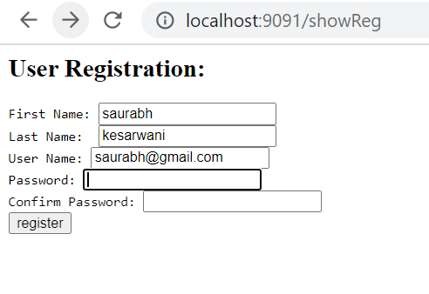

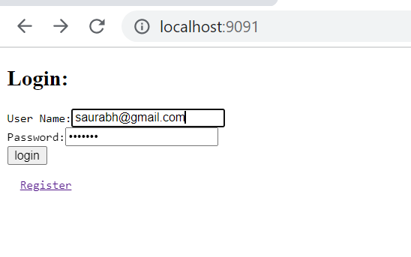

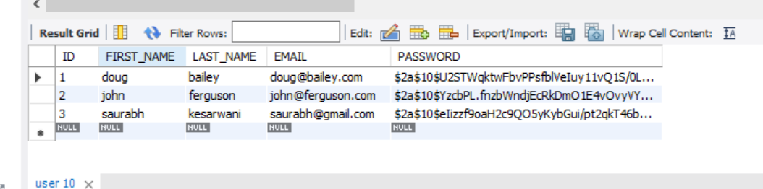

**This user don’t have any roles**

**Oauth Concept**

Open authentication and authorization framework

Example

Tax filing website instead of asking user to register , it will ask to login through facebook.

Once we login tax filing website able to fetch profile info from facebook.

This entire flow is possible through oauth framework

Again tax filing want to upload document of user in google drive it will redirect to google login

This is again possible due to oauth , it will allow only to upload document not to access mail.

Note

Google will decide how much authorization given to tax filing

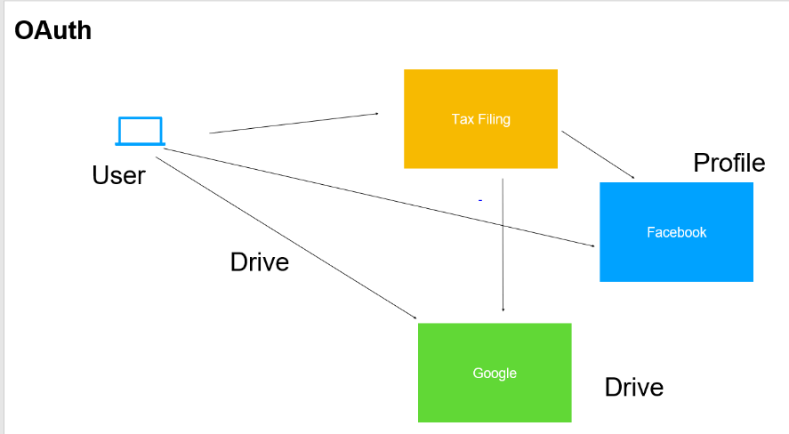

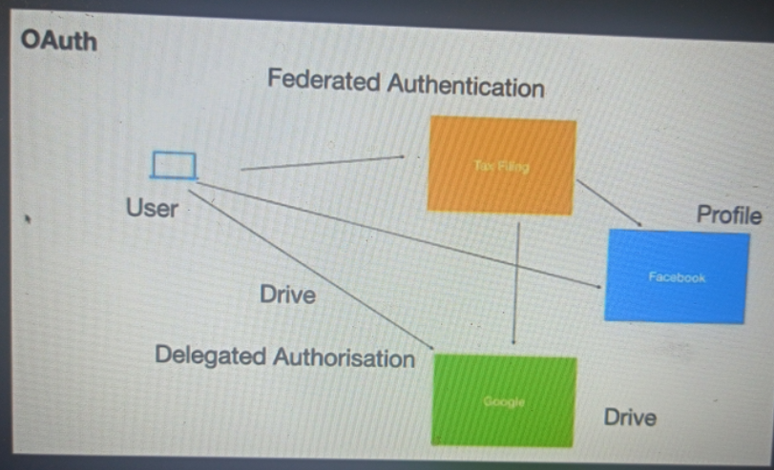

**There are four imp component in oauth**

**Resource server :--**

this is where resources or user data is store .this could be the restful endpoints or web application.

Which a client application want to access . The user or resource owner has permission to access these resource.

So when client application want to access certain data on resource server. It will ask end user to authentication directly with authorization server providing the user name and pw. The authorization server will validate user id and pw and it will generate a token.

This token will use by client to send a request to resource server. The resource server will validate token to authorization server.

If token is valid, it will send required data back to client application

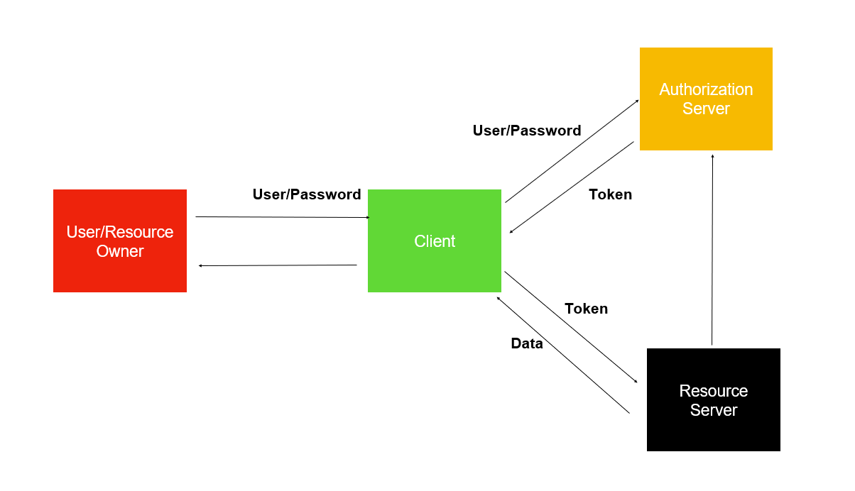

Note :

Once the client application will get a token , it need not to get user id and pw again to access resource server

**Grant Types**

Oauth support multiple work flow

like how user id and pw exchange between resource owner and client and

How user id and pw exchange between resource owner and authorization server

**Grant Types**

Authorization code

Password

Client credentials

Refresh Token

**Note :-**

we can pick appropriate grant type as per our application requirement

**Authorization code grant type**

User trying to file tax returns using a web application. This application want to access google docs of user so that it can use them and file his return. At this point it will ask user to authorize with the google auth server. The user will be redirected to login page.

The user enter user name and pw at which point the auth server tell the client app the user has granted the permission. The client app has not got the token yet. At this point the client apllication need to send has it own user id and pw which register itself to the auth server.once auth server get details of client it will send token to client. Once the token got it can do whatever it want to do with the resource server.

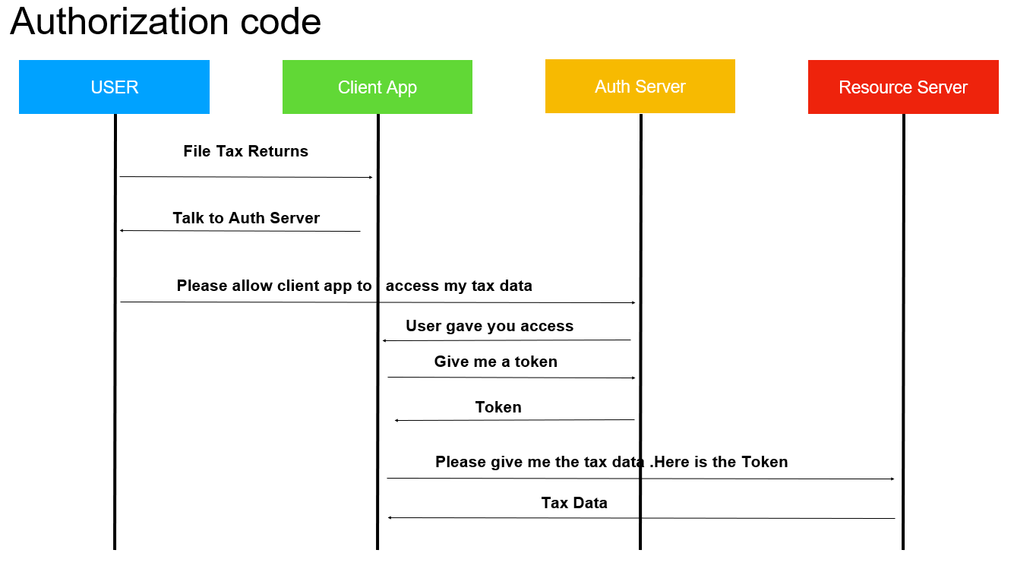

**Note :**

The user details are never known to client application

What does a authentication server do?

An authentication server is an application that facilitates the authentication of an entity that attempts to access a network. Such an entity may be a human user or another server. An authentication server can reside in a dedicated computer, an Ethernet switch, an access point or a network access server.

**Client id and secret given to client by authorization server when it register to the auth server**

**Password Grant type**

**The only difference between Authorization code grant type and Password Grant type**

In authorization code grant type client don’t know about user id and pw but in Password Grant type user giver user name and password to Password Grant type and it will send it own credential and also user name and pw to auth server

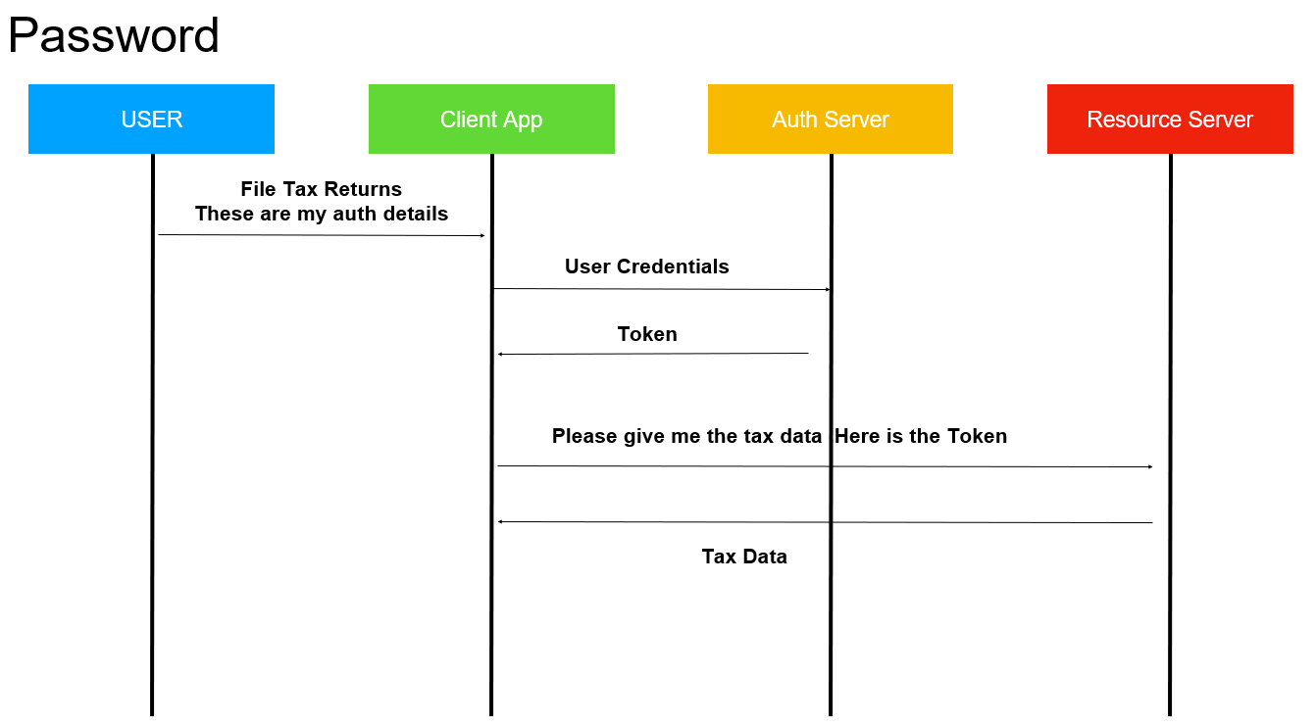

**Note :--**

**Auth server :-- google or fb account where client app are already registered it**

User details will directly given to client app

**Login using fb account uses :- Authorization code**

**Resource Server** – store user's data and http services which can return user data to authenticated clients.

What is a resource server in OAuth?

The resource server is **the OAuth 2.0 term for your API server**. The resource server handles authenticated requests after the application has obtained an access token. Large scale deployments may have more than one resource server.

**Client credential grant type**

**Here don’t have user in picture**

Think like an application accessing another application like in m/s

Very typical in single sign on application

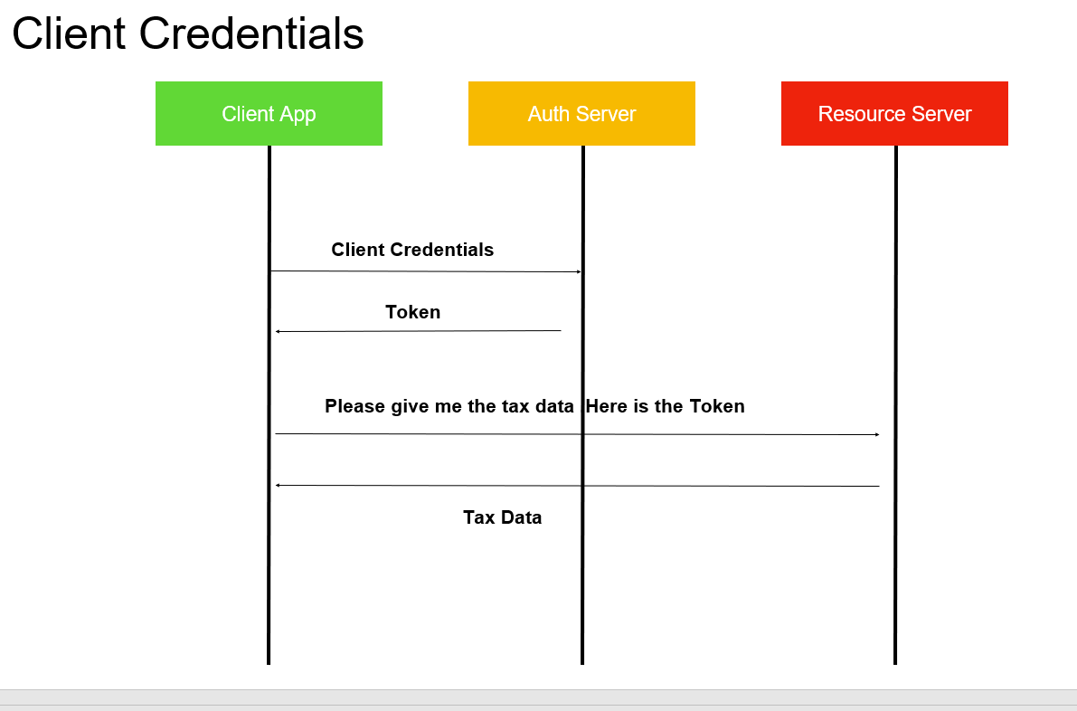

**Refresh Token**

Along with the token auth server also handsover refresh token. Suppose token expire then to repeat again entire flow again it will send refresh token to resource server and it will validate token to auth server.

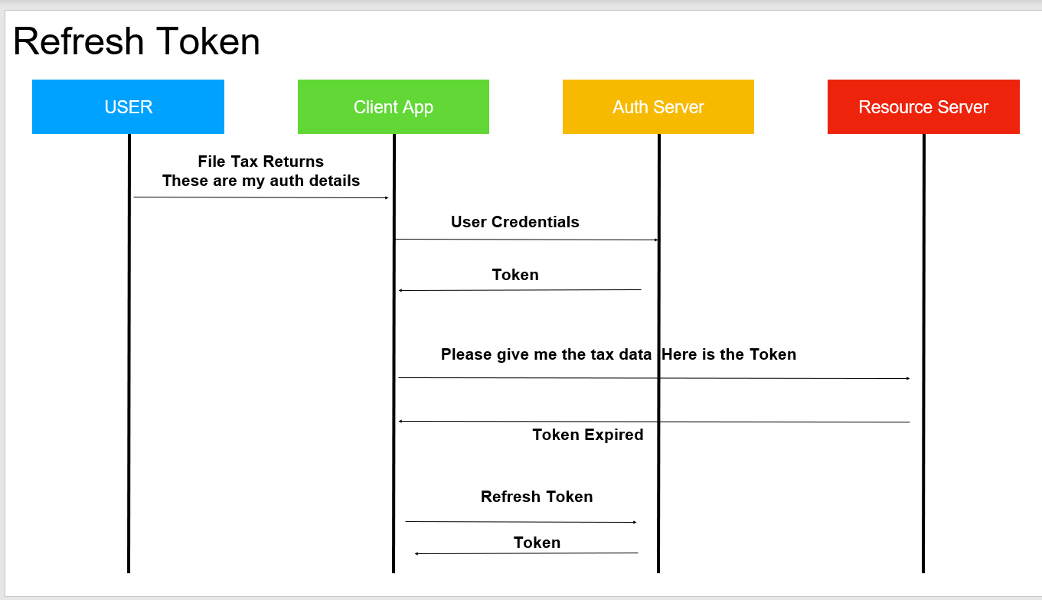

**Note:---**

We can create our own grant type also if required

**Google Oauth Playground**

**Client app :--**

**google playground**

**Search contact :----click it , and ask for authorize with google credential once will authorize it will get token and**

**That token we can use in resource server to get contact details**

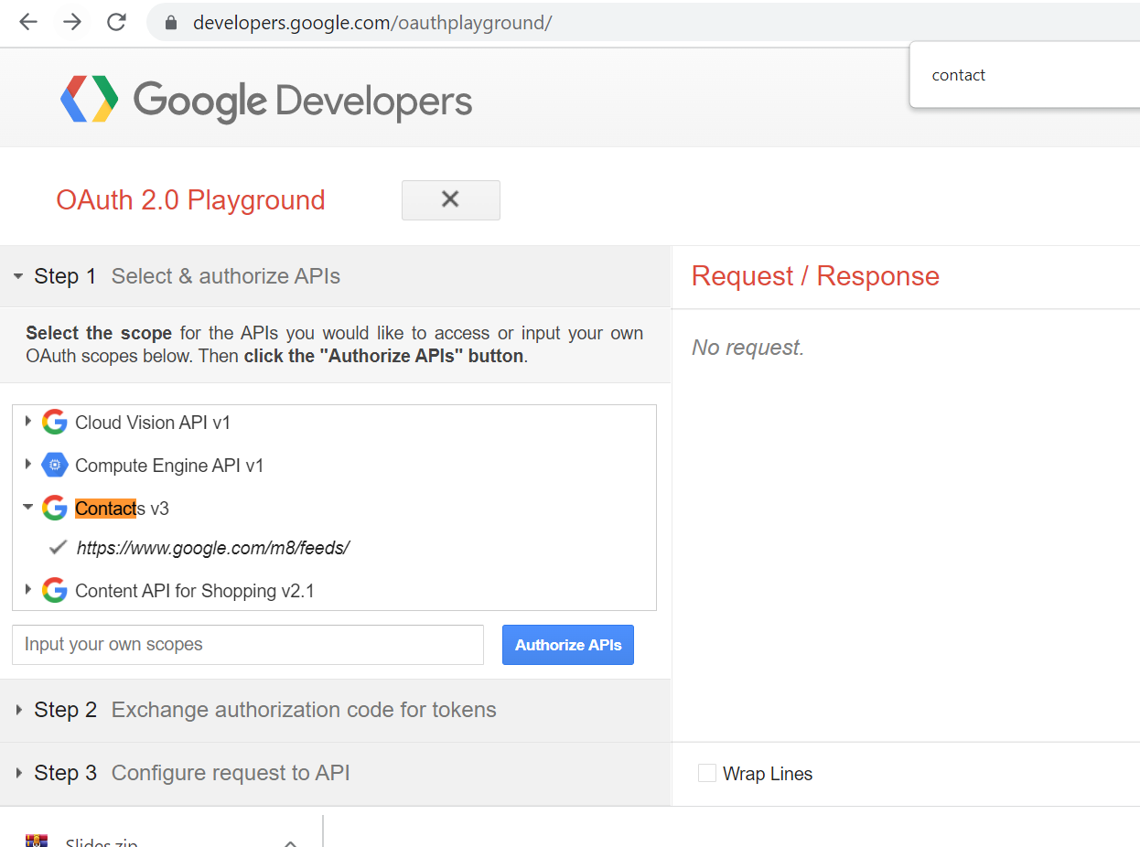

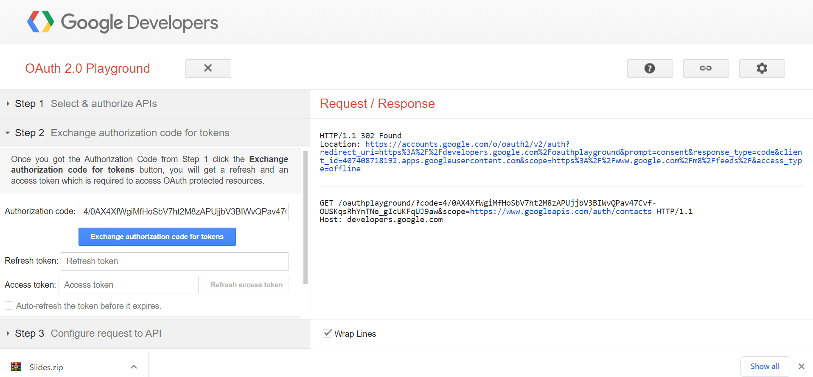

**Oauth in action**

**Steps**

Authentication server will authenticate user details and client details, generate a token and store token in tokenstore

**AuthenticationServer :**---- responsible for authenticating and generate a token

**ResourceServer :-**-- responsible for receiving a token and verifying whether token is valid and grant permission to appropriate url

**Step 1:----Add maven dependency**

Will add in CouponService project

For oauth we are using version below 2.4 release

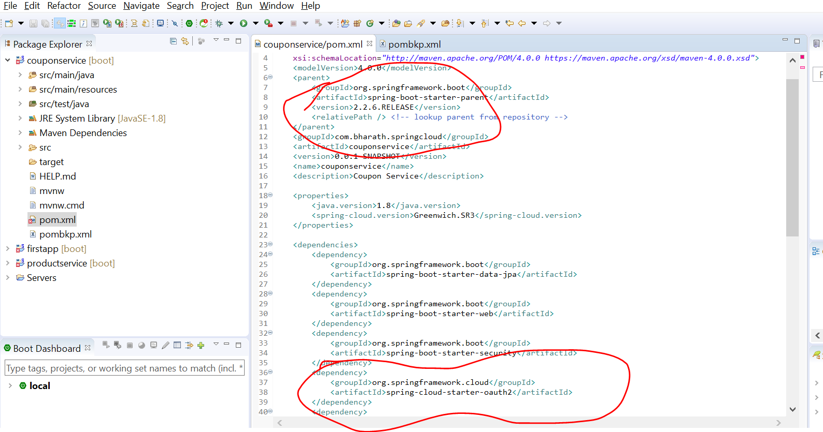

**Step 2:----Create WebSecurityConfig**

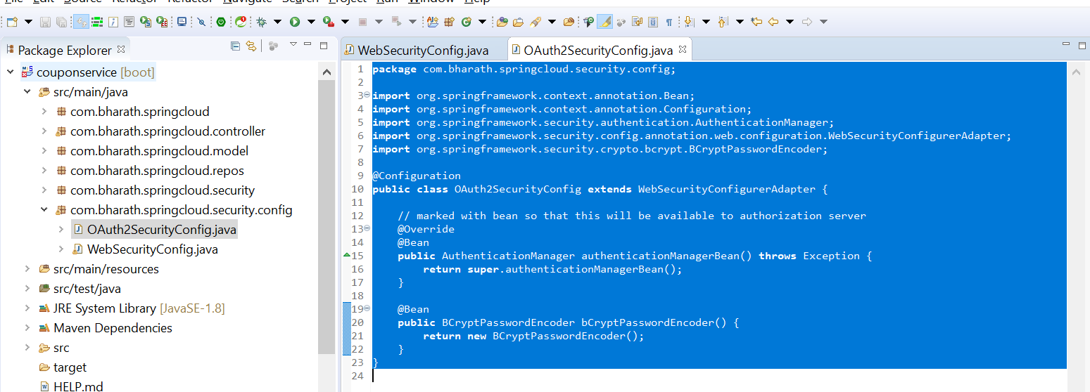

**Create AuthorizationServer Part1**

**We need to tell authorizationServer about token store**

It will retrieve userdetails from database

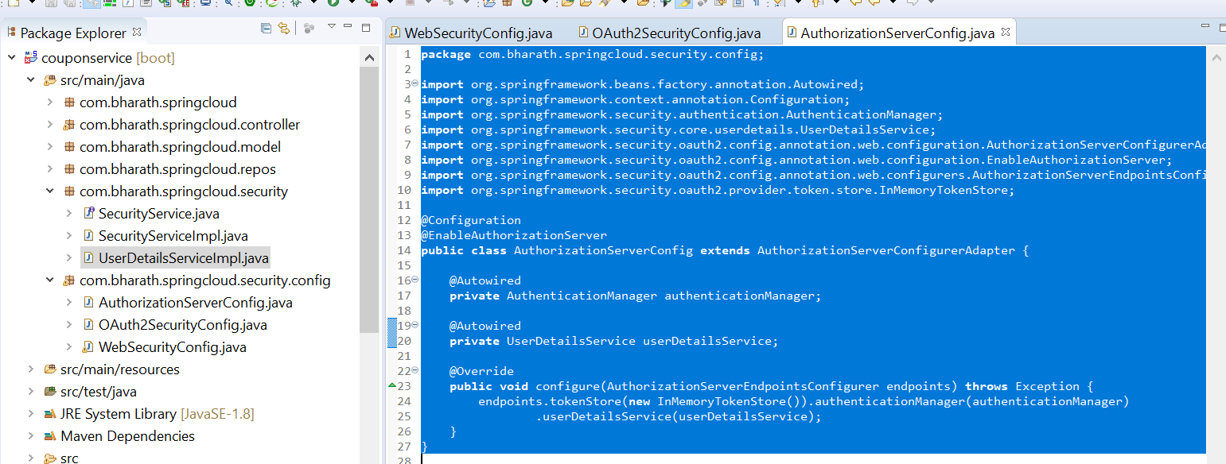

**Create AuthorizationServer Part2**

Will configure client details in Authorization Server

**Note:**

Will using resource id again in resource server that will be link like authorization server and resource server

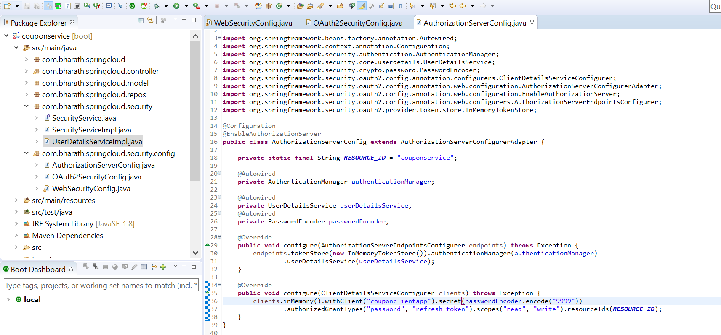

**Create Resource Server part -1**

**Note :--**

ResourceServerConfigurerAdapter is very similar to webSecurityConfigurerAdapte

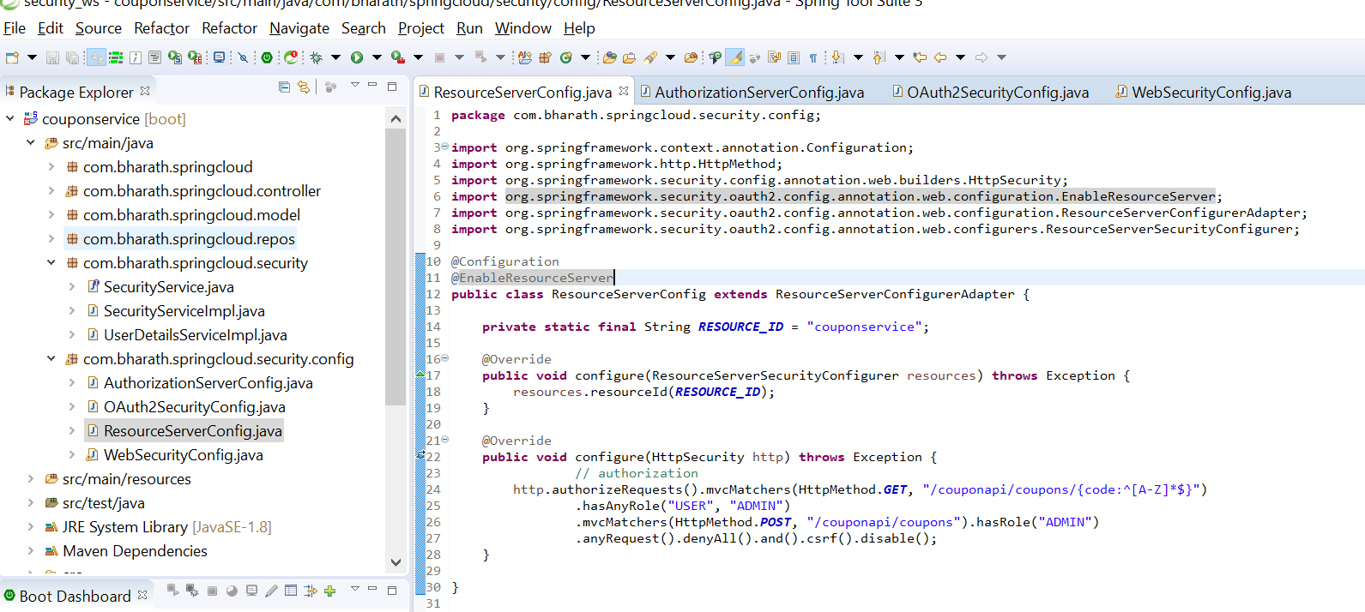

**Testing**

**Step 1:---**

**retrieve a token by hitting authorization server**

**Default is :----**/oauth/token

We need to provide client details and also user details in password grant types to authorization server

This is what we configured in memory . These are client details

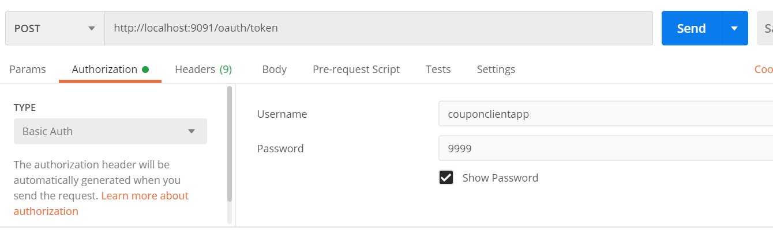

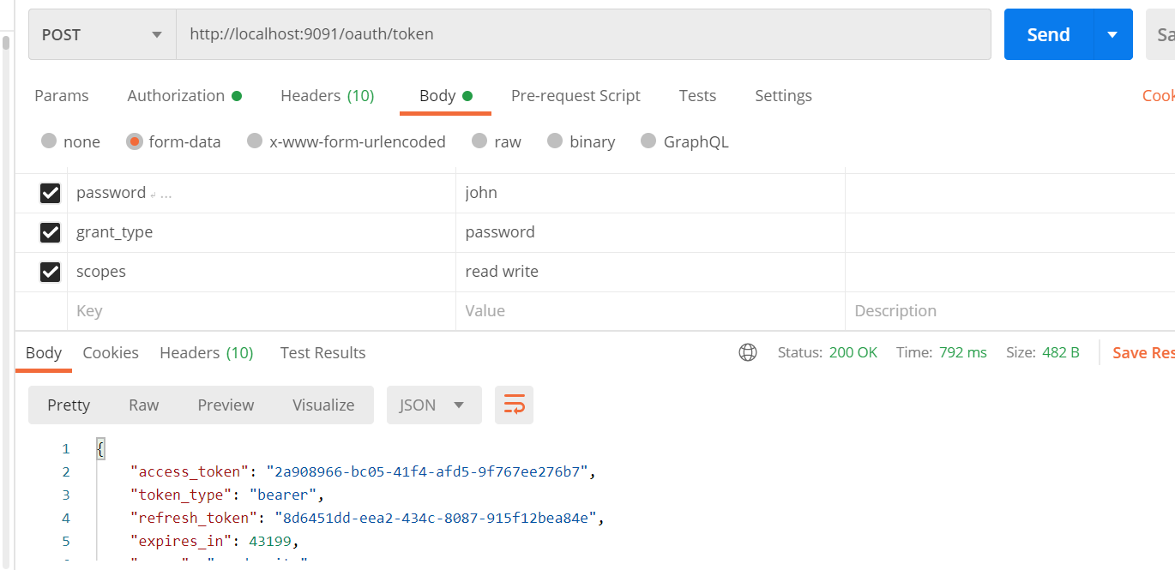

This request hit the authorization server . It will go all regular spring security flow.

Once the authentication is successful it will generate a token for us.

It will use token_store in memory

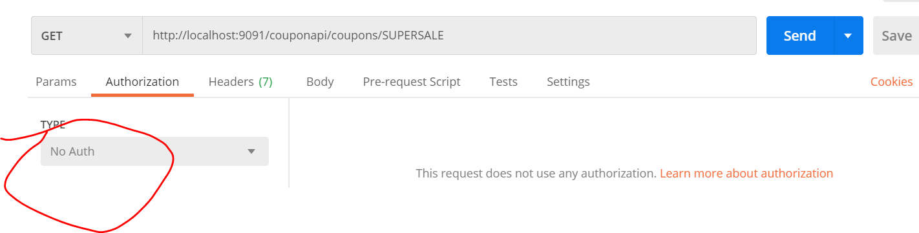

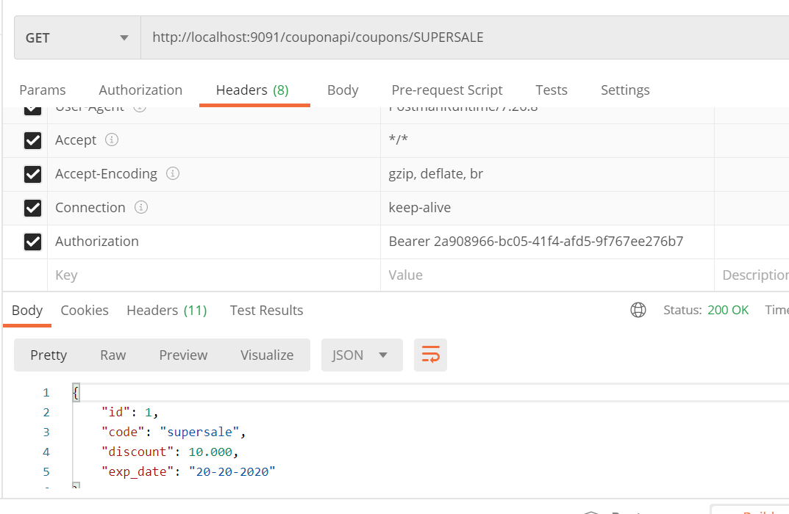

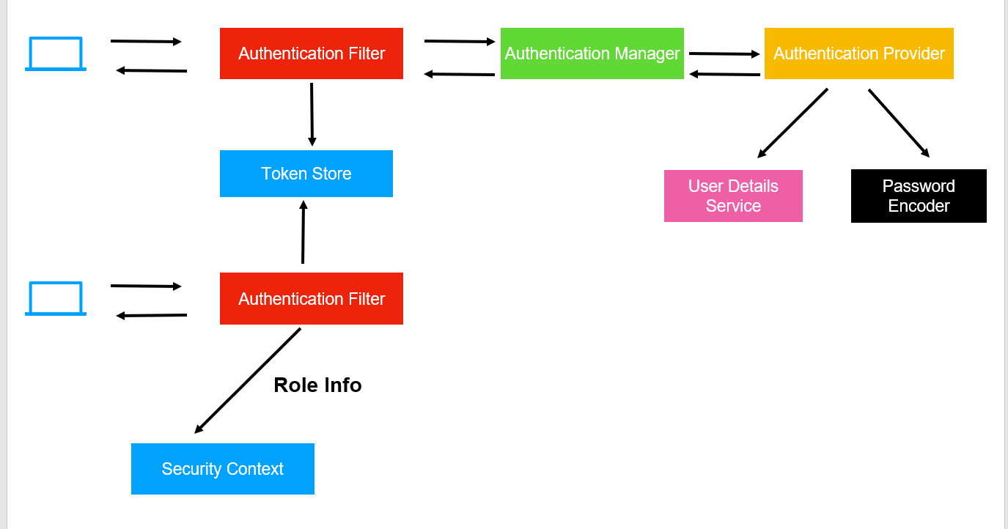

Resource server will take the token ,communicate with authorization server if this token is valid. It will look token_store to do the validation then it will fetch user details will store info in security context because it need to know which user has access of which resource

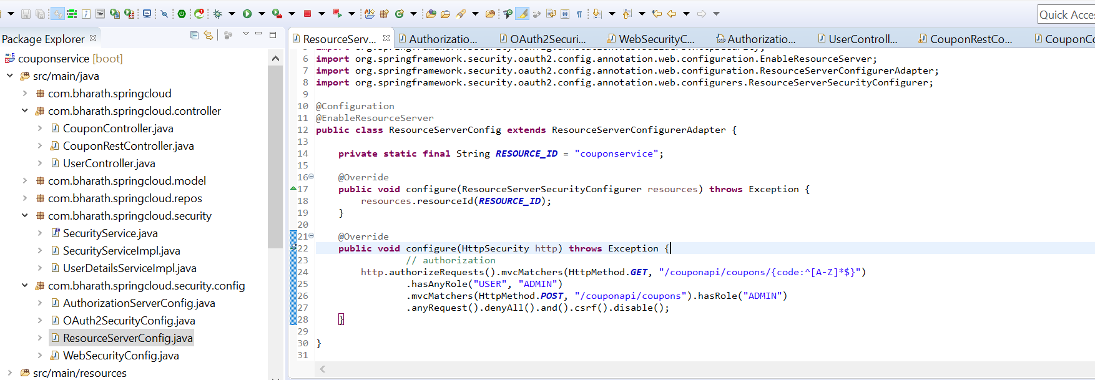

Authorization server doesn’t care of storing the details but resource server does

John does have admin access to create coupon

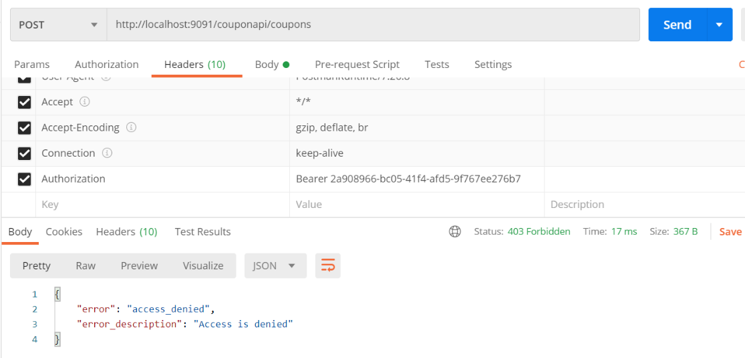

With doug

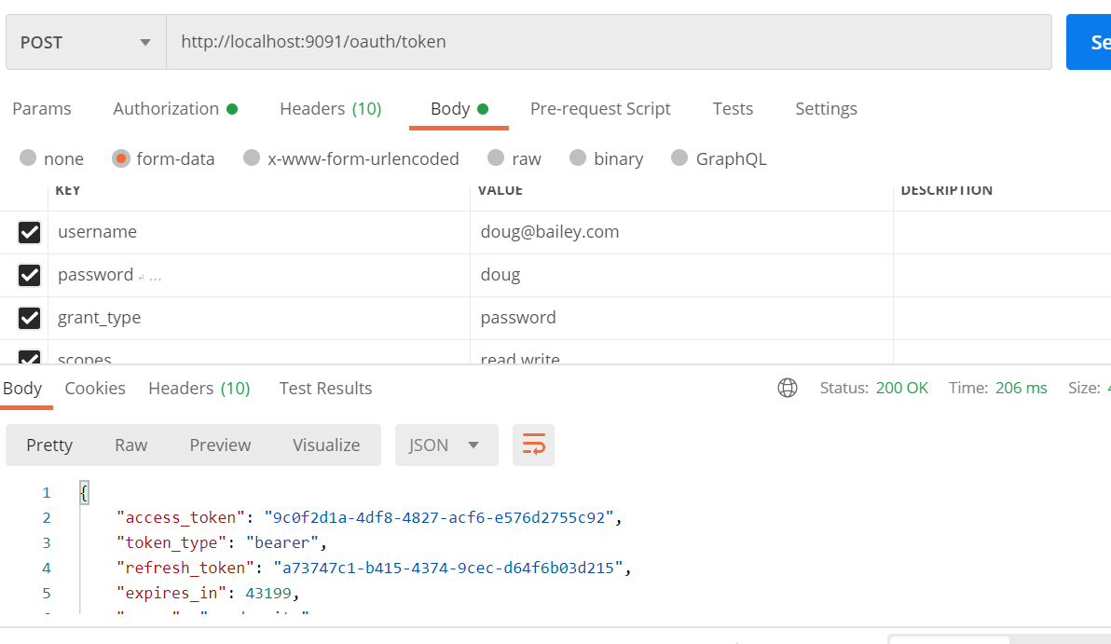

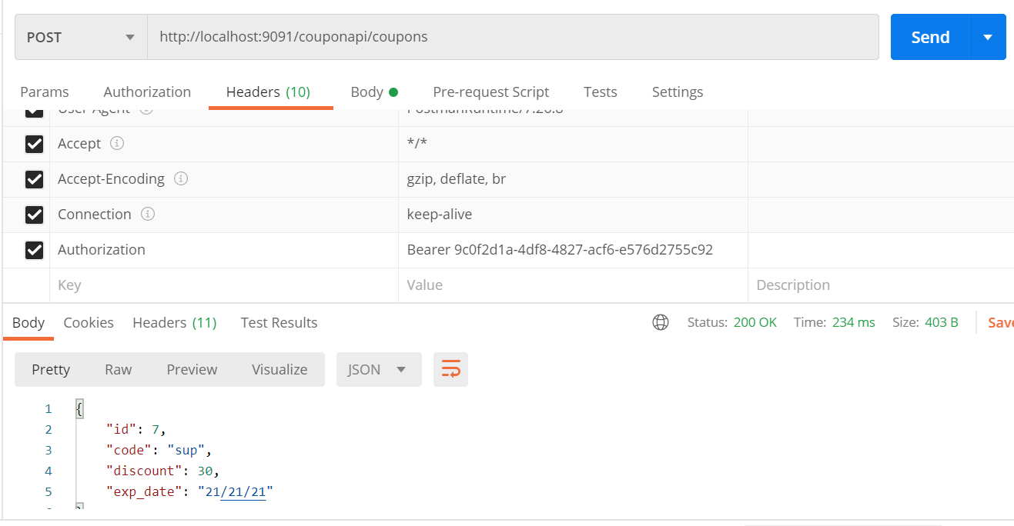

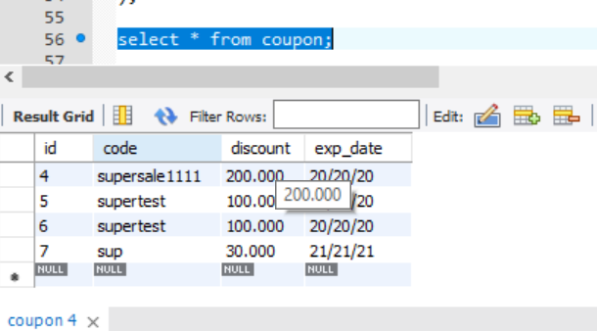

We got token by authorization server and once the token is used by resource server it validate against token store and retrieve user info from userdetails service and check access of admin .

**Store token in db**

**Note :**

So far we use in memory token store so once the application is down it no longer valid

We can permanently store token in d/b

Spring security will use this table by default to store token

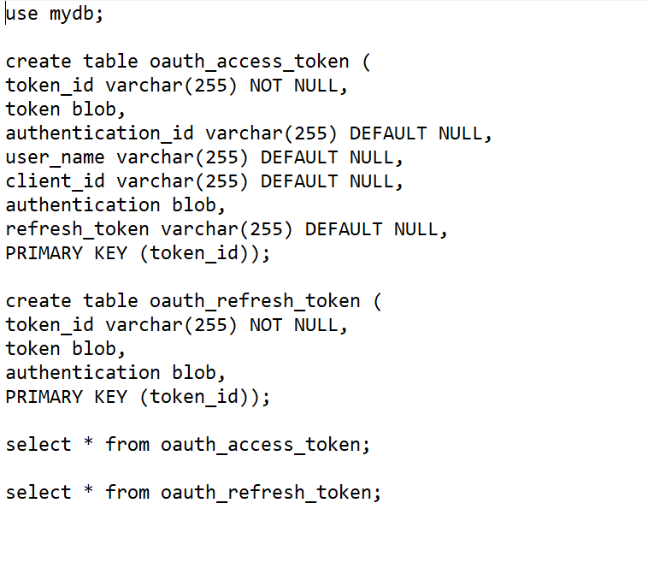

**Note :**

**Spring will inject a data source**

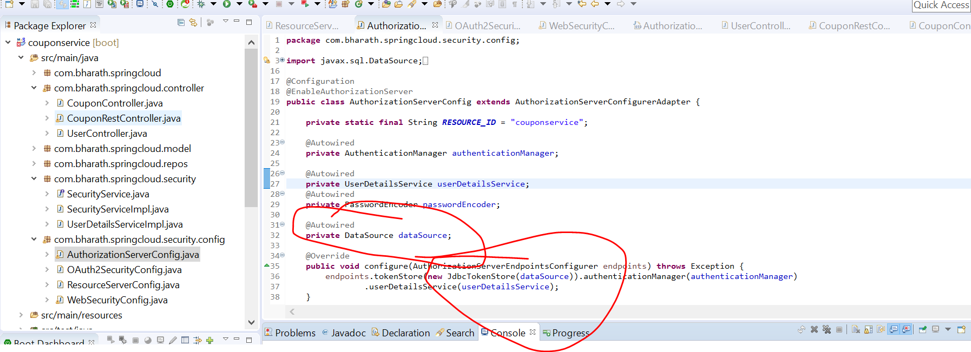

We don’t need to write any sql, JdbcTokenStore know how to store token in table.

**Imp point:---**

resource server will directly go into database to validate token instead of going in memory authorization server to validate

Token

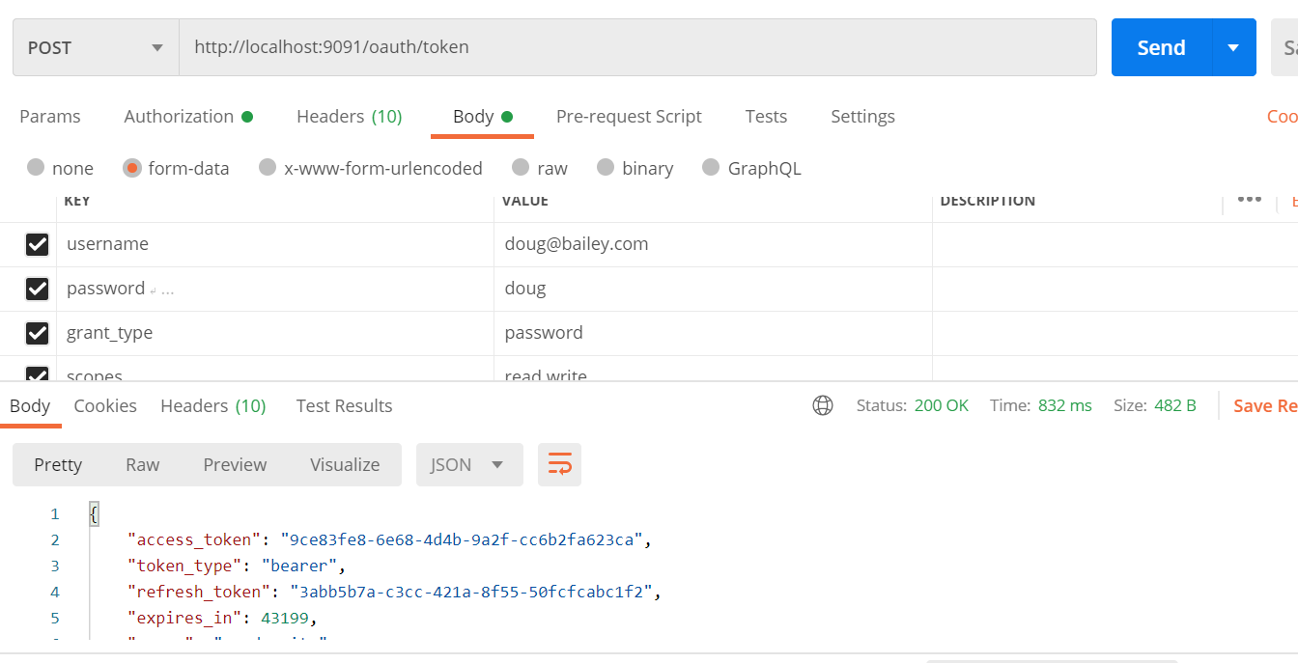

Note: this time token generated from d/b

